

**KENDRIYA VIDYALAYA SANGATHAN**

**CCT TEST ITEMS**

**CLASS X: CHAPTER 15: PROBABILITY**

|  |  |
| --- | --- |
| **S. NO.** | **TITLE OF TEST ITEM** |
|  | DICE |
|  | DICE |
|  | GAME WITH COINS |
|  | SCHOOL ADMISSION |
|  | FREE TICKETS FOR WORLD CUP |
|  | KITE FLYING COMPETITION |
|  | MUNICIPAL ELECTION |
|  | TERM INSURANCE PLAN |
|  | PLAYING CARDS |
|  | TOSSING A PAIR OF COINS |

**TEST ITEM:1**

**DICE**

**Raju and Mohan are playing with a biased Die having two faces each number 1, three faces each with number 2 and one face with number 3.**

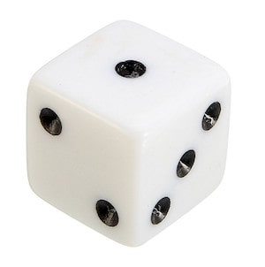

Question: 1. If Raju rolls the given Die once, find the probability of getting number either 1or 3.

………………………………………………………………………………………………………….

|  |  |  |
| --- | --- | --- |
| Domain: Mathematical Literacy | Theme: Dice | Class(es): X (Probability)  Expected Time: 1min.  Total Credit: 2 |
| Description of Item:   |  |  | | --- | --- | | YES | Text | | NO | Table | | NO | Graph | | YES | Map/Picture | | Learning Outcome:  (As per NCERT)   * Students will be able to know about faces of dice. * Students will be **Develop &maintain problem solving skills** | |

|  |  |
| --- | --- |
| FRAMEWORK | CHARACTERISTICS |
| Competency cluster | Connections |
| Overarching idea | Probability |
| Context | Real life problem |
| Item format | closed constructed -response |
| Cognitive Process | Employ |
| Proficiency Level | 2(a) |

Credit Pattern:

Full Credit: 2

Partial Credit: NA

No Credit: 0

Description of Answer Key and Credits:

|  |
| --- |
| Full Credit: 2  Correct Ans: P (1 or 3) = 1/2  No Credit: others response. |

Question: 2. If Mohan rolls the Die twice, then find the probability of getting a sum total of 6.

…………………………………………………………………………………………………………

|  |  |  |
| --- | --- | --- |
| Domain: Mathematical Literacy | Theme: dice | Class(es): X (Probability)  Expected Time: 1 min.  Total Credit: 2 |
| Description of Item:   |  |  | | --- | --- | | YES | Text | | NO | Table | | NO | Graph | | YES | Map | | Learning Outcome:  (As per NCERT)   * Students will be able to know about faces of die * Students will be **Develop &maintain problem solving skills** | |

|  |  |
| --- | --- |
| FRAMEWORK | CHARACTERISTICS |
| Competency cluster | Connections |
| Overarching idea | Sum of numbers on dice |
| Context | Real life problem |
| Item format | Closed constructed response |
| Cognitive Process | Employ |
| Proficiency Level | 2(a) |

Credit Pattern:

Full Credit: 2

Partial Credit: NA

No Credit: 0

Description of Answer Key and Credits:

|  |
| --- |
| Full Credit: 2  Correct Ans is zero  No Credit: others responses |

Q3. If Raju rolls the Die thrice, then probability of getting the sum total 6 will be:

….……………………………………………………………………………………………………………………………

|  |  |  |
| --- | --- | --- |
| Domain: Mathematical Literacy | Theme: Playing with dice | Class(es): X (Probability)  Expected Time: 2min.  Total Credit: 2 |
| Description of Item:   |  |  | | --- | --- | |  | Text | |  | Table | |  | Graph | |  | Map | | Learning Outcome:  (As per NCERT)   * Students will be able to know sample space. * Students will be **Develop &maintain problem solving skills** | |

|  |  |
| --- | --- |
| FRAMEWORK | CHARACTERISTICS |
| Competency cluster | Connections |
| Overarching idea | Sample space |
| Context | Real life problem |
| Item format | closed constructed -response |
| Cognitive Process | Employ |
| Proficiency Level | 2 |

Credit Pattern:

Full Credit: 2

Partial Credit: NA

No Credit: 0

Description of Answer Key and Credits:

|  |
| --- |
| Full Credit: 7/27  No Credit: Other response |

Question:4. If Mohan rolls the given Die thrice, then find the probability of getting the sum greater than 6.

………………………………………………………………………………………………………….

|  |  |  |
| --- | --- | --- |
| Domain: Mathematical Literacy | Theme: DICE | Class(es): X (Probability)  Expected Time: 2min.  Total Credit: 2 |
| Description of Item:   |  |  | | --- | --- | | YES | Text | | NO | Table | | NO | Graph | | YES | Map | | Learning Outcome:  (As per NCERT)   * Students will be able to know sample space. * Students will be **Develop &maintain problem solving skills** | |

|  |  |
| --- | --- |
| FRAMEWORK | CHARACTERISTICS |
| Competency cluster | Connections |
| Overarching idea | Sample space. |
| Context | Real life problem |
| Item format | Closed constructed -response |
| Cognitive Process | Employ |
| Proficiency Level | 2 |

Credit Pattern:

Full Credit: 2

Partial Credit: NA

No Credit: 0

Description of Answer Key and Credits:

|  |
| --- |
| Full Credit: 2  Correct Ans: 10/27  No credit: Other responses |

Question 5. If Raju rolls the given Die thrice, then what will be the probability of getting the sum, a prime number?

………………………………………………………………………………………………………………………………………………..

|  |  |  |
| --- | --- | --- |
| Domain: Mathematical Literacy | Theme: DICE | Class(es):-X (Probability)  Expected Time: 1min.  Total Credit: 2 |
| Description of Item:   |  |  | | --- | --- | | YES | Text | | NO | Table | | NO | Graph | | YES | Map | | Learning Outcome:  (As per NCERT)   * Students can understand about sample space. * Students will be **Develop &maintain problem solving skills** | |

|  |  |
| --- | --- |
| FRAMEWORK | CHARACTERISTICS |
| Competency cluster | Connections |
| Overarching idea | Prime numbers |
| Context | Real life problem |
| Item format | Closed constructed -response |
| Cognitive Process | Employ |
| Proficiency Level | 3 |

Credit Pattern:

Full Credit: 2

Partial Credit: NA

No Credit: 0

Description of Answer Key and Credits:

|  |
| --- |
| Full Credit: 2  Correct Ans 13/27  No credit: Other responses |

Name: - OP SWAMI

Designation: PGT (MATHS)

KV Gurugram (shift-2)

Contact No. 9810250465

**TEST ITEM-2**

**DICE**

There is a picture of two dice. Dice are special number cubes for which the following rule applies: The total number of dots on two opposite faces is always seven. You can make a simple number cube by cutting, folding and gluing cardboard. This can be done in many ways.

.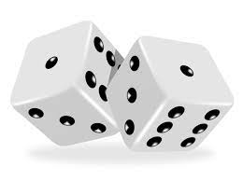

Question 1. In the figure below you can see four cuttings that can be used to make cubes, with dots on the sides.

Which of the following shapes can be folded together to form a cube that obeys the rule that the sum of opposite faces is 7? For each shape, circle either "Yes" or "No" in the table below.

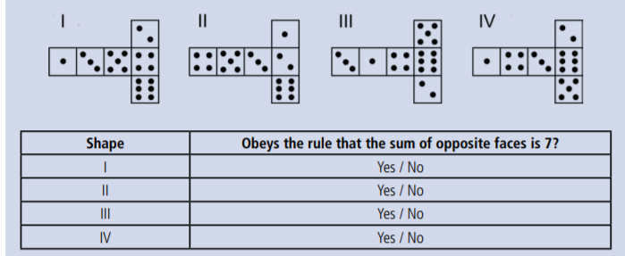

|  |  |  |
| --- | --- | --- |
| Domain: Mathematical Literacy | Theme: DICE | Class(es): - X (Probability)  Expected Time: 2 min.  Total Credit: 2 |
| Description of Item:   |  |  | | --- | --- | | Text and Image | Text  Image | | Yes | Table | | No | Graph | | No | Map | | yes | Image | | Learning Outcome:  (As per NCERT)  Students will be able to Use the concept of sum of numbers on the opposite side on a dice. | |

Mathematical Literacy

|  |  |
| --- | --- |
| FRAMEWORK | CHARACTERISTICS |
| Competency Cluster | Connection |
| Overarching Idea | Knowledge about dice |
| Context | Scientific |
| Item format | Complex multiple choice |
| Cognitive Process | Understanding |
| Proficiency Level | 5 |

Credit Pattern:

Full Credit: 2(1/2 for each correct option)

Partial Credit: NA

No Credit: 0

Description of Answer Key and Credits:

|  |
| --- |
| Full credit: 2  for answer No, Yes, Yes, No  No credit: for three or more wrong responses  Partial Credit: up to three correct responses |

Question 2. Out of the given two dice, One Die is thrown. Find the probability of getting number 7 on the face of the thrown Die.

( a) 1/6 (b) 0 (c) 7/36 (d) None of these

|  |  |  |
| --- | --- | --- |
| Domain: Mathematical Literacy | Theme: DICE | Class(es): - X (Probability)  Expected Time: 2 min.  Total Credit: 2 |
| Description of Item:   |  |  | | --- | --- | | Text and Image | Text  Image | | Yes | Table | | No | Graph | | No | Map | | yes | Image | | Learning Outcome:  (As per NCERT)  Students will be able to Use the concept of probability | |

Mathematical Literacy

|  |  |
| --- | --- |
| FRAMEWORK | CHARACTERISTICS |
| Competency Cluster | Connection |
| Overarching Idea | Knowledge about probability |
| Context | Scientific/Knowledge |
| Item format | MCQ |
| Cognitive Process | Understanding |
| Proficiency Level | 6 |

Credit Pattern:

Full Credit: 2

Partial Credit: NA

No Credit: 0

Description of Answer Key and Credits:

|  |
| --- |
| Full credit: 2  for answer: 0  No credit: for any other response  sum of numbers on the opposite side on a dice. |

Question 3. Out of these two dice, one Die is biased and has number 6 on its each face. Find the difference between the probability of the following two situations:

1. Sum of dice comes 8 when one of the dice is biased and another one is unbiased.
2. The sum of the dice is 8 when both dice are unbiased.

(a) 1/4 (b) 0 (c) 5/36 (d) 1/36

|  |  |  |
| --- | --- | --- |
| Domain: Mathematical Literacy | Theme: DICE | Class(es): - X (Probability)  Expected Time: 2 min.  Total Credit: 2 |
| Description of Item:   |  |  | | --- | --- | | Text and Image | Text  Image | | Yes | Table | | No | Graph | | No | Map | | yes | Image | | Learning Outcome:  (As per NCERT)  Students will be able to Use the concept of probability | |

Mathematical Literacy

|  |  |
| --- | --- |
| FRAMEWORK | CHARACTERISTICS |
| Competency Cluster | Connection |
| Overarching Idea | Knowledge about probability |
| Context | Scientific/Knowledge |
| Item format | MCQ |
| Cognitive Process | Understanding/Critical thinking |
| Proficiency Level | 6 |

Credit Pattern:

Full Credit: 2

Partial Credit: NA

No Credit: 0

Description of Answer Key and Credits:

|  |
| --- |
| Full credit: 2  for correct answer 1/4  No credit: for any other response  sum of numbers on the opposite side of dice. |

Question 4. If both above dice thrown simultaneously, Find the probability of getting the sum of the numbers on both dice comes a prime number.

(a) 1/4 (b) 18/36 (c) 15/36 (d) 9/36

|  |  |  |
| --- | --- | --- |
| Domain: Mathematical Literacy | Theme: DICE | Class(es): - X (Probability)  Expected Time: 2 min.  Total Credit: 2 |
| Description of Item:   |  |  | | --- | --- | | Text and Image | Text  Image | | Yes | Table | | No | Graph | | No | Map | | yes | Image | | Learning Outcome:  (As per NCERT)  Students will be able to Use the concept of probability | |

Mathematical Literacy

|  |  |
| --- | --- |
| FRAMEWORK | CHARACTERISTICS |
| Competency Cluster | Connection |
| Overarching Idea | Knowledge about probability |
| Context | Scientific/Knowledge |
| Item format | MCQ |
| Cognitive Process | Understanding/Critical thinking |
| Proficiency Level | 4 |

Credit Pattern:

Full Credit: 2

Partial Credit: NA

No Credit: 0

Description of Answer Key and Credits:

|  |
| --- |
| Full credit: for correct answer 15/36  No credit: for any other response  sum of numbers on the opposite side of dice and about prime numbers. |

Question 5. In below figure construction has been made by using seven identical dice with their faces numbered from 1 to 6. When the construction is viewed from the top, the faces of five dice can be seen. Find the probability of the dots visible from the top.

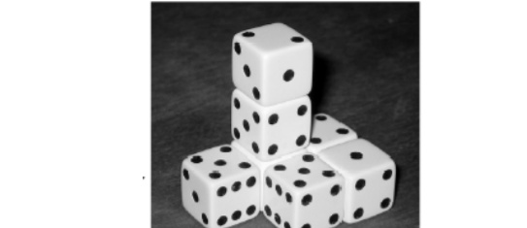

(a) 14/36 (b) 17/147 (c) 14/17 (d) 15/17

|  |  |  |
| --- | --- | --- |
| Domain: Mathematical Literacy | Theme: DICE | Class(es): :- X (Probability)  Expected Time: 2 min.  Total Credit: 2 |
| Description of Item:   |  |  | | --- | --- | | Text and Image | Text  Image | | Yes | Table | | No | Graph | | No | Map | | yes | Image | | Learning Outcome:  (As per NCERT)  Students will be able to Use the concept of probability | |

Mathematical Literacy

|  |  |
| --- | --- |
| FRAMEWORK | CHARACTERISTICS |
| Competency Cluster | Connection |
| Overarching Idea | Knowledge about probability |
| Context | Scientific/Knowledge |
| Item format | MCQ |
| Cognitive Process | Understanding/Critical thinking |
| Proficiency Level | 6 |

Credit Pattern:

Full Credit: 2

Partial Credit: 0

No Credit: 0

Description of Answer Key and Credits:

|  |
| --- |
| Full credit: for correct answer 17/147  Partial credit : 0  No credit: for any other response  sum of numbers on the opposite side of dice and interpretation requires a prescriptive from the photo of three dimensional view . |

**Name of teacher / Item writer: JITENDER SINGH**

**Designation: PGT (MATHS)**

**Email: jitu1051976@gmail.com**

**Phone No. 9467346795**

**Name of the Vidyalaya: k.v.no.2 sirsa**

**TEST ITEM :3**

**GAME WITH COINS**

Three children Raja, Kamal and Neelam are playing a game with coins. Each child tossed a coin 25 times and noted the result head or tail. They can win all the balloons if probability of getting head is more than 90 percent.

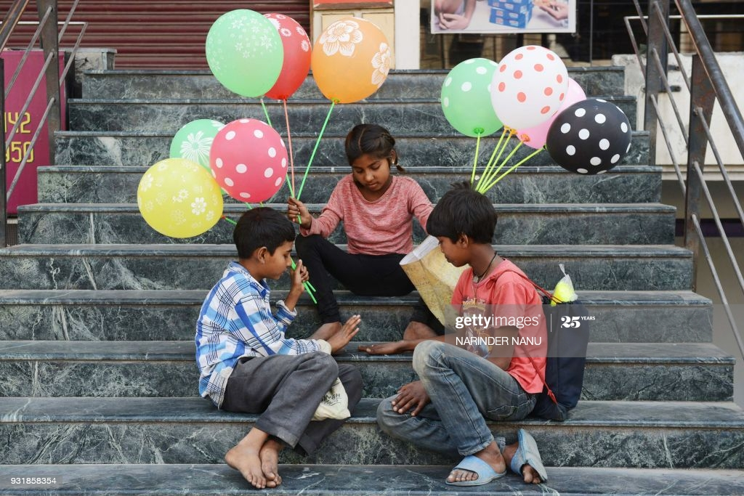

No. of Heads and Tails are given below **(Table No.1)**

|  |  |  |  |
| --- | --- | --- | --- |
| Name | Raja | Kamal | Neelam |
| No. of Heads | 17 | 15 | 19 |
| No. of tails | 8 | 10 | 6 |

Question 1.Can any onewin all the balloons? If yes, then tell the name.

………………………………………………………………………………………………………………………………..

|  |  |  |
| --- | --- | --- |
| Domain: Mathematical Literacy | Theme: GAME WITH COINS | Class(es): X (Probability)  Expected Time: 2 min.  Total Credit: 2 |
| Description of Item:   |  |  | | --- | --- | | YES | Text | | YES | Table | | NO | Graph | | YES | Map | | Learning Outcome:  (As per NCERT)   * Students will be able to know comparison of fractions and conversion. * Students will be **Develop &maintain problem solving skills** | |

|  |  |
| --- | --- |
| FRAMEWORK | CHARACTERISTICS |
| Competency cluster | Connections |
| Overarching idea | Comparison |
| Context | Real life problem |
| Item format | closed constructed -response |
| Cognitive Process | Employ |
| Proficiency Level | 2 |

Credit Pattern:

Full Credit: 2

Partial Credit: NA

No Credit: 0

Description of Answer Key and Credits:

|  |
| --- |
| Full Credit: For correct solution Raja, probability of Head is 68%, Kamal: - 60% and Neelam: -76%. Nobody can win the balloons  No Credit: Other responses |

**Question 2.**If the coin is tossed 50 times, outcomes of heads and tails became double in table -1, then who can win the balloons.

|  |  |  |
| --- | --- | --- |
| Domain: Mathematical Literacy | Theme: Game with COINS | Class(es): -X (Probability)  Expected Time: 2 min.  Total Credit: 2 |
| Description of Item:   |  |  | | --- | --- | | YES | Text | | YES | Table | | NO | Graph | | YES | Map | | Learning Outcome:  (As per NCERT)   * Students will be able to know concepts of the Probability. * Students will be **Develop &maintain problem solving skills** | |

|  |  |
| --- | --- |
| FRAMEWORK | CHARACTERISTICS |
| Competency cluster | Connections |
| Overarching idea | Comparison |
| Context | Real life problem |
| Item format | closed constructed -response |
| Cognitive Process | Employ |
| Proficiency Level | 2 |

Description of Answer Key and Credits:

|  |
| --- |
| Full Credit: No change in percentage. Nobody can win the balloon.  No Credit: others responses |

Q3: If the coin is tossed outcome of heads became double and tails halved in table -1.Is this experiment possible? Give reason.

|  |  |  |
| --- | --- | --- |
| Domain: Mathematical Literacy | Theme: Game with Coin | Class(es): X (Probability)  Expected Time: 1min.  Total Credit: 2 |
| Description of Item:   |  |  | | --- | --- | | YES | Text | | YES | Table | | NO | Graph | | NO | Map | | Learning Outcome:  (As per NCERT)   * Students will be able to know concepts of the Probability. * Students will be **Develop &maintain problem solving skills** | |

|  |  |
| --- | --- |
| FRAMEWORK | CHARACTERISTICS |
| Competency cluster | Connections |
| Overarching idea | Probability and fraction |
| Context | Real life problem |
| Item format | closed constructed -response |
| Cognitive Process | Employ |
| Proficiency Level | 2 |

Credit Pattern:

Full Credit: 2

Partial Credit: NA

No Credit: 0

Description of Answer Key and Credits:

|  |
| --- |
| Full Credit:2.  Ans Experiment is not possible.  No credit: - Other responses |

Question 4.The sum of the probability of a pair of persons will be above 90% and they can win all the balloons (From table-1). How many such pair can be formed?

|  |  |  |
| --- | --- | --- |
| Domain: Mathematical Literacy | Theme: Game with coin | Class(es): X (Probability)  Expected Time: 1min.  Total Credit: 2 |
| Description of Item:   |  |  | | --- | --- | | YES | Text | | YES | Table | | NO | Graph | | NO | Map | | Learning Outcome:  (As per NCERT)   * Students will be able to know concepts of the Probability. * Students will be **Develop &maintain problem solving skills** | |

|  |  |
| --- | --- |
| FRAMEWORK | CHARACTERISTICS |
| Competency cluster | Connections |
| Overarching idea | Probability and fraction |
| Context | Real life problem |
| Item format | Closed constructed -response |
| Cognitive Process | Employ |
| Proficiency Level | 2 |

Credit Pattern:

Full Credit: 2

Partial Credit: NA

No Credit: 0

Description of Answer Key and Credits:

|  |
| --- |
| Full Credit: 3 pairs, Raja & Kamal, Kamal & Neelam, Neelam&Raja.  No credit: - Other responses. |

Name: - OP SWAMI

Designation: PGT (MATHS)

KV Gurugram (shift-2)

Contact No. 9810250465

Mail address: - opswamimaths@gmail.com

**TEST ITEM: -4**

During the admission procedure in a school, the number of students seeking admission is more than that of the seats available in the class so that school administration decides to organize a draw so that each student has equal possibility of getting admission in the school. The following category of students applied for admission.

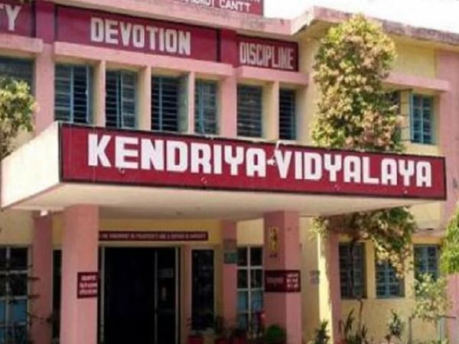

|  |  |  |  |  |  |
| --- | --- | --- | --- | --- | --- |
| Service/ Social Category. | GEN | SC | OBC | ST | EWS |
| 1 | 60 | 40 | 25 | 12 | 00 |
| 2 | 45 | 15 | 18 | 10 | 00 |
| 3 | 20 | 17 | 12 | 8 | 12 |
| 4 | 18 | 13 | 10 | 15 | 10 |
| 5 | 72 | 50 | 45 | 25 | 18 |
| TOTAL | 215 | 135 | 110 | 70 | 40 |

Question 1. If all the admission forms are shuffled and one form is drawn randomly, what is the probability that an OBC student belonging to either of the categories 1,2,3 or 4 will get admission?

|  |  |  |
| --- | --- | --- |
| Domain: Mathematical Literacy | Theme: Admission | Class(es): X (Probability)  Expected Time: 1min.  Total Credit: 2 |
| Description of Item:   |  |  | | --- | --- | | YES | Text | | YES | Table | | NO | Graph | | NO | Map | | Learning Outcome:  (As per NCERT)   * Students will be able to know data analysis * Students will be **Develop &maintain problem solving skills** | |

|  |  |
| --- | --- |
| FRAMEWORK | CHARACTERISTICS |
| Competency cluster | connections |
| Overarching idea | Probability |
| context | Real life problem |
| Item format | Closed constructed -response |
| Cognitive Process | Employ |
| Proficiency Level | 2 |

Credit Pattern:

Full Credit: 2

Partial Credit: NA

No Credit: 0

Description of Answer Key and Credits:

|  |
| --- |
| Full Credit: For correct solution 65/570  No credit: - Other responses |

Question 2.If SC and ST category’s admission forms are shuffled and one form is drawn randomly, what is the probability that student from service category 1either SC or ST will get admission?

…………………………………………………………………………………………………………………………………..

|  |  |  |
| --- | --- | --- |
| Domain: Mathematical Literacy | Theme: Admission | Class(es): X (Probability)  Expected Time: 1min.  Total Credit: 2 |
| Description of Item:   |  |  | | --- | --- | | YES | Text | | YES | Table | | YES | Graph | |  | Map | | Learning Outcome:  (As per NCERT)   * Students will be able to know data analysis * Students will be **Develop &maintain problem solving skills** | |

|  |  |
| --- | --- |
| FRAMEWORK | CHARACTERISTICS |
| Competency cluster | connections |
| Overarching idea | Probability |
| context | Real life problem |
| Item format | Closed constructed -response |
| Cognitive Process | Employ |
| Proficiency Level | 2 |

Credit Pattern:

Full Credit: 2

Partial Credit: NA

No Credit: 0

Description of Answer Key and Credits:

|  |
| --- |
| Full Credit: For correct solution52/205  No credit: - Other responses |

Question 3 If General, SC, OBC and ST category’s admission forms are shuffled and one form is drawn randomly, what is the probability that student from category-1 will get admission ?

………………………………………………………………………………………………………………………………………………..

|  |  |  |
| --- | --- | --- |
| Domain: Mathematical Literacy | Theme: Admission | Class(es): X (Probability)  Expected Time: 1min.  Total Credit: 2 |
| Description of Item:   |  |  | | --- | --- | | YES | Text | | YES | Table | | NO | Graph | | NO | Map | | Learning Outcome:  (As per NCERT)   * Students will be able to know data analysis * Students will be **Develop &maintain problem solving skills** | |

|  |  |
| --- | --- |
| FRAMEWORK | CHARACTERISTICS |
| Competency cluster | connections |
| Overarching idea | Probability |
| context | Real life problem |
| Item format | Closed constructed -response |
| Cognitive Process | Employ |
| Proficiency Level | 2 |

Credit Pattern:

Full Credit: 2

Partial Credit: NA

No Credit: 0

Description of Answer Key and Credits:

|  |
| --- |
| Full Credit: For correct solution 137/450  No credit: - Other responses |

Question 4. If EWS, SC and ST category’s admission forms are shuffled and one form is drawn randomly, what is the probability that student either SC or EWS student from category-3 will get admission?

………………………………………………………………………………………………………………………………………………..

|  |  |  |
| --- | --- | --- |
| Domain: Mathematical Literacy | Theme: Admission | Class(es): X (Probability)  Expected Time: 1min.  Total Credit: 2 |
| Description of Item:   |  |  | | --- | --- | | YES | Text | | YES | Table | | NO | Graph | | NO | Map | | Learning Outcome:  (As per NCERT)   * Students will be able to know about data analysis. * Students will be **Develop &maintain problem solving skills** | |

|  |  |
| --- | --- |
| FRAMEWORK | CHARACTERISTICS |
| Competency cluster | connections |
| Overarching idea | Probability |
| context | Real life problem |
| Item format | Closed constructed -response |
| Cognitive Process | Employ |
| Proficiency Level | 2 |

Credit Pattern:

Full Credit: 2

Partial Credit: NA

No Credit: 0

Description of Answer Key and Credits:

|  |
| --- |
| Full Credit: For correct solution29/245  No credit: - Other responses |

**Question 5.** If General, SC, OBC and ST category’s admission forms are shuffled and one form is drawn randomly, what is the probability that a student of EWS category will get admission?

………………………………………………………………………………………………………………………………………………..

|  |  |  |
| --- | --- | --- |
| Domain: Mathematical Literacy | Theme: Admission | Class(es): X (Probability)  Expected Time: 1min.  Total Credit: 2 |
| Description of Item:   |  |  | | --- | --- | | YES | Text | | YES | Table | | NO | Graph | | NO | Map | | Learning Outcome:  (As per NCERT)   * Students will be able to know about uncertainty & data * Students will be **Develop &maintain problem solving skills** | |

|  |  |
| --- | --- |
| FRAMEWORK | CHARACTERISTICS |
| Competency cluster | connections |
| Overarching idea | Probability |
| context | Real life problem |
| Item format | Closed constructed -response |
| Cognitive Process | Employ |
| Proficiency Level | 2 |

Credit Pattern:

Full Credit: 2

Partial Credit: NA

No Credit: 0

Description of Answer Key and Credits:

|  |
| --- |
| Full Credit: For correct solution is Zero  No credit: - Other responses |

Name: - OP SWAMI

Designation: PGT (MATHS)

KV Gurugram (shift-2)

Contact No. 9810250465

Mail address: - opswamimaths@gmail.com

**Test item 5**

**FREE TICKETS FOR WORLD CUP**

Geeta wanted to watch football world cup final match. She saw an advertisement that a radio station has 25 free tickets to football world cup final match to give away. Radio announced that one participant can send only one SMS for free ticket. SMS`s are received from 20000 listeners out of which 12000 are female. SMS`s are then selected at random one at a time until all free tickets are given away.

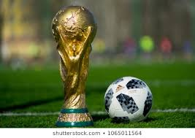

QUESTION 1

The first 24 tickets have been given away to the participants and Gita’s SMS`s has yet not been selected. What is Geeta’s chance of winning the last ticket, based on above said information.

( a) 1/25 (b) 1/20000 (c) 1/19976 (d) none of these

|  |  |  |
| --- | --- | --- |
| Domain: Mathematical Literacy | Theme: world cup | Class(es): X (Probability)  Expected Time: 2 min.  Total Credit: 2 |
| Description of Item:   |  |  | | --- | --- | | Text and Image | Text  Image | | Yes | Table | | No | Graph | | No | Map | | Yes | Image | | Learning Outcome:  (As per NCERT)  Students will be able to Use the concept of probability and shows the interest in game. | |

Mathematical Literacy

|  |  |
| --- | --- |
| FRAMEWORK | CHARACTERISTICS |
| Competency Cluster | Connection |
| Overarching Idea | Knowledge about probability |
| Context | Scientific/ interest |
| Item format | MCQ |
| Cognitive Process | Understanding/Critical thinking |
| Proficiency Level | 5 |

Credit Pattern:

Full Credit: 2

Partial Credit: 1

No Credit: 0

Description of Answer Key and Credits:

|  |
| --- |
| Full credit: for correct answer 1/19976  Partial credit : for total case 19976  No credit: for any other response  Explanation: using the concept of probability find the percentage of winner of ticket. |

Q2 Out of first 24 tickets 14 males have already won the ticket and remaining are won by females.

Chances that last ticket is won by Geeta is .

( a) 24/25 (b) 11990/20000 (c) 1/19976 (d) 11990/19976

|  |  |  |
| --- | --- | --- |
| Domain: Mathematical Literacy | Theme: world cup | Class(es): :- X (Probability)  Expected Time: 2 min.  Total Credit: 2 |
| Description of Item:   |  |  | | --- | --- | | Text and Image | Text  Image | | Yes | Table | | No | Graph | | No | Map | | Yes | Image | | Learning Outcome:  (As per NCERT)  Students will be able to Use the concept of probability and shows the interest in game. | |

Mathematical Literacy

|  |  |
| --- | --- |
| FRAMEWORK | CHARACTERISTICS |
| Competency Cluster | Connection |
| Overarching Idea | Knowledge about probability |
| Context | Scientific/ interest |
| Item format | MCQ |
| Cognitive Process | Understanding/Critical thinking |
| Proficiency Level | 5 |

Credit Pattern:

Full Credit: 2

Partial Credit: 1

No Credit: 0

Description of Answer Key and Credits:

|  |
| --- |
| Full credit: for correct answer 11990/19976  Partial credit : for total case 11990  No credit: for any other response  Explanation : using the concept of probability find the percentage of winner of ticket. |

Question 3

How many more males should have sent SMS`s so that the chances of winning a ticket is equal for both male/female

( a) 4000 (b) 2000 (c) 12000 (d) can not be determined

|  |  |  |
| --- | --- | --- |
| Domain: Mathematical Literacy | Theme: world cup | Class(es): - X (Probability)  Expected Time: 2 min.  Total Credit: 2 |
| Description of Item:   |  |  | | --- | --- | | Text and Image | Text  Image | | Yes | Table | | No | Graph | | No | Map | | Yes | Image | | Learning Outcome:  (As per NCERT)  Students will be able to Use the concept of probability and shows the interest in game. | |

Mathematical Literacy

|  |  |
| --- | --- |
| FRAMEWORK | CHARACTERISTICS |
| Competency Cluster | Connection |
| Overarching Idea | Knowledge about probability |
| Context | Scientific/ interest |
| Item format | MCQ |
| Cognitive Process | Understanding/Critical thinking |
| Proficiency Level | 6 |

Credit Pattern:

Full Credit: 2

No Credit: 0

Description of Answer Key and Credits:

|  |
| --- |
| Full credit: for correct answer 4000  No credit: for any other response  Explanation: using the concept of probability find the percentage of winner of ticket. |

Q4 In the same condition, the number of winner tickets is doubled and one ticket is left for male while rest are won by female. Find the probability of winning last ticket by any male.

(a) 1/19951 (b) 1/8000 (c) 8000/19951 (d) cannot be determined

|  |  |  |
| --- | --- | --- |
| Domain: Mathematical Literacy | Theme: world cup | Class(es): :- X (Probability)  Expected Time: 2 min.  Total Credit: 2 |
| Description of Item:   |  |  | | --- | --- | | Text and Image | Text  Image | | Yes | Table | | No | Graph | | No | Map | | Yes | Image | | Learning Outcome:  (As per NCERT)  Students will be able to Use the concept of probability and shows the interest in game. | |

Mathematical Literacy

|  |  |
| --- | --- |
| FRAMEWORK | CHARACTERISTICS |
| Competency Cluster | Connection |
| Overarching Idea | Knowledge about probability |
| Context | Scientific/ interest |
| Item format | MCQ |
| Cognitive Process | Understanding/Critical thinking |
| Proficiency Level | 6 |

Credit Pattern:

Full Credit: 2

No Credit: 0

Description of Answer Key and Credits:

|  |
| --- |
| Full credit: for correct answer 8000/19951  No credit: for any other response  Explanation : using the concept of probability find the percentage of winner of ticket. |

**Name of teacher / Item writer: JITENDER SINGH**

**Designation: PGT (MATHS)**

**Email: jitu1051976@gmail.com**

**Phone No. 9467346795 :Name of the Vidyalaya: k.v.no.2 sirsa**

**TEST ITEM: -6**

**Kite flying competition**

Kite flying competition was held in the nearby society ground whose dimensions are 700m by 400m.There is a triangular park of area 400-metre square in the society ground, there is also a square pond of side 40 m in the corner of the ground. if William’s kite is cut by John.

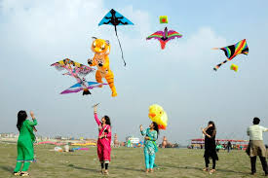

**Question 1what is the probability that the kite of William fall in the park.**

**….…………………………………………………………………………………………………………**

|  |  |  |
| --- | --- | --- |
| Domain: Mathematical Literacy | Theme: Kite Flaying | Class(es): X (Probability)  Expected Time: 1min.  Total Credit: 2 |
| Description of Item:   |  |  | | --- | --- | | YES | Text | | YES | Table | | NO | Graph | | YES | IMAGE | | Learning Outcome:  (As per NCERT)   * Students will be able to know area of plane figures * Students will be **Develop &maintain problem solving skills** | |

|  |  |
| --- | --- |
| FRAMEWORK | CHARACTERISTICS |
| Competency cluster | Connections |
| Overarching idea | Probability |
| context | Real life problem |
| Item format | Closed constructed -response |
| Cognitive Process | Employ |
| Proficiency Level | 2 |

Credit Pattern:

Full Credit: 2

Partial Credit: NA

No Credit: 0

Description of Answer Key and Credits:

|  |
| --- |
| Full Credit: For correct solution **(fall in park) = Area of park/ area of Ground**  **= 400/700x400**  **=1/700**  No credit: - Other responses |

**Question 2 What is the probability that kite of William fall into the pond?**

**………………………………………………………………………………………………………………..**

|  |  |  |
| --- | --- | --- |
| Domain: Mathematical Literacy | Theme: Kite Flaying | Class(es): X (Probability)  Expected Time: 1min.  Total Credit: 2 |
| Description of Item:   |  |  | | --- | --- | | YES | Text | | YES | Table | | NO | Graph | | YES | IMAGE | | Learning Outcome:  (As per NCERT)   * Students will be able to know area of plane figures * Students will be **Develop &maintain problem solving skills** | |

|  |  |
| --- | --- |
| FRAMEWORK | CHARACTERISTICS |
| Competency cluster | Connections |
| Overarching idea | Probability |
| context | Real life problem |
| Item format | Closed constructed -response |
| Cognitive Process | Employ |
| Proficiency Level | 2 |

Credit Pattern:

Full Credit: 2

Partial Credit: NA

No Credit: 0

Description of Answer Key and Credits:

|  |
| --- |
| Full Credit: **P(fall in park) = Area of pound/ area of Ground**  **= side x side/ length x breadth**  **= 40x 40/700x400**  **=4/700**  **=1/175**  No credit: - Other responses |

**Question 3 What is the probability that kite of William fall in park or pond?**

**….……………………………………………………………………………………………………………**

|  |  |  |
| --- | --- | --- |
| Domain: Mathematical Literacy | Theme: Kite Flaying | Class(es): X (Probability)  Expected Time: 1min.  Total Credit: 2 |
| Description of Item:   |  |  | | --- | --- | | YES | Text | | YES | Table | | NO | Graph | | YES | Image | | Learning Outcome:  (As per NCERT)   * Students will be able to know concepts of Probability. * Students will be **Develop &maintain problem solving skills** | |

|  |  |
| --- | --- |
| FRAMEWORK | CHARACTERISTICS |
| Competency cluster | Connections |
| Overarching idea | Probability |
| context | Real life problem |
| Item format | Closed constructed -response |
| Cognitive Process | Employ |
| Proficiency Level | 2 |

Credit Pattern:

Full Credit: 2

Partial Credit: NA

No Credit: 0

Description of Answer Key and Credits:

|  |
| --- |
| Full Credit: **P (fall in park or pound) = P(park) + P(pound)**  **= 1/700 + 1/175**  **= 5/700**  **= 1/140**  No credit: - Other responses |

**Question 4 What is the probability that kite of John fall into pond?**

……………………………………………………………………………………………………………………………….

|  |  |  |
| --- | --- | --- |
| Domain: Mathematical Literacy | Theme: kite Flaying | Class(es): X (Probability)  Expected Time: 1min.  Total Credit: 2 |
| Description of Item:   |  |  | | --- | --- | | YES | Text | | YES | Table | | NO | Graph | | YES | Image | | Learning Outcome:  (As per NCERT)   * Students will be able to know concepts of Probability. * Students will be **Develop &maintain problem solving skills** | |

|  |  |
| --- | --- |
| FRAMEWORK | CHARACTERISTICS |
| Competency cluster | Connections |
| Overarching idea | Probability |
| context | Real life problem |
| Item format | Closed constructed -response |
| Cognitive Process | Employ |
| Proficiency Level | 2 |

Credit Pattern:

Full Credit: 2

Partial Credit: NA

No Credit: 0

Description of Answer Key and Credits:

|  |
| --- |
| Full Credit: **For correct solution ZERO, since William’s kite cut by john**  No credit: - Other responses |

Name: - OP SWAMI, Designation: PGT (MATHS)

KV Gurugram (shift-2), Contact No. 9810250465

Mail address: - opswamimaths@gmail.com

**Test item 7**

**MUNICIPAL ELECTION**

Municipal election was declared in a city. In a particular ward, there is an open seat for all contestant (i.e. any person whether belongs to reserved category or not can fill the form for M.C.) There are seven contestants in that ward out of which three are females and rest is males. Out of 3 females one female and out of 4 males two males come from reserved category. There are 20,000 voters in that ward.

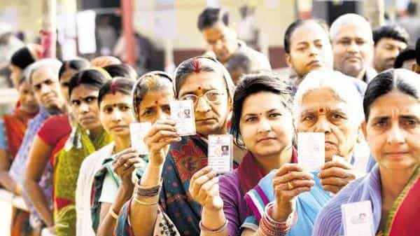

On the basis of above information give the answers of the following questions:

Question 1 What is the chance that a female candidate can win?

………………………………………………………………………………………………..

|  |  |  |
| --- | --- | --- |
| Domain: Mathematical Literacy | Theme: Municipal Election | Class(es):- X (Probability)  Expected Time: 2 min.  Total Credit: 2 |
| Description of Item:   |  |  | | --- | --- | | YES | Text | | NO | Graph | | NO | Map | | YES | Image | | Learning Outcome:  (As per NCERT)  Students are able to know possibilities of an event. | |

Mathematical Literacy

|  |  |
| --- | --- |
| FRAMEWORK | CHARACTERISTICS |
| Competency Cluster | Connection |
| Overarching Idea | Knowledge about Probability |
| Context | Game of chance |
| Item format | Short answer type |
| Cognitive Process | *Formulate* |
| Proficiency Level | 1(a) |

Credit Pattern:

Full Credit: 2

Partial Credit: 1

No Credit: 0

Description of Answer Key and Credits:

|  |
| --- |
| Full credit: 2 Marks  Correct Answer:P(winning of Female ) = $\frac{3}{7}$ No credit: 0 Marks (for wrong answer and wrong formula)  Partial credit: 1 Marks (when only formula is written) |

Question 2What is the chance that a male person can win?

………………………………………………………………………………………………………………..

|  |  |  |
| --- | --- | --- |
| Domain: Mathematical Literacy | Theme: Municipal Election | Class(es): X (Probability)  Expected Time: 2 min.  Total Credit: 2 |
| Description of Item:   |  |  | | --- | --- | | YES | Text | | NO | Graph | | NO | Map | | YES | Image | | Learning Outcome:  (As per NCERT)  Students are able to know possibilities of an event . | |

Mathematical Literacy

|  |  |
| --- | --- |
| FRAMEWORK | CHARACTERISTICS |
| Competency Cluster | Connection |
| Overarching Idea | Knowledge about Probability |
| Context | Game of chance |
| Item format | Short answer type |
| Cognitive Process | *Formulate* |
| Proficiency Level | 1(a) |

Credit Pattern:

Full Credit: 2

Partial Credit: 1

No Credit: 0

Description of Answer Key and Credits:

|  |
| --- |
| Full credit: 2 Marks  Correct answer: P(winning of Male ) = $\frac{4}{7}$ No credit: 0 Marks (for wrong answer and wrong formula)  Partial credit: 1 Marks (when only formula is written) |

Question3: If one more contestant from each reserved and unreserved female increases then what will be the probability of winning the reserved female candidate?

…………………………………………………………………………………………………………………………………..

|  |  |  |
| --- | --- | --- |
| Domain: Mathematical Literacy | Theme: Municipal Election | Class(es): - X (Probability)  Expected Time: 2 min.  Total Credit: 2 |
| Description of Item:   |  |  | | --- | --- | | YES | Text | | NO | Graph | | NO | Map | | YES | Image | | Learning Outcome:  (As per NCERT)  Students are able to know possibilities of an event . | |

Mathematical Literacy

|  |  |
| --- | --- |
| FRAMEWORK | CHARACTERISTICS |
| Competency Cluster | Connection |
| Overarching Idea | Knowledge about Probability |
| Context | Game of chance |
| Item format | Short answer type |
| Cognitive Process | *Formulate* |
| Proficiency Level | 1(a) |

Credit Pattern:

Full Credit: 2

Partial Credit: 1

No Credit: 0

Description of Answer Key and Credits:

|  |
| --- |
| Full credit: 2 Marks  Correct Answer:P(winning of reserved female candidate) = $\frac{2}{9}$ No credit: 0 Marks (for wrong answer and wrong formula)  Partial credit: 1 Marks (when only formula is written) |

Question 4: will the chance of winning remain same for male candidate if one unreserved male person takes his name back from the candidature list? If not, then what is the new probability of winning the unreserved male person?

|  |  |  |
| --- | --- | --- |
| Domain: Mathematical Literacy | Theme: Municipal Election | Class(es): :- X (Probability)  Expected Time: 2 min.  Total Credit: 2 |
| Description of Item:   |  |  | | --- | --- | | YES | Text | | NO | Graph | | NO | Map | | YES | Image | | Learning Outcome:  (As per NCERT)  Students are able to know possibilities of an event. | |

Mathematical Literacy

|  |  |
| --- | --- |
| FRAMEWORK | CHARACTERISTICS |
| Competency Cluster | Connection |
| Overarching Idea | Knowledge about Probability |
| Context | Game of chance |
| Item format | Short answer type |
| Cognitive Process | *Formulate* |
| Proficiency Level | 1(a) |

Credit Pattern:

Full Credit: 2

Partial Credit: 1

No Credit: 0

Description of Answer Key and Credits:

|  |
| --- |
| Full credit: 2 Marks  Correct Answer:No , chance of winning will change if one unreserved male  person removes his name from candidature list  New P (winning the unreserved male person) = $\frac{1}{6}$ No credit: 0 Marks (for wrong answer and wrong formula)  Partial credit: 1 Marks (when only formula is written) |

Question 5. Are the chances of winning for all the contestants equal?

………………………………………………………………………………………………………………………………

|  |  |  |
| --- | --- | --- |
| Domain: Mathematical Literacy | Theme: Municipal Election | Class(es): :- X (Probability)  Expected Time: 2 min.  Total Credit: 2 |
| Description of Item:   |  |  | | --- | --- | | YES | Text | | NO | Graph | | NO | Map | | YES | Image | | Learning Outcome:  (As per NCERT)  Students are able to know possibilities of an event. | |

Mathematical Literacy

|  |  |
| --- | --- |
| FRAMEWORK | CHARACTERISTICS |
| Competency Cluster | Connection |
| Overarching Idea | Knowledge about Probability |
| Context | Game of chance |
| Item format | Short answer type |
| Cognitive Process | *Formulate* |
| Proficiency Level | 1(a) |

Credit Pattern:

Full Credit: 2

Partial Credit: 1

No Credit: 0

Description of Answer Key and Credits:

|  |
| --- |
| Full credit: 2 Marks  The events of winning all the contestants are not equal.  No credit: 0 Marks (for wrong answer)  No Partial credit |

**Name of teacher / Item writer: JITENDER SINGH**

**Designation: PGT (MATHS)**

**Email: jitu1051976@gmail.com**

**Phone No. 9467346795 :Name of the Vidyalaya: k.v.no.2 sirsa**

**Test item 8**

**TERM INSURANCE PLAN**

A particular term insurance company has two options in the application form before issuing the policy – Smoker or Non-smoker. As a smoker has more chance of getting lung disease and death chance is comparatively higher. So premium payment is more for a smoking person.

Company gives a rider plan (i.e. for some critical diseases) along with normal term plan by paying some extra premium money.

In a certain time period, company issues 100 policies of which 30% are for smokers and rest for non-smoker customers. Also, half the smokers and 2/5 th of non – smoking customers have purchased a rider plan along with a normal plan.



On the basis of above information give the answers of the following questions:

Q1) Find the probability that company issues policy for a smoker with rider plan.

……………………………………………………………………………………………………………………………..

|  |  |  |
| --- | --- | --- |
| Domain: Mathematical Literacy | Theme: TERM INSURANCE PLAN | Class(es): :- X (Probability)  Expected Time: 2 min.  Total Credit: 2 |
| Description of Item:   |  |  | | --- | --- | | YES | Text | | NO | Graph | | NO | Map | | YES | Image | | Learning Outcome:  (As per NCERT) | |

Mathematical Literacy

|  |  |
| --- | --- |
| FRAMEWORK | CHARACTERISTICS |
| Competency Cluster | Connection |
| Overarching Idea | Knowledge about Probability |
| Context | Game of chance |
| Item format | Short answer type |
| Cognitive Process | *Formulate* |
| Proficiency Level | 1(a) |

Credit Pattern:

Full Credit: 2

Partial Credit: 1

No Credit: 0

Description of Answer Key and Credits:

|  |
| --- |
| Full credit: 2 Marks  Correct answer:P(issuance of policy for a smoker with rider plan) = $\frac{15}{100}$ Total smokers = 30 and half of it i.e. 15 have a rider plan.  No credit: 0 Marks (for wrong answer and wrong formula)  Partial credit: 1 Marks (when only formula is written) |

Q2) Find the probability that company issues policy for a non- smoker without a rider plan.

……………………………………………………………………………………………………………………………………….

|  |  |  |
| --- | --- | --- |
| Domain: Mathematical Literacy | Theme: TERM INSURANCE PLAN | Class(es): :- X (Probability)  Expected Time: 2 min.  Total Credit: 2 |
| Description of Item:   |  |  | | --- | --- | | NO | Table | | YES | Text | | NO | Graph | | YES | Image | | Learning Outcome:  (As per NCERT)  Students will be aware about their health by knowing possibility of causing death due to bad habits. | |

Mathematical Literacy

|  |  |
| --- | --- |
| FRAMEWORK | CHARACTERISTICS |
| Competency Cluster | Connection |
| Overarching Idea | Knowledge about Probability |
| Context | Game of chance |
| Item format | Short answer type |
| Cognitive Process | *Formulate* |
| Proficiency Level | 1(a) |

Credit Pattern:

Full Credit: 2

Partial Credit: 1

No Credit: 0

**Description of Answer Key and Credits:**

|  |
| --- |
| Full credit: 2 Marks  Correct Answer:  P(issuance of policy for a non- smoker without a rider plan ) = $\frac{42}{100}$ Total non-smokers =70 of which 2/5 (i.e. 28) has a rider plan and 3/5 (i.e. 42) don’t has a rider plan .  No credit: 0 Marks (for wrong answer and wrong formula)  Partial credit: 1 Marks (when only formula is written) |

Q3) Find the probability that company issues policy for a smoker without a rider plan .

|  |  |  |
| --- | --- | --- |
| Domain: Mathematical Literacy | Theme: Game of chance | Class(es): - X (Probability)  Expected Time: 2 min.  Total Credit: 2 |
| Description of Item:   |  |  | | --- | --- | | YES | Text | | NO | Graph | | NO | Map | | YES | Image | | Learning Outcome:  (As per NCERT)  Students will be aware about their health by knowing possibility of causing death due to bad habits. | |

Mathematical Literacy

|  |  |
| --- | --- |
| FRAMEWORK | CHARACTERISTICS |
| Competency Cluster | Connection |
| Overarching Idea | Knowledge about Probability |
| Context | Game of chance |
| Item format | Short answer type |
| Cognitive Process | *Formulate* |
| Proficiency Level | 1(a) |

Credit Pattern:

Full Credit: 2

Partial Credit: 1

No Credit: 0

Description of Answer Key and Credits:

|  |
| --- |
| Full credit : 2 Marks  Correct answer : P(issuance of policy for a smoker without a rider plan) = $\frac{15}{100}$ Total smokers = 30 and half of it i.e. 15 have a rider plan and 15 don’t have a rider plan.  No credit : 0 Marks (for wrong answer and wrong formula)  Partial credit : 1 Marks (when only formula is written) |

Q4) Find the probability that company issues policy for a non-smoker with rider plan.

…………………………………………………………………………………………………………………………………………

|  |  |  |
| --- | --- | --- |
| Domain: Mathematical Literacy | Theme: TERM INSURANCE PLAN | Class(es): :- X (Probability)  Expected Time: 2 min.  Total Credit: 2 |
| Description of Item:   |  |  | | --- | --- | | YES | Text | | NO | Graph | | NO | Map | | YES | Image | | Learning Outcome:  (As per NCERT)  Students will be aware about their health by knowing possibility of causing death due to bad habits. | |

Mathematical Literacy

|  |  |
| --- | --- |
| FRAMEWORK | CHARACTERISTICS |
| Competency Cluster | Connection |
| Overarching Idea | Knowledge about Probability |
| Context | Game of chance |
| Item format | Short answer type |
| Cognitive Process | *Formulate* |
| Proficiency Level | 1(a) |

Credit Pattern:

Full Credit: 2

Partial Credit: 1

No Credit: 0

Description of Answer Key and Credits:

|  |
| --- |
| Full credit : 2 Marks  Correct answer :  P(issuance of policy for a non- smoker with a rider plan ) = $\frac{28}{100}$ Total non-smokers =70 of which 2/5 (i.e. 28) has a rider plan and 3/5 (i.e. 42) don’t has a rider plan .  No credit : 0 Marks (for wrong answer and wrong formula)  Partial credit : 1 Marks (when only formula is written) |

Q5) Compare the chance that a policy holder (without rider plan) has lung disease or not .

|  |  |  |
| --- | --- | --- |
| Domain: Mathematical Literacy | Theme: TERM INSURANCE PLAN | Class(es): :- X (Probability)  Expected Time: 2 min.  Total Credit: 2 |
| Description of Item:   |  |  | | --- | --- | | YES | Text | | NO | Graph | | NO | Map | | YES | Image | | Learning Outcome:  (As per NCERT)  Students will be aware about their health by knowing possibility of causing death due to bad habits. | |

Mathematical Literacy

|  |  |
| --- | --- |
| FRAMEWORK | CHARACTERISTICS |
| Competency Cluster | Connection |
| Overarching Idea | Knowledge about Probability |
| Context | Game of chance |
| Item format | Short answer type |
| Cognitive Process | *Formulate* |
| Proficiency Level | 1(a) |

Credit Pattern:

Full Credit: 2

Partial Credit: 1

No Credit: 0

Description of Answer Key and Credits:

|  |
| --- |
| Chance that a policy holder (with out rider plan) has lung disease  = P(issuance of policy for a smoker without a rider plan) = $\frac{15}{100}$ And  Chance that a policy holder (with out rider plan) don’t has lung disease  = P(issuance of policy for a non- smoker without a rider plan ) = $\frac{42}{100}$ Ratio of probability in both the cases = 15/100 : 42/100 = 15/42 |

**Name of teacher / Item writer: JITENDER SINGH**

**Designation: PGT (MATHS)**

**Email: jitu1051976@gmail.com**

**Phone No. 9467346795 :Name of the Vidyalaya: k.v.no.2 sirsa**

*************************************************************

**TEST ITEM-9**

**Playing cards**

1. Four persons are playing a bridge game forming teams each of two players. A deck of 52 playing cards is distributed around the table clockwise in such a way that each person gets 13 cards.

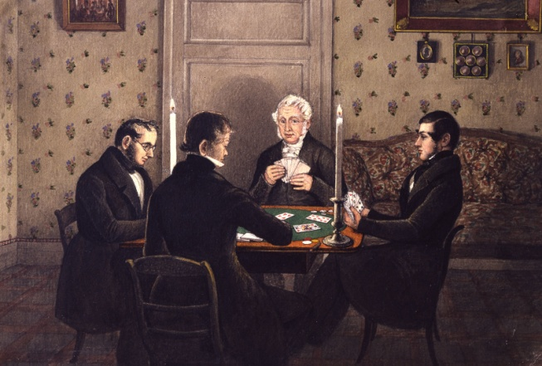

(i) Find the probability of the card drawn by each player with number 5 or 6.

(a)2/13 (b) 11/13 (c) 1/13 (d ) 12/13

|  |  |  |
| --- | --- | --- |
| Domain: Mathematical Literacy | Theme: BRIDGE GAME | Class(es): :- X (Probability)  Expected Time: 2 min.  Total Credit: 2 |
| Description of Item:   |  |  | | --- | --- | | Yes | Text | | No | Graph | | No | Map | | YES | Image | | Learning Outcome:  (As per NCERT)  Students are able to know about probability | |

Mathematical Literacy

|  |  |
| --- | --- |
| FRAMEWORK | CHARACTERISTICS |
| Competency Cluster | Connection |
| Overarching Idea | Knowledge about PROBABILITY |
| Context | Playing cards |
| Item format | MCQ |
| Cognitive Process | *employ* |
| Proficiency Level | 1(a) |

Credit Pattern:

Full Credit: 2

Partial Credit: NA

No Credit: 0

Description of Answer Key and Credits:

|  |
| --- |
| Full credit: for answer 2/13  No credit: for any other answer |

(ii) Find the probability of the card drawn by each player with number less than 8.

(a) 6/13 (b) 5/13 (c) 7/13 (d ) None of these

|  |  |  |
| --- | --- | --- |
| Domain: Mathematical Literacy | Theme: BRIDGE GAME | Class(es): :- X (Probability)  Expected Time: 2 min.  Total Credit: 2 |
| Description of Item:   |  |  | | --- | --- | | Yes | Text | | No | Graph | | No | Map | | yes | Image | | Learning Outcome:  (As per NCERT)  Students are able to know about probability | |

Mathematical Literacy

|  |  |
| --- | --- |
| FRAMEWORK | CHARACTERISTICS |
| Competency Cluster | Connection |
| Overarching Idea | Knowledge about PROBABILITY |
| Context | Playing cards |
| Item format | MCQ |
| Cognitive Process | *Formulate* |
| Proficiency Level | 1(a) |

Credit Pattern:

Full Credit: 2

Partial Credit: NA

No Credit: 0

Description of Answer Key and Credits:

|  |
| --- |
| Full credit: Correct option (a) 6/13 |

(iii)Find the probability of the card drawn by each player with number between 2 and 9.

(a) 7/13 (b) 5/13 (c) 6/13 (d ) 3/13

|  |  |  |
| --- | --- | --- |
| Domain: Mathematical Literacy | Theme: BRIDGE GAME | Class(es):--X (Probability)  Expected Time: 2 min.  Total Credit: 2 |
| Description of Item:   |  |  | | --- | --- | | Text and Image | Text  Image | | Yes | Table | | No | Graph | | No | Map | | yes | Image | | Learning Outcome:  (As per NCERT)  Students are able to know about probability | |

Mathematical Literacy

|  |  |
| --- | --- |
| FRAMEWORK | CHARACTERISTICS |
| Competency Cluster | Connection |
| Overarching Idea | Knowledge about PROBABILITY |
| Context | Playing cards |
| Item format | MCQ |
| Cognitive Process | *Formulate* |
| Proficiency Level | 1(a) |

Credit Pattern:

Full Credit: 2

Partial Credit: NA

No Credit: 0

Description of Answer Key and Credits:

|  |
| --- |
| Full credit: Correct option (c ) 6/13 |

(iv) What is the probability that any one person gets queen of spade?

(a) 1/3 (b) 1/4 (c) 1/2 (d ) 1

|  |  |  |
| --- | --- | --- |
| Domain: Mathematical Literacy | Theme: :BRIDGE GAME | Class(es): :- X (Probability)  Expected Time: 2 min.  Total Credit: 2 |
| Description of Item:   |  |  | | --- | --- | | Yes | Text | | No | Graph | | No | Map | | YES | Image | | Learning Outcome:  (As per NCERT)  Students are able to know about probability | |

Mathematical Literacy

|  |  |
| --- | --- |
| FRAMEWORK | CHARACTERISTICS |
| Competency Cluster | Connection |
| Overarching Idea | Knowledge about PROBABILITY |
| Context | Playing cards |
| Item format | MCQ |
| Cognitive Process | *Evaluate* |
| Proficiency Level | 1(a) |

Credit Pattern:

Full Credit: 2

No Credit: 0

Description of Answer Key and Credits:

|  |
| --- |
| Full credit: Correct option (b ) 1/ 4 |

Name: - OP SWAMI

Designation: PGT (MATHS)

KV Gurugram (shift-2)

Contact No. 9810250465

Mail address: - opswamimaths@gmail.com

**Test item 10**

**Tossing a pair of coins**

Anita, Bina and Charu were fighting to get first chance in a game. ‘Anita’ says let us toss two coins. If both heads appear, Anita will take first chance. If both Tails appear ‘Bina’ will get it & if one head & one tail, ‘Charu’ will get the first chance.

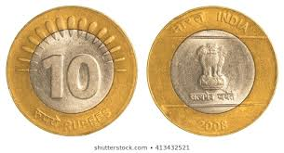

Question 1.What is the probability of‘Anita’ getting the first chance?

(a) 1/4 (b) 1/2 (c) 1/3 (d ) 2/3

|  |  |  |
| --- | --- | --- |
| Domain: Mathematical Literacy | Theme: **Tossing of pair of coins** | Class(es): :- X (Probability)  Expected Time: 2 min.  Total Credit: 2 |
| Description of Item:   |  |  | | --- | --- | | Yes | Text | | No | Graph | | No | Map | | YES | Image | | Learning Outcome:  (As per NCERT)  Students are able to know about probability | |

Mathematical Literacy

|  |  |
| --- | --- |
| FRAMEWORK | CHARACTERISTICS |
| Competency Cluster | Connection |
| Overarching Idea | Knowledge about PROBABILITY |
| Context | Tossing coins |
| Item format | MCQ |
| Cognitive Process | *Formulate* |
| Proficiency Level | 1(a) |

Credit Pattern:

Full Credit: 2

Partial Credit: NA

No Credit: 0

Description of Answer Key and Credits:

|  |
| --- |
| Full credit: Correct option (a) ¼ |

Question 2.What is the probability that ‘Bina’ gets the first chance?

(a) 1/4 (b) 1/3 (c) 1/2 (d ) 2/3

|  |  |  |
| --- | --- | --- |
| Domain: Mathematical Literacy | Theme: **Tossing of pair of coins** | Class(es): :- X (Probability)  Expected Time: 2 min.  Total Credit: 2 |
| Description of Item:   |  |  | | --- | --- | | Yes | Text | | No | Graph | | No | Map | | YES | Image | | Learning Outcome:  (As per NCERT)  Students are able to know about probability | |

Mathematical Literacy

|  |  |
| --- | --- |
| FRAMEWORK | CHARACTERISTICS |
| Competency Cluster | Connection |
| Overarching Idea | Knowledge about PROBABILITY |
| Context | Tossing coins |
| Item format | Closed constructed response |
| Cognitive Process | *Formulate* |
| Proficiency Level | 1(a) |

Credit Pattern:

Full Credit: 2

Partial Credit: NA

No Credit: 0

Description of Answer Key and Credits:

|  |
| --- |
| Full credit: Correct option (a) 1/4 |

Question 3.What is the probability that ‘Bina’ gets the first chance?

(a) 1/3 (b) 1/2 (c) 1/4 (d ) 3/ 4

|  |  |  |
| --- | --- | --- |
| Domain: Mathematical Literacy | Theme: **Tossing of pair of coins** | Class(es): :- X (Probability)  Expected Time: 2 min.  Total Credit: 2 |
| Description of Item:   |  |  | | --- | --- | | Yes | Text | | No | Graph | | No | Map | | YES | Image | | Learning Outcome:  (As per NCERT)  Students are able to know about probability | |

Mathematical Literacy

|  |  |
| --- | --- |
| FRAMEWORK | CHARACTERISTICS |
| Competency Cluster | Connection |
| Overarching Idea | Knowledge about PROBABILITY |
| Context | Tossing coins |
| Item format | MCQ |
| Cognitive Process | *Formulate* |
| Proficiency Level | 1(a) |

Credit Pattern:

Full Credit: 2

Partial Credit: NA

No Credit: 0

Description of Answer Key and Credits:

|  |
| --- |
| Full credit : for option b  No credit for any other option |

Question4. Is her decision fair as per given statement?

(a) Yes (b) No (c) Do not say anything (d) None of these

|  |  |  |
| --- | --- | --- |
| Domain: Mathematical Literacy | Theme: **Tossing of pair of coins** | Class(es): :- X (Probability)  Expected Time: 2 min.  Total Credit: 2 |
| Description of Item:   |  |  | | --- | --- | | Yes | Text | | No | Graph | | No | Map | | YES | Image | | Learning Outcome:  (As per NCERT)  Students are able to know about probability | |

Mathematical Literacy

|  |  |
| --- | --- |
| FRAMEWORK | CHARACTERISTICS |
| Competency Cluster | Connection |
| Overarching Idea | Knowledge about PROBABILITY |
| Context | Tossing coins |
| Item format | MCQ |
| Cognitive Process | *Formulate* |
| Proficiency Level | 1(a) |

Credit Pattern:

Full Credit: 2

Partial Credit: NA

No Credit: 0

Description of Answer Key and Credits:

|  |
| --- |
| Full credit: Ans Full credit for option (b)  No credit for any other option |

**Name of teacher / Item writer: JITENDER SINGH**

**Designation: PGT (MATHS)**

**Email: jitu1051976@gmail.com**

**Phone No. 9467346795 :Name of the Vidyalaya: k.v.no.2 sirsa**