KENDRIYA VIDYALAYA SANGATHAN

CCT TEST ITEMS
CLASS VII: CHAPTER 15: VISUALIZING SOLID SHAPED

S. NO. | TITLE OF TEST ITEM
 | 3 D TO 2D
 | STEP PATTERN
 | DICEY GAME
 | RUBIK’S CUBE
 | SHADOW GAME
 | SINGLE COLOUR 3 X 3 CUBE
 | SINGLE COLOUR 4 X 4 CUBE
 | COUNTING CUBES
 | AMAZING SHAPES
 | WHAT’S ON THE OTHER SIDE
 | CHINTU’S BIRTHDAY PARTY
 | DICE AND NETS
 | WHERE IS MY SHADOW?
SCORING KEY FOR ITEMS 1 TO 13

ITEM 1: 3 D TO 2D

Domain :  Mathematical Literacy | Topic: Visualising solid shapes  Learning Outcome :Visualising and interpreting  (As perNCERT) | Class: VII  Expected Time :12 min  Total Credit :10
Description of item: | Mike and Harvey wanted to block print geometrical shapes on a plain white tablecloth, but they couldn’t find any of the 2D shapes they wanted. Instead they found many 3D solid shapes lying about. Mike came up with an idea to convert these 3D solids into simple 2D shapes by cutting them open and using their cross section to print the shapes. Help Mike and Harvey figure out what shapes the cross-sections of the 3D solids will form when sliced open as shown in the figures-  Que 1. Which best describes the two-dimensional shape created by the cross-section shown?  - Oval  - Circle  - Ellipse  - Sphere  Que 2. Which best describes the two-dimensional shape created by the cross-section shown?  - Square  - Triangle  - Rectangle  - Trapezoid  Que 3. Which best describes the two-dimensional shape created by the cross-section shown?  - Circle  - Rectangle  - Ellipse  - Parallelogram  Que 4. Which best describes the two-dimensional shape created by the cross-section shown?  - Square  - Triangle  - Trapezoid  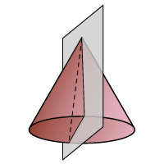  - Rectangle  Que 5. Which best describes the two-dimensional shape created by the cross-section shown?  - Circle  - Ellipse  - Triangle  - Rectangle  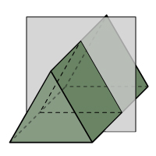  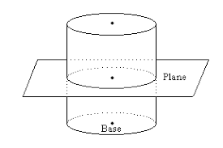  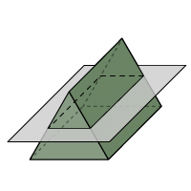  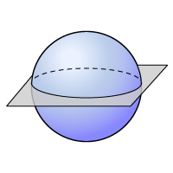

ITEM 2: STEP PATTERN

Domain : Mathematical Literacy | Topic: Visualising solid shapes  Learning Outcome :Visualising and Interpreting  (As perNCERT) | Class: VII  Expected Time :10 min  Total Credit :8
Description of item: | Arman likes to build step pattern using from small identical cubes like the one shown in the following diagram: Arman has lots of small cubes. He uses glue to join cubes together to make other blocks pattern as shown below.  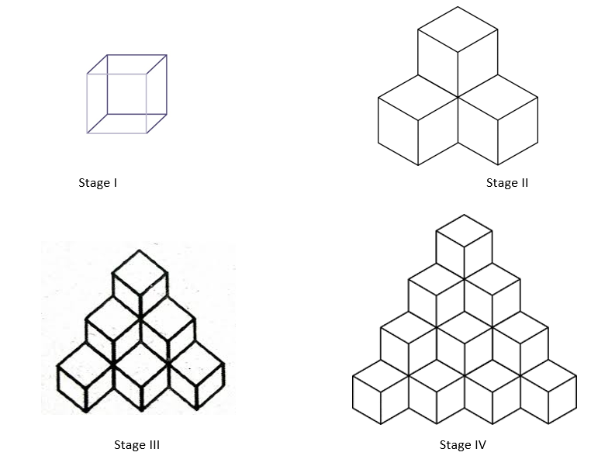  He uses one cube for stage I, four cubes for stage II.  Que 1. How many cubes will he use for stage III?  Que 2. How many cubes will he use for stage IV?  Que 3. How many number of squares will be there in top view of this stage II arrangement?  Que 4. Are the numbers of squares in the top view, side view and front view the same?  Yes / No

ITEM 3: DICEY GAME

Domain : Mathematical Literacy | Topic: Visualising Solid Shapes  Learning Outcome :Visualising& Interpreting  (As perNCERT) | Class: VII  Expected Time :12 min  Total Credit:10
Description of item: | Shikamaru and his friends were playing ludo when one of them lost the dice. To lazy to go out and get it Shikamaru decided to make a new dice at home with cardboard and glue. He gave a part of cardboard to each of his 5 friends who were playing and told them to make a net of a dice.He also informed them that Dice are special number cubes for which the following rule applies: The total number of dots on two opposite faces is always seven.  When his friends returned the cut out cardboards Shikamaru found that not all of the nets could be made into dice. Help Shikamaru identify which of the following nets can be made into a die by folding.  Que No Net made by his friends Is a net of cube? Is a net of Dice?  1. YES /NO YES /NO  2. YES /NO YES /NO  3. YES /NO YES /NO  4 YES /NO YES /NO  5 YES /NO YES /NO

ITEM 4: RUBIK’S CUBE

Domain : Mathematical Literacy | Topic: Visualising Solid shapes  Learning Outcome :Visualising and evaluating  (As perNCERT) | Class: VII  Expected Time : 10 min  Total Credit :8
Description of item: | Zoe liked playing with the Rubik’s cube. She could match all the six colours in a few seconds. On her 12th birthday her uncle bought her 4 new puzzles similar to the Rubik’s cube in structure but of different shapes. Excited about the new puzzles she took them to her school and showed it to her friends and Maths teacher. Her Maths teacher on seeing the puzzles showed them how the traditional Rubik’s cube can be unfolded to form its net  She then made four new nets labelled from one to four and asked the children to match the puzzles with their respective nets. Help Zoe and her friends to find the correct match  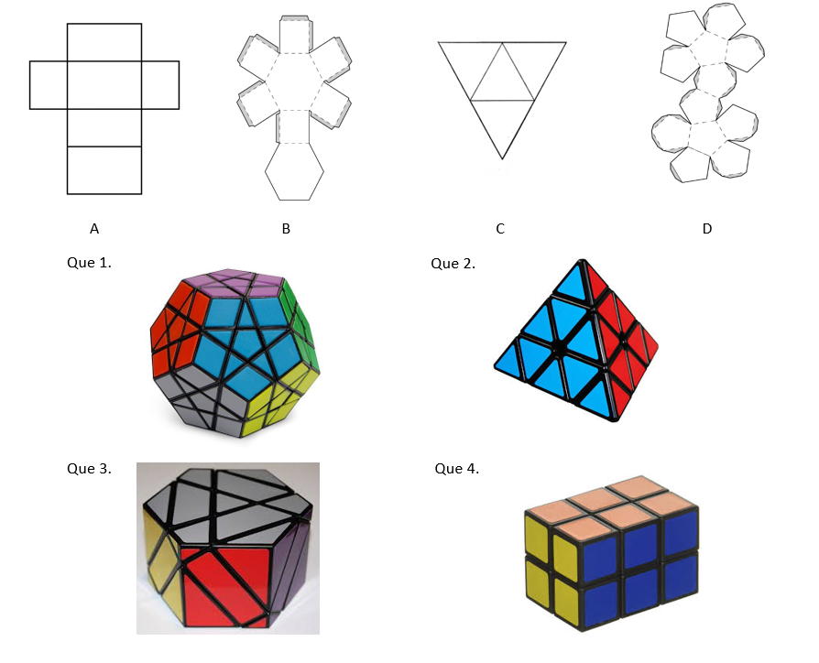

ITEM 5: SHADOW GAME

Domain : Mathematical Literacy | Topic: Visualising solid shapes  Learning Outcome :Visualisng and interpreting (As perNCERT) | Class: VII  Expected Time :12min  Total Credit :10
Description of item: | Rhea witnessed a shadow dance in zedlands got talent. As she was learning about 3D shapes in school she decided to find out the shadows the shape would cast on a wall. Before trying them out herself she decided to deduce the 2D shapes she could make with the 3D shapes she had.  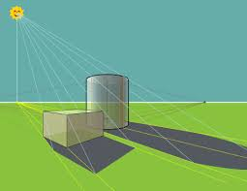  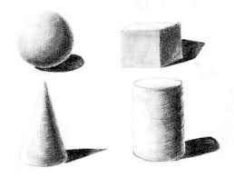  Que 1.What shadows will be cast by a ball (Sphere)?  Que 2. What shadows will be cast by a Cylindrical container?  Que 3.Cone cast two type of shadow one is triangle .Other will be  Que 4. Can a Rubik’s Cube cast three different type of Shadow :  Yes / No  Que 5 . If yes, list the shapes the shadow of a Rubik’s cube can take.

ITEM 6: SINGLE COLOUR 3 x 3 CUBE

Domain : Mathematical Literacy | Topic: Visualising Solid shapes  Learning Outcome :Visualising& Interpreting  (As per NCERT) | Class: VII  Expected Time :10  Total Credit:8
Description of item: | In a cube of dimension n  - Number of cubes having no surface painted =(n - 2)³  - Number of cubes having one surface painted=(n - 2)² x 6  - Number of cubes having two surface painted=( n- 2) x 12  - Number of cubes having three surface painted=number of vertex of the cube.  - There cannot be a cube which has more than three surface painted  A cube of 3 x 3 in single colouris made up of 27 small cubes. After the arrangement it is painted with blue colour.  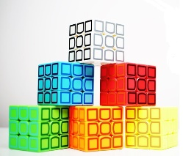  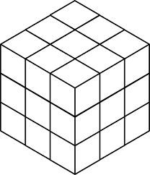  Que 1. How many cubes have no coloured face at all?  - 6  - 1  - 0  - 8  Que 2. How many cubes have one blue coloured face?  - 6  - 1  - 12  - 8  Que 3. How many cubes have two blue coloured face?  - 6  - 1  - 12  - 8  Que 4. How many cubes have three blue coloured face?  - 6  - 1  - 12  - 8

ITEM 7: SINGLE COLOUR 4 x 4 CUBE

Domain : Mathematical Literacy | Topic: Visualising Solid shapes  Learning Outcome :Visualising& Interpreting  (As perNCERT) | Class: VII  Expected Time :10  Total Credit:8
Description of item: | In a cube of dimension n  - Number of cubes having no surface painted =(n - 2)³  - Number of cubes having one surface painted=(n - 2)² x 6  - Number of cubes having two surface painted=( n- 2) x 12  - Number of cubes having three surface painted=number of vertex of the cube.  - There cannot be a cube which has more than three surface painted  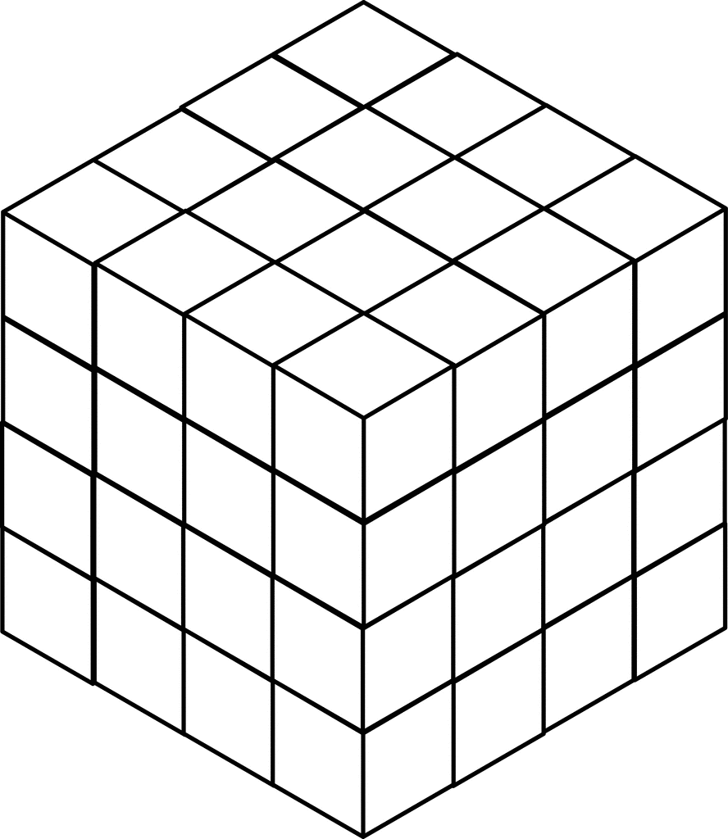  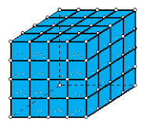  A cube of 4 x 4in single colouris made up of 64 small cubes. After the arrangement it is painted with blue colour  Que 1. How many cubes have no coloured face at all?  a) 8  b)24  c) 0  d) 16  Que 2. How many cubes have one blue coloured face?  a)8  b)24  c)32  d) 16  Que 3. How many cubes have two blue coloured face?  a) 8  b) 24  c) 40  d) 16  Que 4. How many cubes have three blue coloured face?  a) 16  b) 6  c) 12  d) 8

ITEM 8: COUNTING CUBES

Domain : Mathematical Literacy | Topic: Visualising Solid Shapes  Learning Outcome: Visualise, Understand.  (As per NCERT) | Class: VII  Expected Time :  Total Credit : 6
Description of item: | Visualise and interpret from the figure provided

Read the given passage and write the answer in the space given.
A school has to organize Annual Day function and each class was given the duty to decorate the campus with plants and balloons.
Class VII students had to construct a stand for potted plants using cubical bricks as shown below.

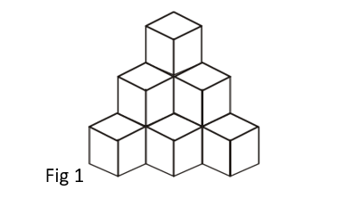

Q1. Anu and Veena are discussing how many bricks they will need to complete the arrangement. Anu quickly counts and says they will need 6 cubes. Is she correct? How many cubes are actually needed for such an arrangement?

Q2. If 12 ml of paint is required to paint the 6 faces of one cube, how much paint will be needed to colour all the outer faces of the given arrangement of cubes in fig 1?

------------------------------------------------------------------------------------------

Q3. Another group of students were told to add an extra row at the bottom to the arrangement as shown below, how many extra cubes will be needed?
Fig 2 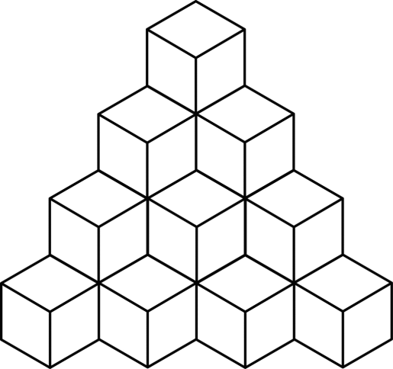

ITEM 9: AMAZING SHAPES

Domain : Mathematical Literacy | Topic: Visualising Solid Shapes  Learning Outcome: Visualise, Understand.  (As per NCERT) | Class: VII  Expected Time :  Total Credit : 6
Description of item: | Visualise and interpret from the figure provided

Solids that are made up of straight edges and flat faces and vertices are called polyhedrons. On the other hand, solids with curved surfaces are not polyhedrons. 3-Dimensional solids can be formed by using nets of the required shape.
The following chart shows nets of different solids.
Observe the solids and answer the questions.

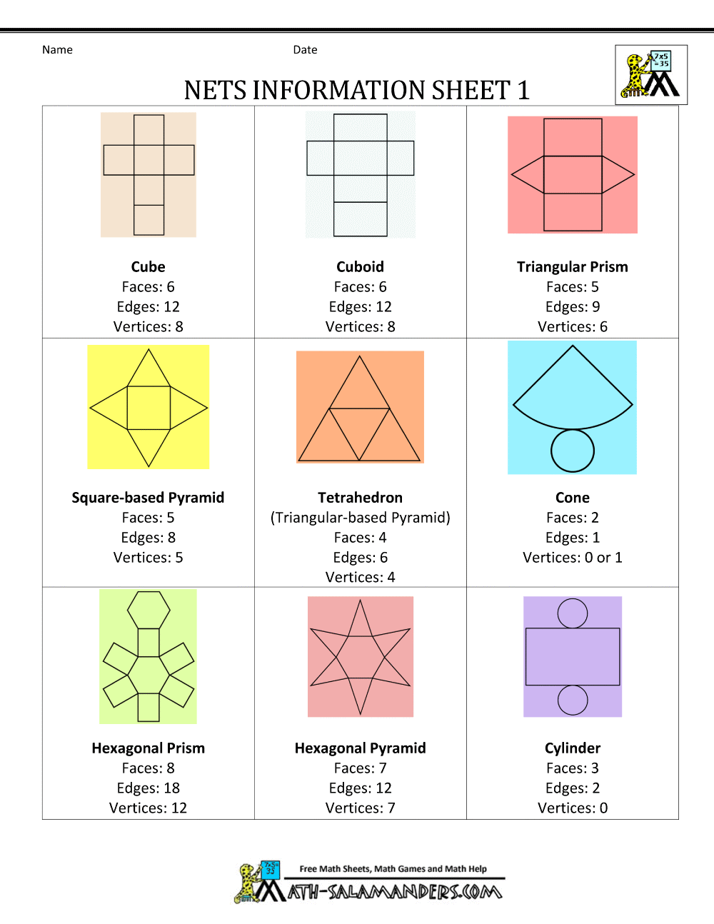
Q1. Which 2 nets of solids among these cannot form polyhedrons?
Answer -------------------------------------------

Q2. Nikitha, a class VII student has to prepare any 4 solids from these nets.
She selected 4 nets of her choice as shown in fig 1 to 4.

Which of the given options shows the correct matching of nets in order?
a) Cylinder, square based pyramid, triangular prism, hexagonal prism
b) Cylinder, triangular prism, square based pyramid, hexagonal pyramid
c) Cylinder, tetrahedron, triangular prism, hexagonal pyramid
d) Cylinder, square based pyramid, triangular prism, hexagonal prism

Fig 1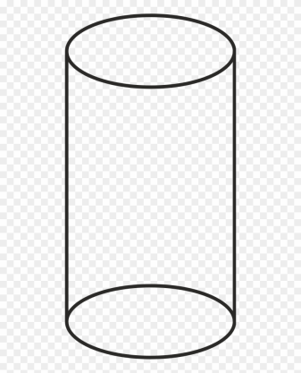 Fig 2 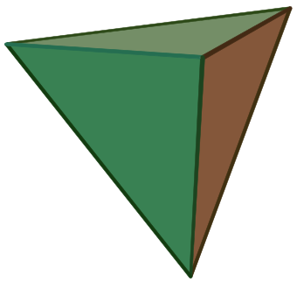

Fig 3 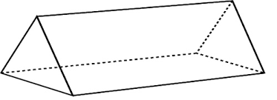 Fig 4 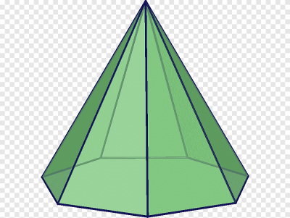

Q3. Platonic solids are defined as polyhedrons in which all the faces are regular polygons of the same type.
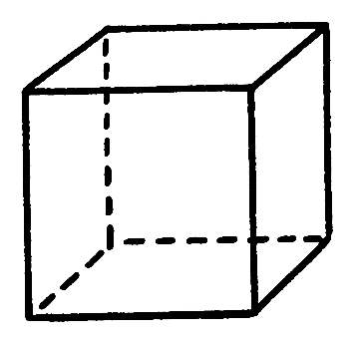
For example, A cube is a platonic solid because all the 6 faces are regular polygons that are squares. In the chart, there are 2 platonic solids. One is a cube. Which is the other?

- Cuboid
- Tetrahedron
- Triangular Prism
- Square based Pyramid

ITEM 10: WHAT’S ON THE OTHER SIDE

Domain : Mathematical Literacy | Topic: Visualizing Solid Shapes  Learning Outcome: Visualize, Understand.  (As per NCERT) | Class: VII  Expected Time :  Total Credit : 6
Description of item: | Understand ,analyze the figure provided

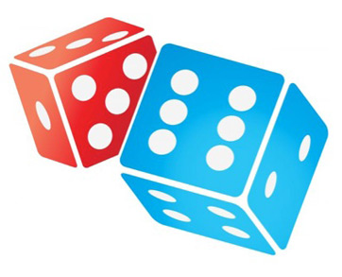
Dice are cubes whose faces are numbered from 1 to 6. The numbering is such that the sum of the dots on the opposite faces of the dice is always 7.

Q1. In the given picture of the dice what would be the number of dots on the side opposite to two dots?
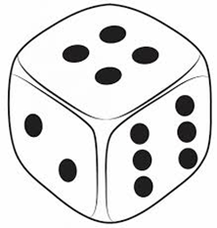
Q2. In the picture given below, the sum of dots facing up on both dice is 6. What would be the sum of dots facing down?
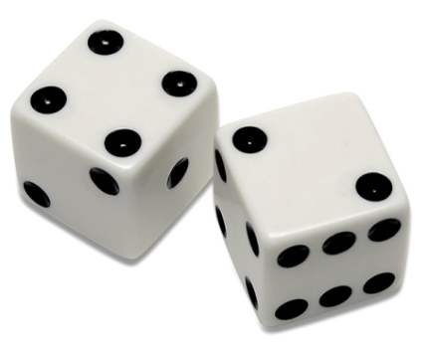
Q3. Cubes are stacked up in the given arrangement as shown below.
Which among the three diagrams gives the top view?
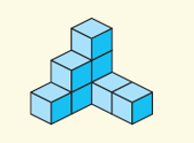
a)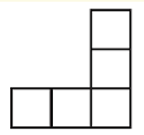b)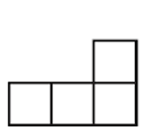c)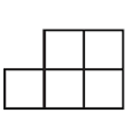

ITEM 11: CHINTU’S BIRTHDAY PARTY

Domain : Mathematical Literacy | Topic: Visualizing Solid Shapes  Learning Outcome: Visualize, Understand.  (As per NCERT) | Class: VII  Expected Time : 9 mts  Total Credit : 8
Description of item: | Able to visualise and comprehend 3D shapes.

It was Chintu’s 12th birthday last Monday. He received many gifts from his friends and relatives. The gifts were packed in boxes of different shapes. Though he was very happy about all the gifts, he was more excited for the gifts his best friends, Rohan, Anuj and Ayush got him. Rohan gifted him a Pencil Box, Anuj gifted a Rubik’s Cube and Ayush gifted a Toblerone Chocolate bar. They enjoyed many savouries and sweets such as ice-creams, cakes and candies.

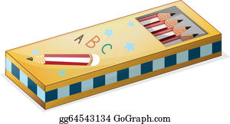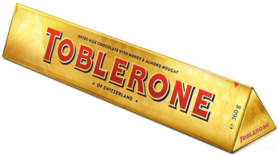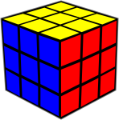

- Match the items with the net of their boxes.

 | Item |  | Net
i | 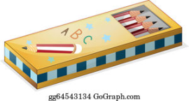 | A | 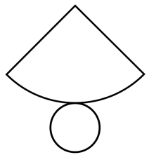
ii | 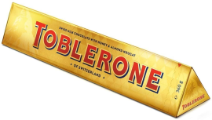 | B | 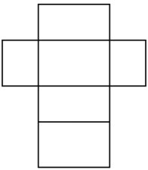
iii |  | C | 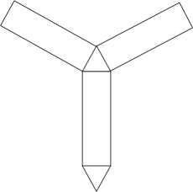

- Complete the following table.

Item | No. of Vertices | No. of Faces
Toblerone Chocolate bar
Rubik’s Cube | 8
Ice-Cream Cone |  | 2

- How many Rubik’s cubes of side 8cms does Chintu need to make a bigger cube of size 16cms.

- Draw a net for the Rubik’s Cube.

ITEM 12: DICE AND NETS

Domain : Mathematical Literacy | Topic: Visualising Solid Shapes  Learning Outcome: Visualise, Understand.  (As per NCERT) | Class: VII  Expected Time : 10 mts  Total Credit : 10
Description of item: | visualise and comprehend cubes and nets.

Dice are special number cubes with dots on each face. Opposite faces of a die always have a total of seven dots on them? You can make a simple number cube by cutting, folding and gluing cardboard.

- Can this be a net for a die? Explain your answer.
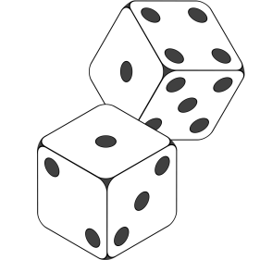
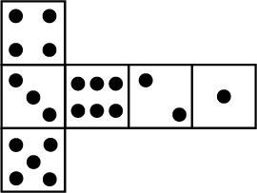

- Write suitable numbers in opposite faces :

- Identify the nets which can be used to make cubes
(i)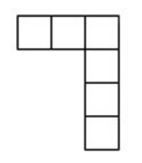(ii)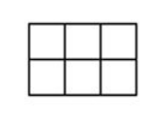
(iii)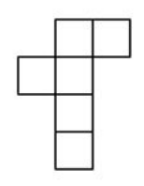(iv)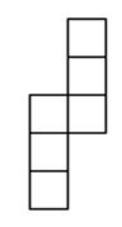

Option-1) i and ii Option-3) iii and iv

Option-2) ii and iv Option-4) only iii

- Two dice are placed side by side as shown. What the total would be on the face opposite to 5+6
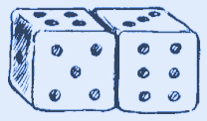

- Three cubes each with 2cm edges are placed side by side to form a cuboid. What will be its length, breadth and height?

ITEM 13: WHERE IS MY SHADOW?

Domain : Mathematical Literacy | Topic: Visualising Solid Shapes  Learning Outcome: Visualisethe objects and understand.  (As per NCERT) | Class: VII  Expected Time : 10 mts  Total Credit : 10
Description of item: | Able to visualise and understand.

A hanging focus light is suspended from the ceiling. Its light beam falls on these objects.

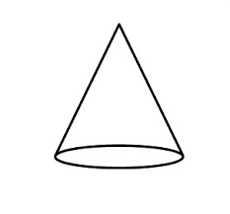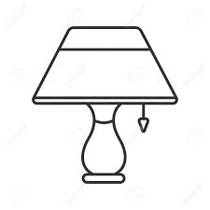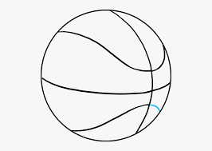
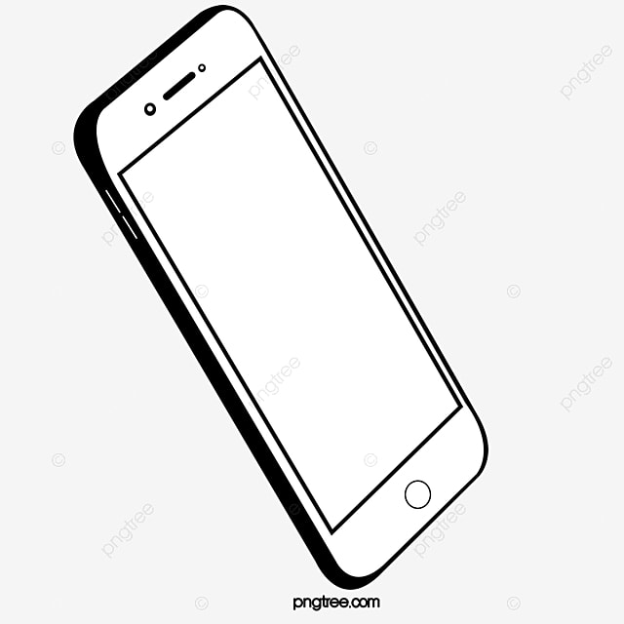

- What is the shape of the shadow formed by an open book?
Answer : ……………………….

- What is the shape of the shadow formed by a table lamp?
Answer : ……………………….

- Which of the given objects casts a triangular shaped shadow?
Answer : ……………………….

- What is the shape of the shadow formed by a basketball?
Answer : ……………………….

- Which of the given objects casts a rectangular shaped shadow?
Answer : ………………………. ...

KENDRIYA VIDYALAYA SANGATHAN
BENGALURU REGION
SCORING KEY – CLASS: VII MATHEMATICS (CHAPTER -15)
TOPIC: VISUALISING SOLID SHAPES
ITEM 1: 3 D TO 2D

Mathematical Literacy
FRAMEWORK | Q 1 | Q 2 | Q 3 | Q 4 | Q 5
Competency Cluster | Visualising& Interpreting | Visualising& Interpreting | Visualising& Interpreting | Visualising& Interpreting | Visualising& Interpreting
Overarching Idea | Space & Shape | Space & Shape | Space & Shape | Space & Shape | Space & Shape
Context | Personal | Personal | Personal | Personal | Personal
Item Format | MCQ | MCQ | MCQ | MCQ | MCQ
Cognitive Process | Interpreting | Interpreting | Interpreting | Interpreting | Interpreting
Proficiency Level | 1 | 1 | 1 | 1 | 1

Credit Pattern
Full Credit: 2
Partial Credit: 0
Nil Credit:0

Description of Answer Key and credits:
1) Full Credit: b) Circle
No Credit : Other Responses

2) Full Credit : b) Triangle
No Credit : Other Responses

3) Full Credit : a) Circle
No Credit : Other responses

4) Full Credit : d) Rectangle
No credit : Other responses

5) Full Credit : c )Triangle
No credit : Other responses

ITEM 2: STEP PATTERN

Mathematical Literacy
FRAMEWORK | Q 1 | Q 2 | Q 3 | Q 4
Competency Cluster | Visualising & Interpreting | Visualising & Interpreting | Visualising & Interpreting | Visualising & Interpreting
Overarching Idea | Space & Shape | Space & Shape | Space & Shape | Space & Shape
Context | Personal | Personal | Personal | Personal
Item Format | Close constructed | Close constructed | Close constructed | MCQ
Cognitive Process | Interpreting | Interpreting | Interpreting | Interpreting
Proficiency Level | 2 | 2 | 1 | 2

Credit Pattern
Full Credit: 2
Partial Credit: 0
Nil Credit:0

Description of Answer Key and credits:
1) Full Credit : 10
No credit : Other responses

2) Full Credit : 20
No credit : Other responses

3) Full Credit : 1
No credit : Other responses

4) Full Credit : Yes
No credit : Other responses

ITEM 3: DICEY GAME

Mathematical Literacy
FRAMEWORK | Q 1 | Q 2 | Q 3 | Q 4 | Q 5
Competency Cluster | Visualising & Interpreting | Visualising & Interpreting | Visualising & Interpreting | Visualising & Interpreting | Visualising & Interpreting
Overarching Idea | Space & Shape | Space & Shape | Space & Shape | Space & Shape | Space & Shape
Context | Personal | Personal | Personal | Personal | Personal
Item Format | MCQ | MCQ | MCQ | MCQ | MCQ
Cognitive Process | Interpreting | Interpreting | Interpreting | Interpreting | Interpreting
Proficiency Level | 2 | 2 | 2 | 2 | 2

Credit Pattern
Full Credit: 2
Nil Credit: 0

Description of Answer Key and credits:
1) Full credit : Net of a dice
No credit : Other responses

2) Full credit : Net of a cube
No credit : Other responses

3) Full Credit : Net of cube
No credit : Other responses

4) Full credit : Net of cube
No credit : Other responses

5) Full credit : Net of dice
No credit : Other responses

ITEM 4: RUBIK’S CUBE

Mathematical Literacy
FRAMEWORK | Q1 | Q2 | Q3 | Q4
Competency Cluster | Visualising & Interpreting | Visualising & Interpreting | Visualising & Interpreting | Visualising & Interpreting
Overarching Idea | Space & Shape | Space & Shape | Space & Shape | Space & Shape
Context | Personal | Personal | Personal | Personal
Item Format | MCQ | MCQ | MCQ | MCQ
Cognitive Process | Interpreting | Interpreting | Interpreting | Interpreting
Proficiency Level | 1 | 1 | 1 | 1

Credit Pattern
Full Credit: 2
Nil Credit: 0

Description of Answer Key and credits:
1) Full Credit: D
No Credit : Other responses

2) Full credit : C
No credit : Other responses

3) Full credit : B
No credit : Other responses

4) Full credit : A
No credit : Other responses

ITEM 5: SHADOW GAME

Mathematical Literacy
FRAMEWORK | Q 1 | Q 2 | Q 3 | Q 4 | Q 5
Competency Cluster | Visualising & Interpreting | Visualising & Interpreting | Visualising & Interpreting | Visualising & Interpreting | Visualising & Interpreting
Overarching Idea | Space & Shape | Space & Shape | Space & Shape | Space & Shape | Space & Shape
Context | Personal | Personal | Personal | Personal | Personal
Item Format | Close constructed | Close constructed | Close constructed | MCQ | Close constructed
Cognitive Process | Interpreting | Interpreting | Interpreting | Interpreting | Interpreting
Proficiency Level | 2 | 2 | 2 | 2 | 2

Credit Pattern
Full Credit: 2
Nil Credit: 0

Description of Answer Key and credits:
1) Full Credit: Circle
No credit : Other responses

2) Full Credit : Rectangle
No credit : Other responses

3) Full Credit : Circle
No credit : Other responses

4) Full credit : Yes
No credit : Other responses

5) 4) Full credit : Square and Hexagon
No credit : Other responses

ITEM 6: SINGLE COLOUR 3 x 3 CUBE

Mathematical Literacy
FRAMEWORK | Q1 | Q2 | Q3 | Q4
Competency Cluster | Visualising& Interpreting | Visualising& Interpreting | Visualising& Interpreting | Visualising& Interpreting
Overarching Idea | Space & Shape | Space & Shape | Space & Shape | Space & Shape
Context | Personal | Personal | Personal | Personal
Item Format | MCQ | MCQ | MCQ | MCQ
Cognitive Process | Interpreting | Interpreting | Interpreting | Interpreting
Proficiency Level | 1 | 1 | 1 | 1

Credit Pattern
Full Credit: 2
Nil Credit: 0

Description of Answer Key and credits:
1) Full Credit : 1
No credit : Other Responses

2) Full Credit :6
No credit : Other responses

3) Full credit : 12
No credit : Other responses

4) Full credit : 8
No credit : Other Responses

ITEM 7: SINGLE COLOUR 4 x 4 CUBE

Mathematical Literacy
FRAMEWORK | Q1 | Q2 | Q3 | Q4
Competency Cluster | Visualising& Interpreting | Visualising& Interpreting | Visualising& Interpreting | Visualising& Interpreting
Overarching Idea | Space & Shape | Space & Shape | Space & Shape | Space & Shape
Context | Personal | Personal | Personal | Personal
Item Format | MCQ | MCQ | MCQ | MCQ
Cognitive Process | Interpreting | Interpreting | Interpreting | Interpreting
Proficiency Level | 1 | 1 | 1 | 1

Credit Pattern
Full Credit: 2
Nil Credit: 0

Description of Answer Key and credits:
1) Full Credit :8
No credit : Other Responses

2) Full Credit : 24
No credit : Other responses

3) Full credit : 24
No credit : Other responses

4) Full credit : 8
No credit : Other Responses

ITEM 8: Counting Cubes

Mathematical Literacy
FRAMEWORK | CHARACTERISTICS
Competency Cluster | Space and shape
Overarching Idea | Interpret , analyze
Context | Societal
Item Format | personal
Cognitive Process | Employ ,interpret
Proficiency Level | Average

Credit Pattern
Full Credit: 2
Partial Credit: 1
Nil Credit: 0

Answer 1.
Full Credit: Anu is wrong. They will need 10 cubes for this arrangement.
Partial Credit: - incomplete answer
Nil Credit: Any other answer.

Answer 2.
Each cube requires 12 ml. which means each face 2ml. We need to paint 30 faces X 2 ml for each face = 60 ml paint is required

Full Credit: complete answer 60ml .
Partial Credit: - partial calculation showed but incomplete answer.
Nil Credit: Any other answer.

Answer 3.
Full Credit: 10 extra cubes are needed.
Partial Credit: -
Nil Credit: Any other answer.

ITEM 9: AMAZING SHAPES

Mathematical Literacy
FRAMEWORK | CHARACTERISTICS
Competency Cluster | Space and shape
Overarching Idea | Interpret , analyze
Context | Societal
Item Format | personal
Cognitive Process | Employ ,interpret
Proficiency Level | Average

Credit Pattern
Full Credit: 2
Partial Credit: 1
Nil Credit: 0

Answer 1.
Full Credit: cone and cylinder
Partial Credit: - any one is written correctly out of cone and cylinder.
Nil Credit: Any other answer.

Answer 2.
Full Credit: option c.
Partial Credit: - -
Nil Credit: Any other answer.

Answer 3.
Full Credit: b) tetrahedron
Partial Credit: -
Nil Credit: Any other answer.

ITEM 10: WHAT’S ON THE OTHER SIDE

Mathematical Literacy
FRAMEWORK | CHARACTERISTICS
Competency Cluster | Space and shape
Overarching Idea | Interpret , analyze
Context | Societal
Item Format | personal
Cognitive Process | Employ ,interpret
Proficiency Level | Average

Credit Pattern
Full Credit: 2
Partial Credit: 1
Nil Credit: 0

Description of Answer Key and credits:
Ans 1.
Full Credit: 5 dots
Partial Credit:-
Nil Credit: any other answer

Ans 2.
Full Credit: 3+5 = 8 dots
Partial Credit: -
Nil Credit: any other answer

Ans 3.
Full Credit: option (a)
Partial Credit: -
Nil Credit: any other answer

ITEM 11: CHINTU’S BIRTHDAY PARTY

Mathematical Literacy
FRAMEWORK | CHARACTERISTICS
Competency Cluster | Able to visualize 3D shapes like cube, cuboid, cone and triangular prism and draw their nets
Overarching Idea | Interpret , analyze
Context | Societal
Item Format | MCQ, Match the Following, Short Response Items personal
Cognitive Process | Employ ,interpret
Proficiency Level | Average

Credit Pattern
Full Credit: 2
Partial Credit: 1
Nil Credit: 0

Description of Answer Key and credits:
- Full credit: 2 Expected Answer: i)-B, ii-C, iii-A
No credit : 0 Other responses

- Full credit: 2 Expected Answer:
Item | No. of Vertices | No. of Faces
Toblerone Chocolate bar | 6 | 5
Rubik’s Cube |  | 6
Ice-Cream Cone | 1
Partial Credit: 1 Expected Answer: If only 2 or 3 entries correctly filled
No credit : 0 Other responses

- Full credit: 2 Expected Answer:8
No credit : 0 Other responses

- Full credit: 2 Expected Answer: Any one of the nets below
No credit : 0 Other responses

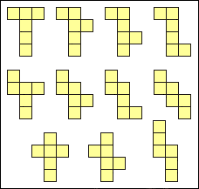

ITEM 12: DICE AND NETS

Mathematical Literacy
FRAMEWORK | CHARACTERISTICS
Competency Cluster | Able to visualize cube and nets
Overarching Idea | Interpret , analyze
Context | Societal
Item Format | Personal /observation
Cognitive Process | Employ ,interpret
Proficiency Level | Average

Credit Pattern
Full Credit: 2
Partial Credit: 1
Nil Credit: 0

Description of Answer Key and credits:
- Full credit:2 Expected Answer: No, as sum of the dots on opposite
sides is not equal to7
Partial credit: 1 Expected Answer: No (without explanation)
No credit: 0 Other responses

- Full credit:2 Expected Answer: DIE-1 : (1,6),(2,5) ,(3,4) &
DIE-2 : (4,3),(1,6) ,(5,2)
No credit: 0 Other responses

- Full credit : 2 Expected Answer: Option-3 (iii and iv)
No credit: 0 Other responses

- Full credit : 2 Expected Answer: 2+1 or 3
Partial credit : 1 If Answer 2 & 1 only mentioned
No credit: 0 Other responses

- Full credit: 2 Expected Answer: 6cms,2cms,2cms in any order
No credit: 0 Other responses

ITEM 13: WHERE IS MY SHADOW?

Mathematical Literacy
FRAMEWORK | CHARACTERISTICS
Competency Cluster | Able to visualize objects
Overarching Idea | Interpret , analyze
Context | Societal
Item Format | Personal /observation
Cognitive Process | Employ ,interpret
Proficiency Level | Average

Credit Pattern
Full Credit: 2
Partial Credit: 1
Nil Credit: 0

Description of Answer Key and credits:
- Full Credit : 2 Rectangle
No Credit: For any other response.

- Full Credit : 2Circle
No Credit: For any other response.

- Full Credit : 2 Cone
No Credit: For any other response.

- Full Credit : 2 Circle
No Credit: For any other response.

- Full Credit :2 Mobile phone /phone
No Credit: For any other response.

Prepared By:

Items 1 to 4

Name of the Teacher / Item Writer: P S KAVITHA
Designation: TGT MATHS
Email:dpskavitha@gmail.com
Phone No.:9008394915
Name of the Vidyalaya: Kendriya Vidyalaya DRDO,Bengaluru

Items 5 to 7

Name of the Teacher: Jaseer K P
Designation: PGT (Maths)
Email:jaseer82@gmail.com
Phone No: 8486986749
Name of the Vidyalaya: Kendriya Vidyalaya IISc Bengaluru

Items 8 to 10

Name of the Teacher: Neela Prashanth
Designation: TGT Math
Email: neelakvrwf@gmail.com
Phone No: 9480069088
Name of the Vidyalaya: KV RWF Yelahanka, Bengaluru.
KVS Region: Bengaluru.

Items 11 to 13

Name of the Teacher: R RAVISANKAR
Designation: PGT (Maths)
Email: rravi1963@gmail.com
Phone No: 9448978400
Name of the Vidyalaya: Kendriya Vidyalaya Malleswaram Bengaluru

