KENDRIYA VIDYALAYA SANGATHAN

CCT TEST ITEMS
CLASS VII: CHAPTER 13: EXPONENTS AND POWERS

S. NO. | TITLE OF TEST ITEM
 | CELLS OF BLOOD
 | DESERTS OF WORLD
 | DISTRIBUTION OF MONEY
 | GRAVITATIONAL FORCE
 | GREEDY TRADER
 | GROWTH OF BACTERIA
 | HALF LIFE EXPONENTIAL DECAY
 | HOW FAR AWAY IS THE SUN?
 | MILKY WAY
 | SIZE OF VIRUSES AND BACTERIA

Domain:  Mathematical Literacy | Theme/ Topic:  Exponents and Powers | Class: VII  Expected Time: 10 Minutes  Total Credits: 08
Learning Outcomes:
To develop an interest in students to study Mathematics as discipline.
To develop positive attitude to think, analyze and articulate logically.
Compassion of values (Evaluate).
Applicability of exponents and power in daily life. (Interpret & Formulate).

UNIT 1 - CELLS OF BLOOD

When a person gets infected or become sick, Doctor advises him for blood test. Pathologist finds the number of cells in per cubic millimeter of blood. His blood report shows the following values -
Red blood cells count (RBC). --. 4.45 x 10⁶ per mm³
White blood cells count (WBC) --. 8.9 x 10³per mm³
(Leucocytes)
Platelets count --. 3.02 x 10⁵ per mm³
Hemoglobin --. 12.8 GM%

Question (1)- The ratio between RBCs and WBCs is
(a) 500 : 1
(b) 1 : 500
(c) 550 : 1
(d) 1 : 100

Question (2) - What is the total number of RBCs and Platelets.

Question (3) - in the sample, which are more WBCs or Platelets?

Question (4) - A microscope helps to see the cell. It has an objective lens and an eyepiece. The objective lens can magnify an object 10³ times and the eyepiece can further magnify an object 10 ² times. What is the maximum magnification on the microscope?

Credit Pattern:
Full Credit 02
Partial Credit 01
No Credit Nil

Description of Answer Key and Credits:
Q No | Answer | Credits
1 | ( a ) | For right answer full credit, otherwise no credit
2 | 4.752 x 10⁶ per mm³ | For right answer full credit, otherwise no credit
3 | Platelets are more.
4 | 10⁵ times | For right answer full credit, otherwise no credit

Name of the teacher / item writer B N Bhalla
Designation TGT Maths
Email visitbhalla2008@gmail.com
Phone Number 9058575676
Name of the Vidyalaya KV NO.1, AFS, AGRA
KVS Region Agra

Domain:  Mathematical Literacy | Theme/ Topic:  Exponents and Powers | Class: VII  Expected Time: 8 Minutes  Total Credits: 08
Learning Outcomes:
To develop an interest in students to study Mathematics as discipline.
To develop positive attitude to think, analyze and articulate logically.
Compassion of values (Evaluate).
Applicability of exponents and power in daily life. (Interpret & Formulate).

UNIT 2 - DESERTS OF WORLD

On our Planet Earth approximately 71% is covered with water and 29% is land, out of this some area is covered by deserts in different continents. The deserts of world are given in the following table.

S. No. | Deserts of World | Area ( Square Km.)
1 | Kalahari, South Africa | 932400
2 | Thar, India | 199430
3 | Gibson, Australia | 155400
4 | Great Victoria, Australia | 647500
5 | Sahara, North Africa | 8598800

Question (1)- Write the area of Sahara desert in standard form.

Question (2)-After writing in standard form, Arrange these values in ascending order.

Question (3)-Using the data in given table, findthe total desert area in Africa in standard form.

Question (4)-The ratio of area of Kalahari and Gibson desert is
(a) 1 : 4
(b) 3 : 2
(c) 6 : 1
(d) 1: 2

Credit Pattern:
Full Credit 02
Partial Credit 01
No Credit Nil

Description of Answer Key and Credits:
Q No | Answer | Credits
1 | 8.5988 x 10⁶ sq.km | For right answer full credit, otherwise no credit
2 | 1.554 x10⁵<1.9943 x10⁵ < 6.475 x10⁵ < 9.324 x10⁵ < 8.5988x10⁶ | For right answer full credit, otherwise no credit
3 | 9.5312 x 10⁶ | For right answer full credit, otherwise no credit
4 | (c) | For right answer full credit, otherwise no credit

Name of the teacher / item writer B N Bhalla
Designation TGTMaths
Email visitbhalla2008@gmail.com
Phone Number 9058575676
Name of the Vidyalaya KV NO.1, AFS, AGRA
KVS Region Agra

Domain:  Mathematical Literacy | Theme/ Topic:  Exponents and Powers | Class: VII  Expected Time: 10 Minutes  Total Credits: 08
Learning Outcomes:
- To develop an interest in students to study Mathematics as discipline.
- To develop positive attitude to think, analyze and articulate logically.
- Compassion of values (Evaluate).
- Applicability of exponents and power in daily life. (Interpret & Formulate).

UNIT 3 - DISTRIBUTION OF MONEY

Mohan divided a sum of rupees into two parts $5^{x}and4^{x}$ and distributed it between his two sons, Parth and Ankur respectively. The product of $5^{x}and4^{x}$ is 8000

Question (1)- The amount of money received by Parth
- Rs 1,000
- Rs 625
- Rs 500
- Rs 125

Question (2)-The amount of money received by Ankur
- Rs 16
- Rs 64
- Rs 256
- Rs 512

Question (3)-What is the ratio of amount of money received by Ankur to the total sum of money?
- $\frac{12}{189}$
- $\frac{125}{189}$
- $\frac{64}{189}$
- $\frac{16}{189}$

Question (4)- What is the ratio of difference of amount of money received by Parth to Ankur ?

Credit Pattern: Full Credit 02
Partial Credit 01
No Credit Nil

Description of Answer Key and Credits:
Q No | Answer | Credits
1 | (d) Rs 125 | For right answer full credit, otherwise no credit
2 | (b) Rs 64 | For right answer full credit, otherwise no credit
3 | $$\frac{61}{64}$$ | For right answer full credit, otherwise no credit
4 | (c ) $\frac{64}{189}$ | For right answer full credit, otherwise no credit

Name of the teacher / item writer Pankaj Varshney
Designation PGT Maths
Email pvarshney28@gmail.com
Phone Number 8445084552
Name of the Vidyalaya KV NO.2, MRN, MATHURA
KVS Region Agra

Domain  Mathematical Literacy | Theme/Topic  Exponents and Powers | Class: VII  Expected Time: 15 Minutes  Total Credits : 08
Learning Outcomes
Use of exponential approach for expressing large values(Employ)
Laws of exponents and standard form(Evaluate)
Applicability of exponents and powers(interpret & Formulate)

UNIT 4 - GRAVITATIONAL FORCE

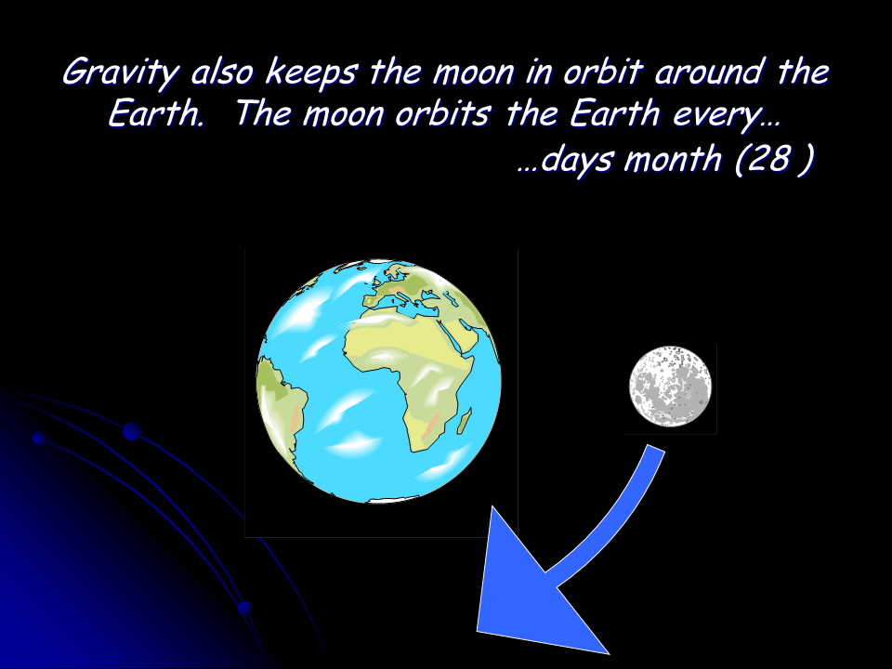

The mass of the earth is 5,976,000,000,000,000,000,000,000 Kg and the radius of the earth is 6.37 x 10⁶m. Moon is the natural satellite of earth which revolves around the sun due to strong gravitational force of the earth. The mass of moon is 7.36 x 10²²Kg. The radius of the moon is 1.74 x 10⁶m. The distance between the earth and moon is 3.84 x 10⁵km.

Q1. Write the mass of earth in standard form?

Q2. Express the distance between earth and moon in m and find its square. Write your answer in standard form?

Q3. Express the double of difference of radius of earth and moon in standard form.

Q4. What will be the product of mass of the moon and mass of earth in exponential form?
a) 4.398336 $×$10⁴⁷kg²
b) 43.98336 $×$10⁴⁷kg²
c) 4.398336 $×$10⁴⁶kg²
d) 43.98336 $×$10⁴⁶kg²

Credit pattern:
Full Credit: 02
Partial Credit: 01
No Credit: Nil

Description of answer key and Credits
Q No. | Answer | Credits
1 | 5.976 $×$ 10²⁴Kg | For right answer full credit, otherwise no credit
2 | 3.84 $×10$⁵$×10$³ = 3.84 $×$ 10⁸m  (3.84 $×$ 10⁸)²= 1.47456$×$ 10¹⁶m² | For right answer full credit, otherwise no credit
3 | 9.26 x 10⁶ | For right answer full credit, otherwise no credit
4 | a | For right answer full credit, otherwise no credit

Name of the teacher/item writer Swati Gupta
Designation TGT Maths
E mail Swatigupta2111@gmail.com
Phone Number 9927969072
Name of Vidyalaya KV AFS Chandinagar
KVS Region Agra

Domain:  Mathematical Literacy | Theme/ Topic:  Exponents and Powers | Class: VII  Expected Time: 12-15 Minutes  Total Credits: 08
Learning Outcomes:
- To develop an interest in students to study Mathematics as discipline.
- To develop positive attitude to think, analyze and articulate logically.
- Compassion of values (Evaluate).
- Applicability of exponents and power in daily life. (Interpret & Formulate).

UNIT 5 - GREEDY TRADER

Once a crook came to a rich trader to trick him. He said ,” I will give you one lakh rupees daily for one month (30 Days) if you will give me just one rupee for first day and from next day you will give me double of what you give me on previous day.” The greedy trader, without showing far-sightedness accepted the offer and signed a contract.

Question (1)- How much amount did the crook give to the trader in 30 days?

Question (2)-How much amount is to be paid to the crook by the trader on 10th day?

Question (3)-Amount paid by the trader to the crook on 20th day is
- $2^{21}$
- $2^{20}$
- $2^{19}$
- $2^{18}$

Question (4)-For whom was the deal more profitable –the trader or the crook? Justify your answer also.

Credit Pattern:
Full Credit 02
Partial Credit 01
No Credit Nil

Description of Answer Key and Credits:
Q No | Answer | Credits
1 | 30 Lakhs | For right answer full credit, otherwise no credit
2 | $${Rs 2}^{9}orRs 512$$ | For right answer full credit, otherwise no credit
3 | (c ) $2^{19}$ | For right answer full credit, otherwise no credit
4 | More profitable for crook | Full credit: For right answer with explanation  Partial credit: For right answer without proper explanationOtherwise no credit

Name of the teacher / item writer Pankaj Varshney
Designation PGT Maths
Email pvarshney28@gmail.com
Phone Number 8445084552
Name of the Vidyalaya KV NO.2, MRN, MATHURA
KVS Region Agra

Domain:  Mathematical Literacy | Theme/ Topic:  Exponents and Powers | Class: VII  Expected Time: 10 Minutes  Total Credits: 08
Learning Outcomes:
- To develop an interest in students to study Mathematics as discipline.
- To develop positive attitude to think, analyze and articulate logically.
- Compassion of values (Evaluate).
- Applicability of exponents and power in daily life. (Interpret & Formulate).

UNIT 6 -GROWTH OF BACTERIA

The number of bacteria in a certain box doubles every hour. There were 5 bacteria present in the box originally and the box wasfully filled with bacteria in 30 hours.

Question (1) - How many bacteria will be present at the end of 4th hour?

Question (2) -In how many hours wills the box be filledhalf with bacteria?

Question (3)-Find the difference in number of bacterial at the end of 10 hours and 11 hours.

Question (4) - The $\frac{1}{4}th$ part of box will be filled with bacteria in
- 7.5 hours
- 15 hours
- 28 hours
- 4 hours

Credit Pattern:
Full Credit 02
Partial Credit 01
No Credit Nil

Description of Answer Key and Credits:
Q No | Answer | Credits
1 | $$5^{4}or 625$$ | For right answer full credit, otherwise no credit
2 | 29 hours | For right answer full credit, otherwise no credit
3 | 4(5¹⁰) | For right answer full credit, otherwise no credit
3 | 28 hours | For right answer full credit, otherwise no credit

Name of the teacher / item writer Pankaj Varshney
Designation PGT Maths
Email pvarshney28@gmail.com
Phone Number 8445084552
Name of the Vidyalaya KV NO.2, MRN, MATHURA
KVS Region Agra

Domain:  Mathematical Literacy | Theme/ Topic:  Exponents and Powers | Class: VII  Expected Time: 10-15 Minutes  Total Credits: 08
Learning Outcomes:
- To develop an interest in students to study Mathematics as discipline.
- Concept of square and cubes. ( Employ)
- Knowledge of division of decimal numbers. (Evaluate).
- Applicability of exponents and power in daily life. (Interpret & Formulate).

UNIT 7
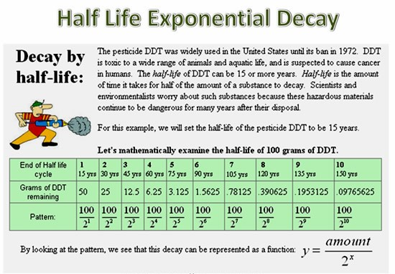

Q.1 According to given situation in how many years 200g.DDT will be decreased to 100g.
a) 10 years b) 12 years c) 15 years d0 20 years

Q.2 How much amount of DDTout of 100g will be remaining in 175 years

Q.3) Find the value of x by using formula y=$\frac{amount}{2^{x}}$ where amount left after decay is 0.048828125 grams and amount is 100 grams.

Q.4) According to given situation in how many years 512 g DDT will be decreased to 1g.
a) 10 years b) 12 years c) 15 years d) 135 years

Credit Pattern:
Full Credit 02
Partial Credit 01
No Credit Nil

Description of Answer Key and Credits:
Q No | Answer | Credits
1 | 15 years | For right answer full credit, otherwise no credit
2 | Or 100/2¹¹grams | For right answer full credit, otherwise no credit
3 | X=11 | For right answer full credit, otherwise no credit
4 | 135 years | For right answer full credit, otherwise no credit

Name of the teacher / item writer Manish Kumar Sharma & O S Bhati
Designation PGT Mathematics & TGT Maths
Email manishkumarsharma.09@gmail.com
Phone Number 7906253479
Name of the Vidyalaya KV Buland shahr Ist shift
KVS Region Agra

Domain:  Mathematical Literacy | Theme/ Topic:  Exponents and Powers | Class: VII  Expected Time: 10 Minutes  Total Credits: 08
Learning Outcomes:
To develop an interest in students to study Mathematics as discipline.
To develop positive attitude to think, analyze and articulate logically.
Compassion of values (Evaluate).
Applicability of exponents and power in daily life. (Interpret & Formulate).

UNIT 8 - How far away is the Sun?

The Sun is at an average distance of about 93,000,000 miles (150,000,000 Kilometer) away from Earth. It is so far away that light from the Sun, travelling at a speed of 300,000 Kilometers per second, takes about 8 minutes to reach us.
Like all other planets in our solar system, Earth travels in its elliptical orbit.
The Sun is at average distance of 228,000,000 Kilometers from the Mars and 108,000,000 Kilometers from the Venus.

Solar System

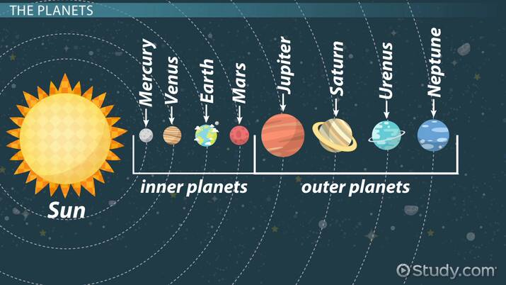

Q1) The distance between Earth and Sun is :
(a) 9.3 × 10⁷ Kilometer (b) 1.50 × 10⁸ Kilometer
(c) 3 × 10⁵ Kilometer (d) 1.08 × 10⁸ Kilometer

Q2) Find the distance between Mars and Venus in standard form?

Q3) Find the approximate time in seconds in standard form in which light reaches Mars from Sun.

Q4) Which planet is far away from Earth, Venus or Mars? Justify by calculating distance in standard form?

Credit pattern:
Full credit – 02 marks
Partial credit – 01 mark
No credit – 0 marks (zero)

Description of Answer Key and Credits:

Q.NO. | Answer Description | Credits Criteria
1 | (B)1.50 × 10⁸ Kilometer | Right answer Full Credit, Otherwise No Credit
2 | 1.2 × 10⁸ Kilometer | Right answer Full Credit, Otherwise No Credit
3 | 7.6 x 10² Sec | Right answer Full Credit, Otherwise No Credit
4 | Wrong or No response  Distance between Earth and any one planet (Earth -Venus=4.2 × 10⁷ or Mars-Earth=7.8 × 10⁷)  Mars is far away from Earth | No Credit  Partial Credit  Full Credit

Name of the teacher / item writer Mr. Prashant Chaturvedi
Designation TGT Maths
Name of the Vidyalaya KNN, GHAZIABAD
KVS Region Agra

Domain:  Mathematical Literacy | Theme/ Topic:  Exponents and Powers | Class: VII  Expected Time: 15-17 Minutes  Total Credits: 10
Learning Outcomes:
- To develop an interest in students to study Mathematics as discipline.
- Concept of square and cubes. ( Employ)
- Knowledge of division of decimal numbers. (Evaluate).
- Applicability of exponents and power in daily life. (Interpret & Formulate).

UNIT 9 - Milky Way

Question: A teacher was teaching in a class, she called a student to come on the Blackboard and write any number with 21 digits. A student wrote 356000000000000000000. Then she asked the students of the class to read the number, but the students were unable to read such a large number. Then teacher taught them how to write numbers in the standard form. Standard form makes the numbers convenient to read and write especially very large numbers or very small number by using power notation. Then she gave students some examples of very large numbers-

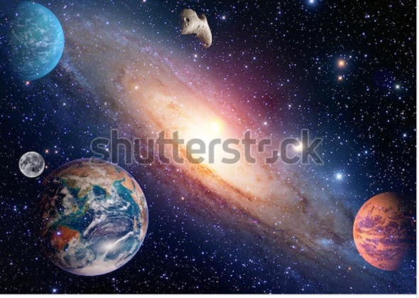

The distance of the sun from the center of the Milky WayGalaxy is estimated to be 300,000,000,000,000,000,000 m
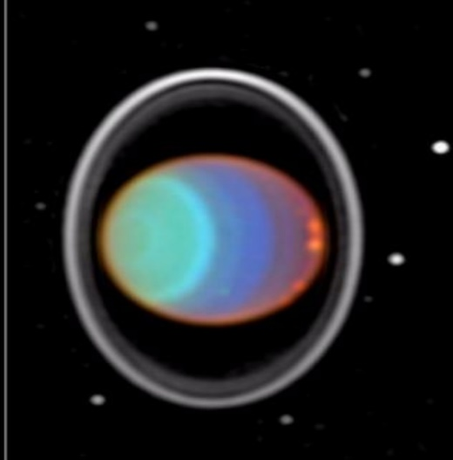

Mass of Uranus is 86,800,000,000,000,000,000,000,000 kg.
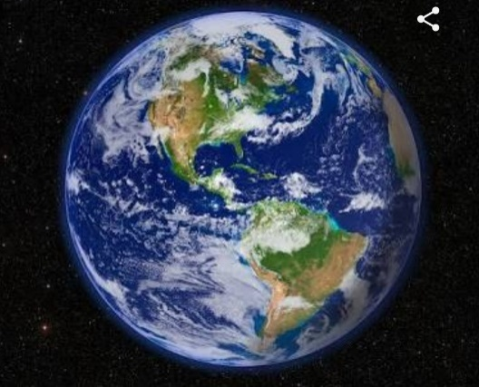

Mass of Earth is 5,976,000,000,000,000,000,000,000 kg.

ANSWER THE FOLLOWING
Q1. The standard form of the number 356000000000000000000 is
- 3.56 X 10
- 3.56 X 10²⁰
- 3.56 X 10²¹
- 356 X 10¹⁸

Q2. A child expressed the distance of sun from the center of Milky Way Galaxy as
300 X 10¹⁸ m is standard form. Is his justification correct?

Q3. Compare the mass of Uranus with mass of Earth by writing them in standard form. Which has greater mass?

Q4. Speed of light in vacuum is 3.0 x ${10}^{8}$ m/sec. Sunlight takes about 8mins to reach the earth. Express the distance of sun from earth in standard form.
- 1.44 x ${10}^{8}$ m B. 2.4 x ${10}^{8}$ m C. 1.44 x ${10}^{11}$m D. 2.4 x ${10}^{11}$ m

Q5. Write in usual form
8.67 X 10¹⁸

Q No | Answer | Credits
1 | 3.56 X 10²⁰ | For right answer full credit, otherwise no credit
2 | No, Standard form is 3.0 X 10²⁰ m. | For right answer full credit, otherwise no credit
3 | Mass of Uranus in standard form = 8.68 X 10²⁵ kg  Mass of Earth in standard form = 5.976 X 10²⁴ kg  Mass of Uranus is greater than Mass of Earth. | For right answer full credit, otherwise no credit
4 | 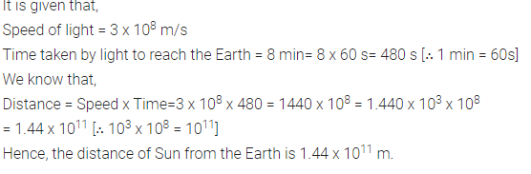 | For right answer full credit, otherwise no credit
5 | 8,670,000,000,000,000,000. | For right answer full credit, otherwise no credit

Name of the teacher / item writer Manish Kumar Sharma& V K Sharma
Designation PGT Mathematics & TGT Maths
Email manishkumarsharma.09@gmail.com
Phone Number 7906253479
Name of the Vidyalaya KV BulandshahrIst shift
KVS Region Agra

Domain:  Mathematical Literacy | Theme/ Topic:  Exponents and Powers | Class: VII  Expected Time: 10 Minutes  Total Credits: 08
Learning Outcomes:
- To develop an interest in students to study Mathematics as discipline.
- To develop positive attitude to think, analyze and articulate logically.
- Compassion of values (Evaluate).
- Applicability of exponents and power in daily life. (Interpret & Formulate).

UNIT 10 - SIZE OF VIRUSES AND BACTERIA

Viruses range in size from 0.02 to 0.25 micron.Bacteria are giants when compared to viruses.
The smallest bacteria are about 0.4 micron. 1 micron= 10⁻⁶metre that is one millionth part of metre.

Question (1)- What are the size of smallest bacteria ?
- 0.4 micron
- 4x 10⁻¹ micron
- 0.04x10¹ micron
- All of the above

Question (2)-Express 0.4 micron in terms of metres in standard form?

Question (3)- Find the ratio of largest size of virus to smallest size of bacteria.

Question (4)- If size of a virus and a bacterium are 0.02 and 0.4 microns. How many times is the size of bacterium as compared to virus?

Credit Pattern:
Full Credit 02
Partial Credit 01
No Credit Nil

Description of Answer Key and Credits:
Q No | Answer | Credits
1 | (d) all of the above | For right answer full credit, otherwise no credit
2 | 4x10⁻⁷metres | For right answer full credit, otherwise no credit
3 | $$\frac{5}{8}$$ | For right answer full credit, otherwise no credit
4 | 20 times | For right answer full credit, otherwise no credit

Name of the teacher / item writer Saurabhkumar
Designation PGT Maths
Email saurabh.1978@hotmail.com
Phone Number 9458070139
Name of the Vidyalaya KV, Sikh lines, Meerut cantt
KVS Region Agra

