KENDRIYA VIDYALAYA SANGATHAN

CCT TEST ITEMS
CLASS VIII: CHAPTER 16: PLAYING WITH NUMBERS

S. NO. | TITLE OF TEST ITEM
 | SURPRIZES WITH CLOCK ARITHMETIC
 | NUMBER FUN WITH CALENDARS-I
 | FUN WITH CALENDAR - II
 | ACROPHONIC SYSTEM
 | NUMBER SYSTEM
 | DAD
 | CARD GAME
 | CRYPTARITHMS
 | CRYPTARITHMETIC
 | GAUSS QUICK ADDITION
SCORING KEY TO ITEMS 1 TO 10

ITEM - 1
Surprizes with Clock Arithmetic

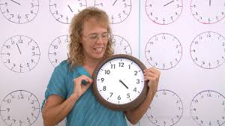

With the proliferation of digital clocks and watches the analogue ones showing time by movement of hands may in near future become an antique object. Twelve-hour clocks are more common than 24-hour clocks. Sam found one such old wall clock face in his store room. This clock had the hour hand only. Being a keen observer, Sam noticed that reckoning of time can be done in hour only in it. He also noticed surprising arithmetic in this mini number system comprising of only twelve numbers.

- Clock Addition: If at a certain time, the clock shows 8 o’clock then five hours hence it would be 1 o’clock. This can be written as 8 + 5 = 1, provided the ‘+’ sign here is taken to denote not ordinary addition but Clock Addition

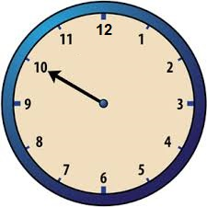

- Sam is working on other clock addition facts like wise and trying to list them in the form of a composite table (Fig 3). His table is incomplete; can you help him to complete it?

+ | 1 | 2 | 3 | 4 | 5 | 6 | 7 | 8 | 9 | 10 | 11 | 12
1 | 2 | 3 | 4 | 5 | 6 | 7 | 8 | 9 | 10 | 11 | 12 | 1
2 | 3 | 4 | 5 | 6 | 7 | 8 | 9 | 10 | 11 | 12 | 1 | 2
3
4
5
6 | 7 | 8 | 9 | 10 | 11 | 12 | 1 | 2 | 3 | 4 | 5 | 6
7
8
9
10
11
12
Fig 3
- Having done Clock Addition, a natural question came to his mind about Clock Multiplication. What does multiplication mean in a system of whole numbers 0,1,2,3,4,….?Sam recalled his teachers words that “it is simply repeated addition”, with number of repetitions becoming the multiplier and the sum becoming the product. Starting say from 9 o’clock, nine hour hence it will be 6 o’clock, again after 9 hours it will be 3 o’clock yet again after 9 hours it will be 12 o’clock and so on. These can be written thus
9 + 9 = 6 or 9 x 2 = 6
9 + 9 + 9 = 3 or 9 x 3 = 3
9 + 9 + 9 + 9 = 12 or 9 x 4 = 12 and so on ,
The signs ‘+’ and ‘x’ here representing Clock Addition and Clock Multiplication respectively.
As you did previously, help him to complete his composite table of Clock Multiplication but with a greater care in fixing the product.

X | 1 | 2 | 3 | 4 | 5 | 6 | 7 | 8 | 9 | 10 | 11 | 12
1 | 1 | 2 | 3 | 4 | 5 | 6 | 7 | 8 | 9 | 10 | 11 | 12
2 | 2 | 4 | 6 | 8 | 10 | 12 | 2 | 4 | 6 | 8 | 10 | 12
3
4
5
6
7 | 7 | 2 | 9 | 4 | 11 | 6 | 1 | 8 | 3 | 10 | 5 | 12
8
9
10
11
12

- For Sam, another Shaking experience was waiting when he attempts to divide one clock face number by another clock face number. Where a whole number can be divided (without remainder) by another whole number, the quotient is obtained uniquely, is it true in the case of clock face numbers.
In whole numbers 5 x 2 = 10, this means 10 ÷ 2 = 5.
Try it for clock numbers division.
8 ÷ 2 = 4 or 10 ( because 4 x 2 = 8 , also 10 x2 = 8)

Similarly (Give the reason)

6 ÷ 3 = 2, 6 or 10 because _________________________________

- When the last clock number is taken as zero itself, then the Clock Arithmetic get recognized as “Modular Arithmetic” developed by the great mathematician Gauss and finding an important place in Number Theory. Another surprize is that a number in modular arithmetic is not just an individual number but one naming a class of numbers, for instance 1 of clock arithmetic names the class of numbers relating to timings 1 hr, 13 hr, 25 hr, 37 hr, 49 hr , . . . etc.(as at these timings the clock will show 1 o’clock.
What class of numbers is related to clock face number 5 __________________

ITEM -2
Number fun with Calendars - I

Calendars are hung prominently in homes, shops and offices. So there may rarely be anyone who is not familiar with this arrangement of numbers in seven columns or rows. But the fascinating patterns that emerge out of this arrangement are secretly known

June 1, 2020 happen to be a Monday. Venuand his family was at home due to the lockdown. Venu’s father is spending time with him due to work from home order from his office. He sees mathematics in everything around.Venu asked his father what fun they could get from the arrangement of numbers on the calendar sheet for june2020.That was all. They had an exciting day just with the calendar.
Here is June-2020 calendar

F (Father): Venu, show me any row or column and I shall instantly give you mean of the numbers in it.
V (Venu): Second row?
F: 10.
V: third column?
F: 16. See that the middle number of the every row or column is the mean. Now I can also give you the instant sum of any row or column for example sum of third column is 80.
V: Oh, I got it, there are 5 numbers in third column and their mean is 16, so their sum is 16 x 5 = 80.
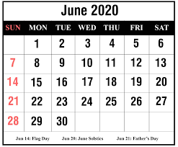

F: If there is no middle term as in Row 1, we can find sum by adding first and last number and multiplying it by half of number of terms.

Qn1 F: Now tell me instantly the mean and sum of all numbers in row 4.
Show Venu’s Calculation here
………………………………………………………………………………
……………………………………………………………………………….
……………………………………………………………………………

F: Now, let me show a rectangle of numbers in the calendar

8 9 10 11
15 16 17 18
Can you find magic in it ?
Add the diagonally opposite numbers:
See
8 + 18 = 26 , 15 + 11 = 26
9 + 17 = 26 , 16 + 10 = 26
So, it’s a magic rectangle!

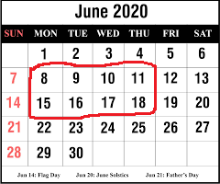

F: Now You might be thinking that the magic happens in this month only, so take any month of any year and rectangle or square of any order.

My choice rectangle is theone in the green border. See the magic
1 + 31 = 32 , 29 + 3 = 32
8 + 24 = 32 , 22 + 10 = 32
15 + 17 = 32 , 2 + 30 = 32
9 + 23 = 32
And middle number is 16 which is the mean of every pair and also mean of all 15 numbers in the rectangle and therefore sum of all the numbers in this rectangle is 16 x 15 = 240

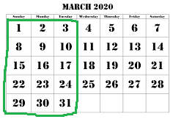

Father asked Venu to find out at least one such rectangle or square of order greater than 3 and find the Patterns in the calendar of January -2020.

Qn. 2 .Draw the border of your selection on the calendar and Show your Findings Here
………………………………………………………………………………………………………………
………………………………………..………………………………………….
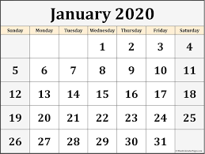

Qn 3. Find instantly the mean of all the numbers inside your selection on the calendar and find a quick sum of all these numbers.
Your answer …………………………………………………………………………..…..……
………………………………..……………………………………..……………
………………………..……………………………………..……………………

ITEM - 3
FUN WITH CALENDAR – II

Calendars are used commonly in homes and schools, shops and offices and so there cannot be anyone who is not familiar with the calendars.
You can find some of the wonderful patterns in a calendar arrangement of numbers which is a new source of mathematical enjoyment.
There is a similar but simpler method to determine the day of the week for any date. If you can do some basic division and addition in your head, you should, with practice, be able to perform the calculation in a matter of seconds.
First, you need to memorise the following “month codes”:

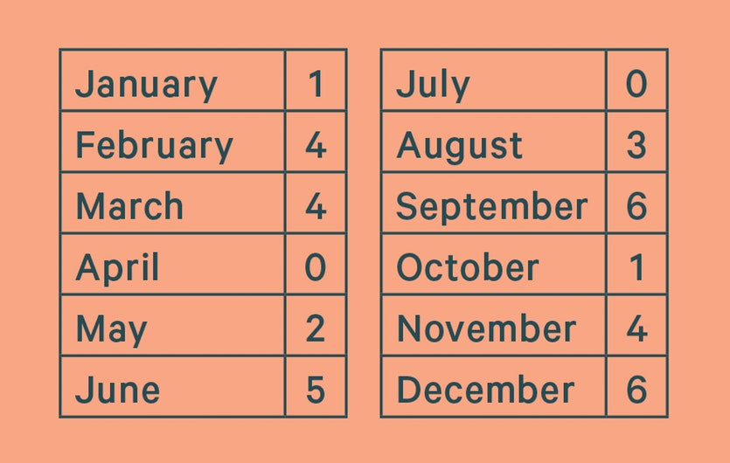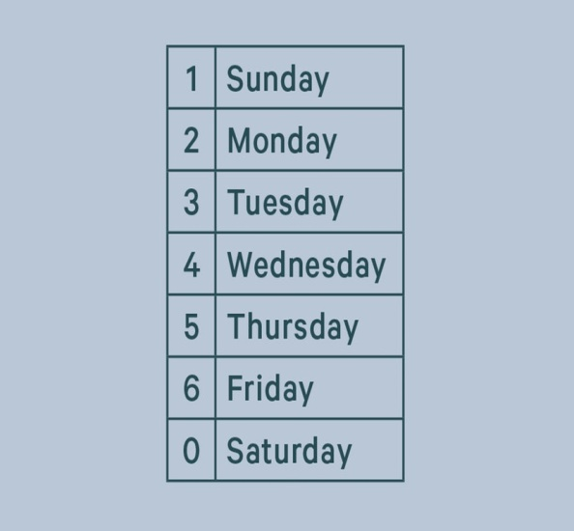

“Day codes” for the days of the week.
In leap years, subtract one from the month code for January and February only! Leap years are any years where the last two digits of the year are a multiple of four. The exception to this rule are century years (those ending with 00) where the whole number must divisible by 400. Thus 1800 and 1900 were not leap years, while 1600 and 2000 were.
To begin, you take the last two digits of the year and divide the number by four.
Disregarding any remainder, add the result to the number you began with.
Add the month code number.
Add the day of the month.
Divide this total by seven
Now disregard the whole number and focus on the remainder. It is the remainder that will tell you the day of the week, according to the following day codes.
For dates in the 1800s, add two to your total. For dates in the 2000s, subtract one. You can do this any time before the final step of dividing by seven.

Question1. What was the day of the week on 17 January 1953?

Question2. On what dates of April, 2001 did Wednesday fall?

Question3. Today is Monday, after 61 days, it will be?
- Wednesday b) Saturday c) Tuesday d) Thursday

Question4. It was Sunday on Jan 1, 2006. What was the day of the week Jan 1, 2010?

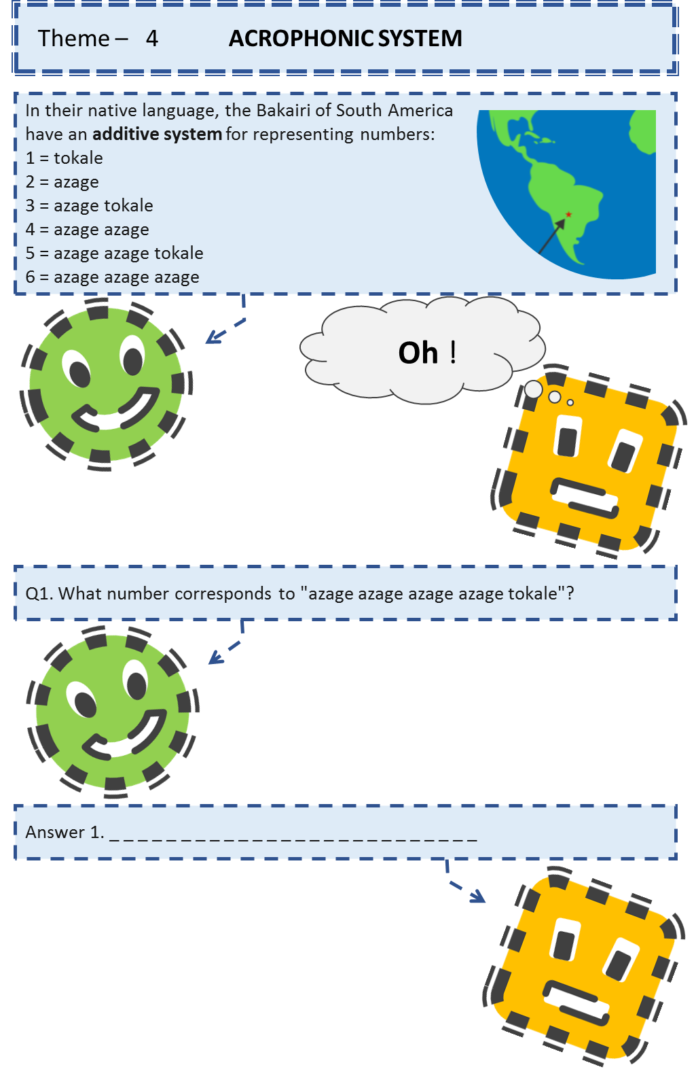
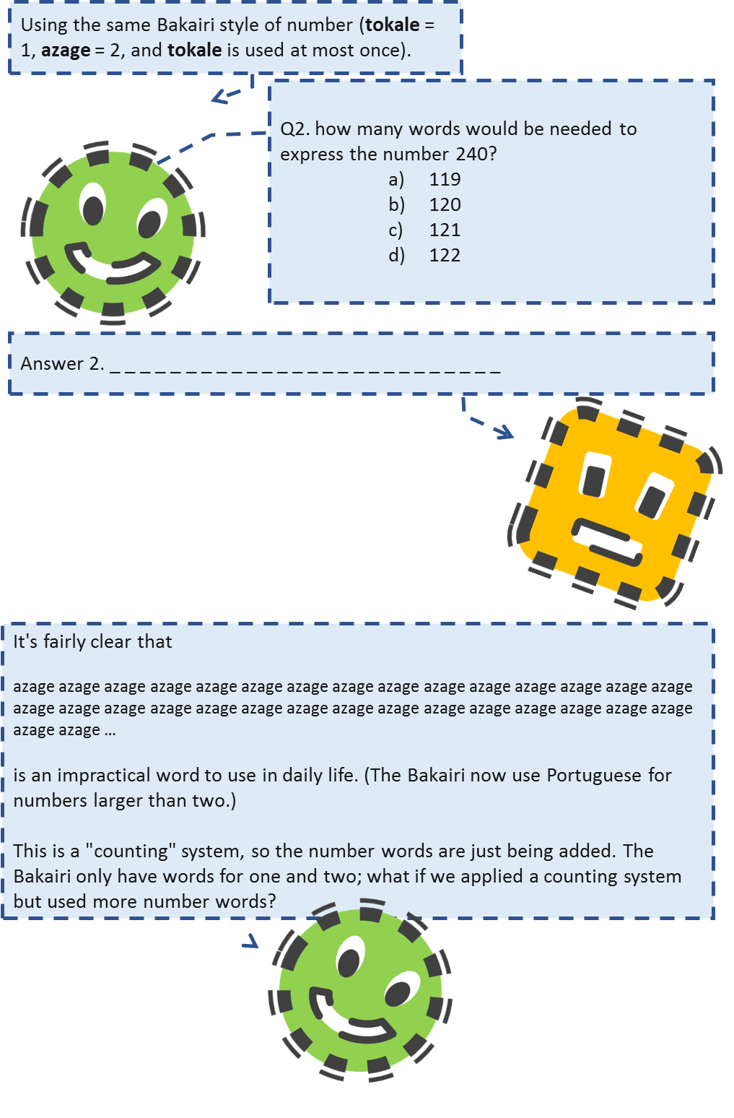
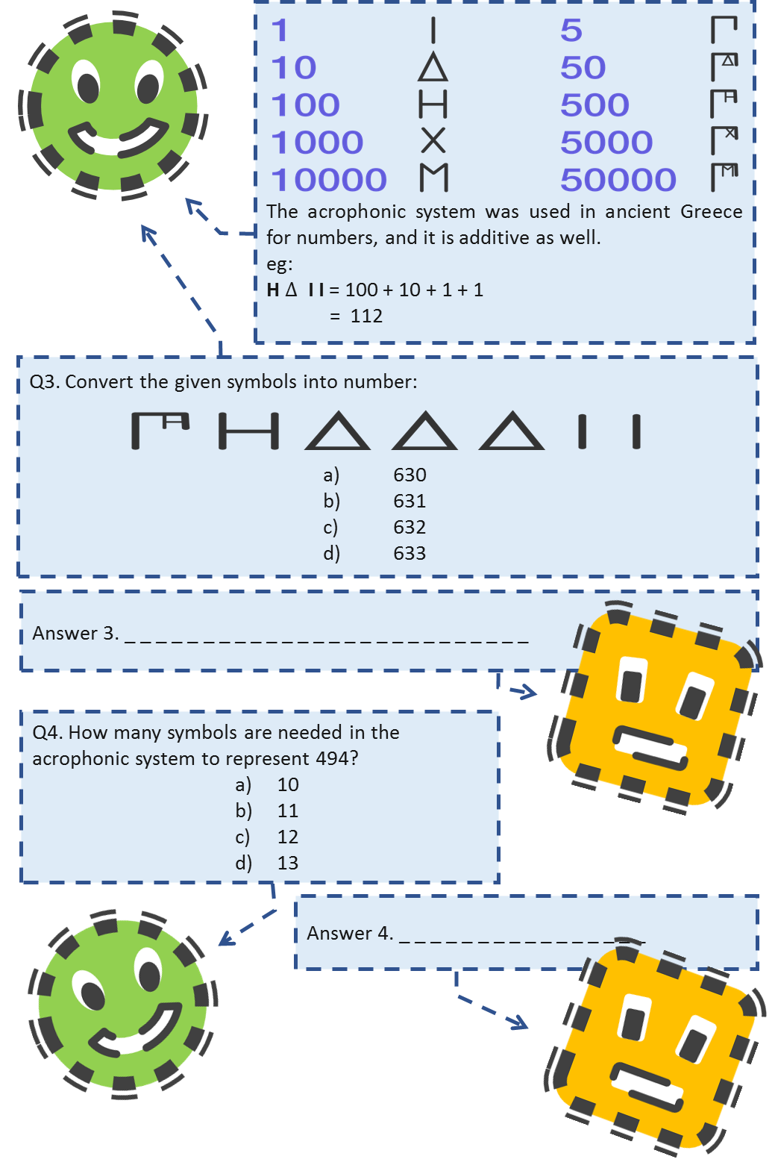
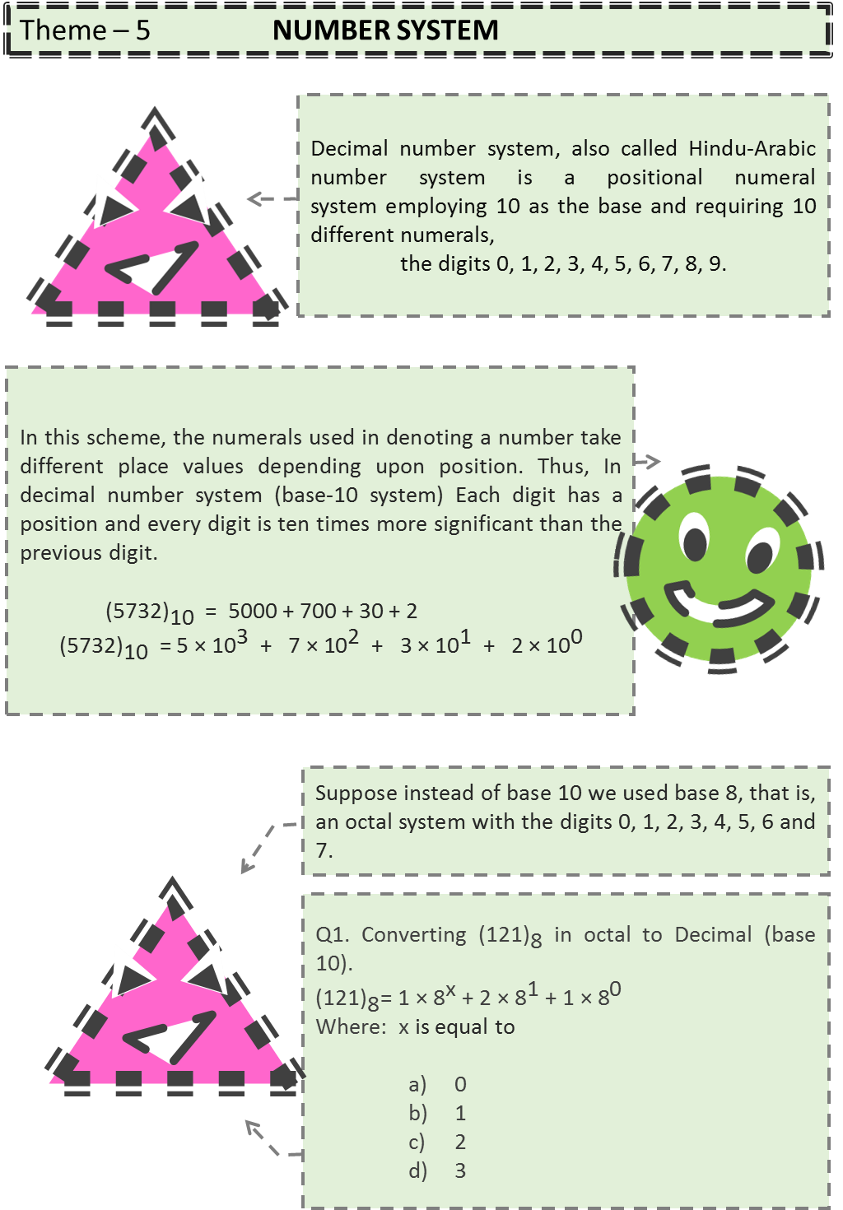
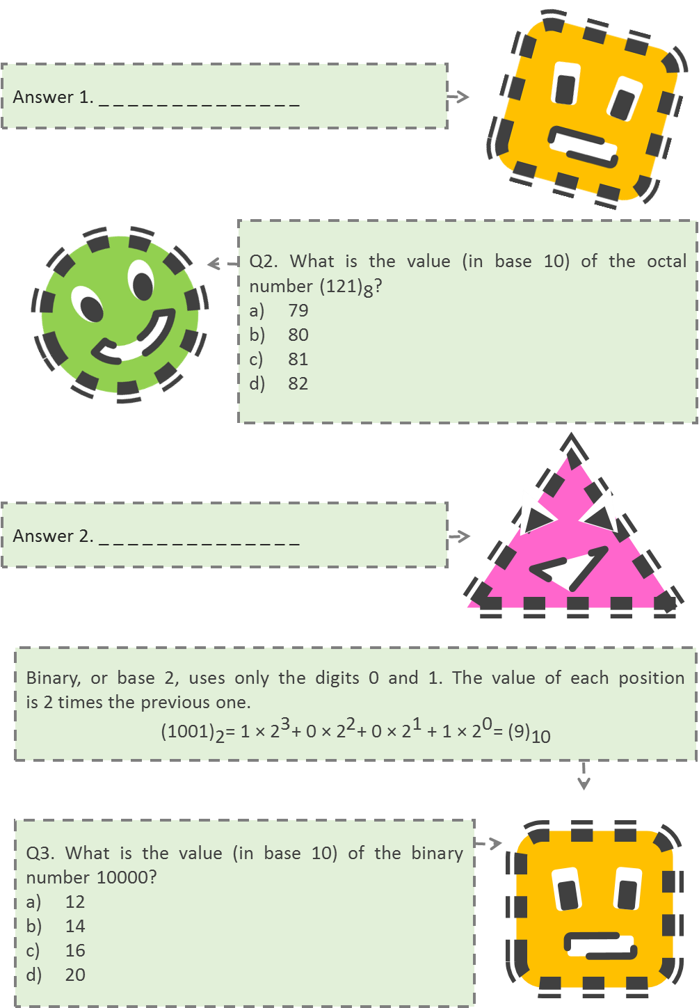
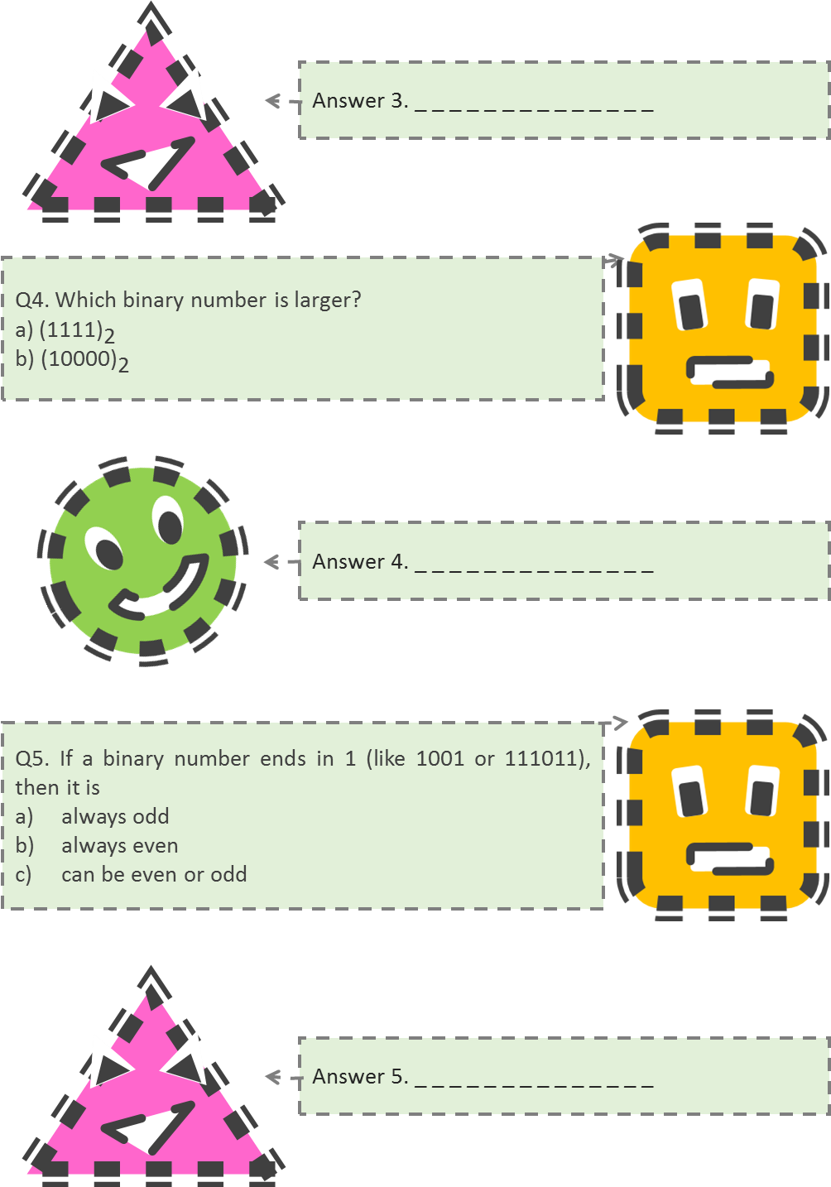

ITEM – 6
DAD

Write a 2-digit number ab and the number obtained by reversing the digits i.e., ba. Find their sum. Let the sum be a 3-digit number dad
i.e., ab + ba = dad
(10a + b) + (10b + a) = dad
11(a + b) = dad

Q 1: The sum a + b cannot exceed 18 (why?)

Q 2: Is dad a multiple of 11?

Q 3: Is dad less than 198?

Q 4: Write all the 3-digit numbers which are multiple of 11 up to 198.

Q 5: Find the values of a and d.

ITEM 7
Card Game

In school, cards competition was held. Two students Daman and Chaman of class VIII A are provided the cards. The cards in their hands are of different colours as shown below:
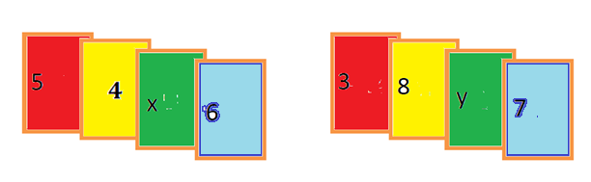

Q 1: What are the total scores in each of their hands ?
Daman’s Score= ------------. Chaman’s Score = -------------.

Q 2: In order to make sum of the digits of cards in each hand be divisible by 9, what are the values of x and y ?

Q3: By using the least values of x and y write the
- greatest number formed by the digits in Daman’s hands.
- smallest number formed by the digits in Chaman’s hands.

Q 4: Is the difference between their greatest numbers formed by the digits in their hands by using the greater value of x and y divisible by 3?

Q 5: State true or false:
The numbers which are divisible by 3 are divisible by 9

ITEM- 8
CRYPTARITHMS

Cryptarithms are puzzles, on various operations on numbers, in which letters take the place of digits and one has to find out which letter represents which digit. While solving cryptarithms involving addition and multiplication, we assume that each letter in a puzzle stands for just one digit and each digit is represented by just one letter. We also assume that first digit of a number cannot be zero.
Example: 3 1 A
+ 1 A 3
5 0 1

in this addition we have to find the value of A.

At one’s place, A+3=_1, so think a number which when added to 3 gives one’s place digit 1. Such a number is 8 as 8+3=11.
Taking A = 8, we obtain the addition as below:
318+183=501, hence A will have a value 8.

Find the value of unknown letters:

Question1:
BA | $$×$$ | B3 | = | 57A

Question2
8A5
+94A
1A33

Question3:
A B * 5 = CAB

Question4:
BA
+AB
DAD

Question5:
AB
+BA
+ B
AAB

ITEM-9
CRYPTARITHMETIC

As clear from the name, which is formed by joining two words Crypto meaning hiding and solving and Arithmetic means standard traditional operations like—addition, subtraction, multiplication and division.

A cryptarithmetic puzzle is a mathematical exercise where the digits of some numbers are represented by letters (or symbols). Each letter represents a unique digit. The goal is to find the digits such that a given mathematical equation is verified.

Cryptarithmetic concepts have been used in the times of World War I and World War II, to transmit important military communications over an open radio frequency.

Rules to Solve Cryptarithmetic Questions
- Every Character/letter must have a unique and distinct value
- The values of a character/letter cannot be changed, and should remain same throughout
- Starting character of number cannot be zero example – 0341 should be simply 341.
- The problem will have only and only one solution
- Addition of two numbers is always even
- In case of addition of two numbers, if there is carry then, the carry can only be 1
- Once all the characters/letters are replaced with numbers, arithmetic operations must be correct.

Now let us, learn all these rules with the help of an example –
If TO + GO = OUT. Find the value of T + G + O + U?

Step-1
The value of O is clearly 1. (Rule 6)
Since, T + G is generating O is carry so value of O is 1.
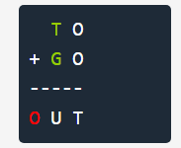
Now, after substituting the values –

Step 2
Value of T = 1 + 1
Thus, value of T = 2
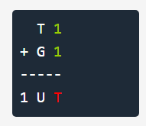

Step 3
Now, 2 + G > 10 (as its resulting a carry 1 on next)
Now, possible values of G to get 1 carry at next step is – {G = 8 or 9}
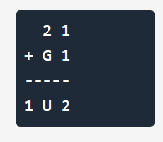

If G is 9 then –
U = 2 + 9 = 11
So value of U becomes 1 and 1 goes to carry
Now, value of O is already 1 so U value cannot be 1 also. (Rule – 1)
Now, obviously the value of G has to be 8, lets verify this also
U = 2 + 8 = 10
So value of U becomes 0, there is no conflict.
So final values are –
T = 2, O = 1, G = 8, U = 0
Replace values in all steps and solution looks like –

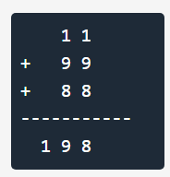

So, the value of T + G + O + U= 2+8+1+0=11

Question 1: USSR + USA = PEACE, what is the value of P + E + A + C + E?
- 9
- 10
- 11
- 12
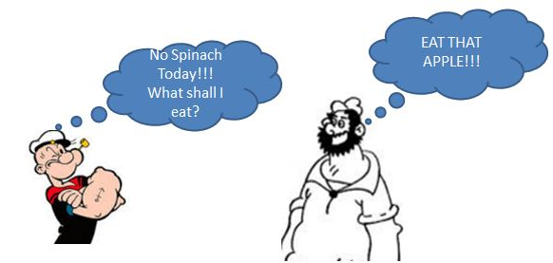

Question 2: If EAT + THAT = APPLE, What is A + P + P + L + E?
- 13
- 14
- 12
- 15

Question 3: If AA + BB + CC = ABC, then what is the value of A+B+C=?
- 15
- 18
- 21
- 12

Question 4: In the following problem, replace the letters of the English alphabet by digits (two or more letters may have the same value) to complete the procedure of division and find D+B+G+H =?

- 14
- 17
- 24
- 19

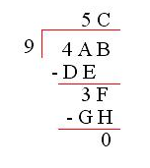

ITEM-10
GAUSS QUICK ADDITION
About two hundred years ago in Germany, the teacher of an unruly class set his students a task designed to keep them quiet for the rest of the day: Add all the numbers from zero to one hundred. Instantly, one six-year-old came up with the solution.

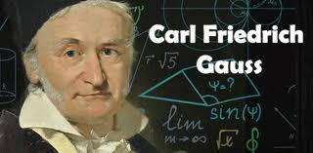

He was Karl Friedrich Gauss who went on to become one of the world's great mathematicians.
Here is how Gausss had added first 100 natural numbers:

1+2+3+4+ .................+97+98+99+100
Secret:  Arrange the numbers in fifty pairs, each adding up to 101: | Example  1+100=101  2+ 99=101  3+ 98=101  4+ 97=101
And so on……………………………. | …………..
 | 50+51=101
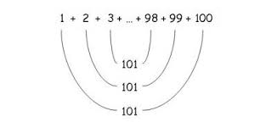

Since you have 50 pairs of numbers which equal 101,
Simply multiply: $50 × 101=5,050$
To multiply by 50 with mathemagical speed, first multiply by 100 (add two zeros), then divide by 2.
Hint:To make the trick more mystifying (after all, you could have easily memorized 5,050), invite the friends to give you any starting number and add the 100 numbers from there.
Example: To add the hundred numbers starting 25 and ending with 124
a) Add $25+124=149$
b) Multiply $149 × 100 = 14,900$
c) Divide $14,900 / 2=7,450$
If starting number is $n$then hundredth number will be $n+99$
If sum of 100 consecutive numbers is k,
Then, sum of first and last number is$n+\left(n+99\right)=2n+99$
$$k=\left(2n+99\right)*100/2$$

Question 1: If you add the 100 numbers starting from 177. Then what is the sum of hundred numbers?
Answer: ………………………….………………………….………………………….………………………….………………………….…………………………….…………………………….…………………………….………

Question 2: If the sum of 100 consecutive numbers is 25250. Then what is the starting number?
Answer: ………………………….………………………….………………………….………………………….………………………….…………………………….…………………………….…………………………….………

Question 3: If the sum of 100 consecutive numbers is 6350. Then what is the last number?
Answer: ………………………….………………………….………………………….………………………….………………………….…………………………….…………………………….…………………………….………

Question 4: What is the sum of first 999 natural numbers?
- 944500
- 499500
- 499900
- 999000

ITEM – 1
Surprizes with Clock Arithmetic

Domain:  Mathematical Literacy | TOPIC/CHAPTER:  SURPRISE WITH CLOCK ARITHMETIC  (PLAYING WITH NUMBER) | Class : VIII  Expected Time : 20 minute  Total Credit: 10
Description of items  $$√$$ Text  $$√$$ Image  $$√$$ Table  Graph  Map  Poem | Learning Outcomes:  To find recreation in numbers and arithmetic.  To introduce children to patterns and give them a taste of “modular mathematics”

FRAMEWORK | CHARACTERISTICS
Competency Cluster | Connection
Overarching Idea | Quantity
Context | Societal, recreational
Item format | Short answer type
Cognitive Process | Evaluating
Proficiency Level | 6

Description of Answer Key and Credits:

Credit Pattern:
Full Credit: 2
Partial Credit: 1
Nil Credit: 0

Question 1:
Full Credit:
+ | 1 | 2 | 3 | 4 | 5 | 6 | 7 | 8 | 9 | 10 | 11 | 12
1 | 2 | 3 | 4 | 5 | 6 | 7 | 8 | 9 | 10 | 11 | 12 | 1
2 | 3 | 4 | 5 | 6 | 7 | 8 | 9 | 10 | 11 | 12 | 1 | 2
3 | 4 | 5 | 6 | 7 | 8 | 9 | 10 | 11 | 12 | 1 | 2 | 3
4 | 5 | 6 | 7 | 8 | 9 | 10 | 11 | 12 | 1 | 2 | 3 | 4
5 | 6 | 7 | 8 | 9 | 10 | 11 | 12 | 1 | 2 | 3 | 4 | 5
6 | 7 | 8 | 9 | 10 | 11 | 12 | 1 | 2 | 3 | 4 | 5 | 6
7 | 8 | 9 | 10 | 11 | 12 | 1 | 2 | 3 | 4 | 5 | 6 | 7
8 | 9 | 10 | 11 | 12 | 1 | 2 | 3 | 4 | 5 | 6 | 7 | 8
9 | 10 | 11 | 12 | 1 | 2 | 3 | 4 | 5 | 6 | 7 | 8 | 9
10 | 11 | 12 | 1 | 2 | 3 | 4 | 5 | 6 | 7 | 8 | 9 | 10
11 | 12 | 1 | 2 | 3 | 4 | 5 | 6 | 7 | 8 | 9 | 10 | 11
12 | 1 | 2 | 3 | 4 | 5 | 6 | 7 | 8 | 9 | 10 | 11 | 12

No Credit: other responses

Question 2:
Full Credit:
X | 1 | 2 | 3 | 4 | 5 | 6 | 7 | 8 | 9 | 10 | 11 | 12
1 | 1 | 2 | 3 | 4 | 5 | 6 | 7 | 8 | 9 | 10 | 11 | 12
2 | 2 | 4 | 6 | 8 | 10 | 12 | 2 | 4 | 6 | 8 | 10 | 12
3 | 3 | 6 | 9 | 12 | 3 | 6 | 9 | 12 | 3 | 6 | 9 | 12
4 | 4 | 8 | 12 | 4 | 8 | 12 | 4 | 8 | 12 | 4 | 8 | 12
5 | 5 | 10 | 3 | 8 | 1 | 6 | 11 | 4 | 9 | 2 | 7 | 12
6 | 6 | 12 | 6 | 12 | 6 | 12 | 6 | 12 | 6 | 12 | 6 | 12
7 | 7 | 2 | 9 | 4 | 11 | 6 | 1 | 8 | 3 | 10 | 5 | 12
8 | 8 | 4 | 12 | 8 | 4 | 12 | 8 | 4 | 12 | 8 | 4 | 12
9 | 9 | 6 | 3 | 12 | 9 | 6 | 3 | 12 | 9 | 6 | 3 | 12
10 | 10 | 8 | 6 | 4 | 2 | 12 | 10 | 8 | 6 | 4 | 2 | 12
11 | 11 | 10 | 9 | 8 | 7 | 6 | 5 | 4 | 3 | 2 | 1 | 12
12 | 12 | 12 | 12 | 12 | 12 | 12 | 12 | 12 | 12 | 12 | 12 | 12

No Credit: other responses

Question 3:
Full Credit: ( $2×3=6, 6×3=6, 10 ×3=6)$
No Credit: other responses

Question 4:
Full Credit: 5hr, 17 hr, 29 hr, 41 hr, 53 hr .....................
No Credit: other responses

Name of the Teacher/Item Writer: Om Prakash
Designation: Vice Principal
Email: omidot@gmail.com
Phone No.: 9459870956
Name of the Vidyalaya: KV Suranussi, Jalandhar
KVS Region: Chandigarh

ITEM – 2
Number fun with Calendars-I

Domain:  Mathematical Literacy | TOPIC/CHAPTER:  NUMBER FUN WITH CALENDARS  (PLAYING WITH NUMBER) | Class : VIII  Expected Time : 20 minute  Total Credit: 10
Description of items  $$√$$ Text  $$√$$ Image  $$√$$ Table  Graph  Map  Poem | Learning Outcomes:  To provide children recreation using patterns of numbers in Calendars.  To introduce children to patterns and give them a taste of “modular mathematics”

FRAMEWORK | CHARACTERISTICS
Competency Cluster | Connections
Overarching Idea | Quantity
Context | Societal, recreational
Item format | Short answer type
Cognitive Process | Evaluating
Proficiency Level | 5 & 6

Description of Answer Key and Credits:

Credit Pattern:
Full Credit: 2
Partial Credit: 1
Nil Credit: 0

Question 1:
Full Credit: Mean = 24, Sum = 24 $×$ 7 = 168
If there are Odd numbers of terms then middle term will be mean, here it is 24 and Sum is the product of Mean and number of terms = 24 $×$ 7 = 168.
Partial Credit: If Mean is right (24) but sum is incorrect.
Or Sum is right (168) but Mean is incorrect-
No Credit: other responses

Question 2:
(There may be many rectangles and squares but Findings must be accurate.)

Full Credit:

Student figure out any arrangement (rectangular or square ) and list all the magic sums ,
Partial Credit:
Student figure out any arrangement (rectangular or square ) and list some of the magic sums ,
No Credit: other responses

Question 3:

Full Credit:

Student finds the mean and the sum correctly
Partial Credit:
Student finds either the mean correctly (sum is not correct) or the sum correctly (mean is not correct).
No Credit: other responses

Name of the Teacher/Item Writer: Om Prakash
Designation: Vice Principal
Email: omidot@gmail.com
Phone No.:9459870956
Name of the Vidyalaya: KV Suranussi, Jalandhar
KVS Region: Chandigarh

ITEM – 3
FUN WITH CALENDAR – II

Domain:  Mathematical Literacy | TOPIC/CHAPTER:  DAY AND CALENDAR  (PLAYING WITH NUMBERS) | Class : VIII  Expected Time : 20 minute  Total Credit: 10
Description of items  $$√$$ Text  Image  $$√$$ Table  Graph  Map  Poem | Learning Outcomes:  Understandinteresting properties of numbers in Calendars  To learn new methods to find particular day of a year.

FRAMEWORK | CHARACTERISTICS
Competency Cluster | Connections
Overarching Idea | Quantity
Context | Personal/Societal
Item format | Multiple Choice
Cognitive Process | Evaluating
Proficiency Level | 4 to 6

Description of Answer Key and Credits:

Credit Pattern:
Full Credit: 2
Partial Credit: 1
Nil Credit: 0

Q01. Full credit: Saturday
Nil credit: Missing or any other response.

Q02. Full credit: 4,11,18,25
Nil credit: Missing or any other response.

Q03. Full credit: option b
Nil credit: Missing or any other response.

Q04. Full credit: Friday
Nil credit: Missing or any other response.

NAME OF THE TEACHER: SHALINI
DESIGNATION: TGT MATH
EMAIL:shalinishalini030@gmail.com
PHONE NUMBER: 9459205756
NAME OF VIDYALAYA: KV SURANUSSI
KVS REGION: CHANDIGARH

ITEM-4
Acrophonic System

Domain: Mathematical Literacy | Theme 4:Acrophonic System | Class(es): 8 th  Expected time: 20 min  Total Credit: 08
Description of Item:  Text yes  Image yes  Table  Graph  Map  Poem | Chapter- Playing with Numbers

Mathematical Literacy:
FRAMEWORK | CHARACTERISTICS
Competency Cluster | Connections
Overarching Idea | Quantity
Context | Educational and Occupational
Item format | Short Answer
Cognitive Process | Thinking, Problem Solving
Proficiency Level | 03

Credit Pattern:
Full Credit: 02
Partial Credit: 01
Nil Credit: 00

Description of Answer Key and Credits:
A1. 9

A2. b) 120

A3. c) 500 + 100 + 10 + 10 + 10 + 1 + 1 = 632

A4. d) 13

Name of the Teacher/Item Writer: Ankur Pathania
Designation: TGT (Maths)
Email: ankurpathania75@gmail.com
Phone No: 9478892731
Name of the Vidyalaya: No 2. Pathankot
KVS Region: Chandigarh

ITEM-5
Number System

Domain: Mathematical Literacy | Theme 5:  Number System | Class(es): 8 th  Expected time: 20 min  Total Credit: 10
Description of Item:  Text yes  Image yes  Table  Graph  Map  Poem | Chapter- Playing with Numbers

Mathematical Literacy:
FRAMEWORK | CHARACTERISTICS
Competency Cluster | Connections
Overarching Idea | Quantity
Context | Educational and Occupational
Item format | Short Answer
Cognitive Process | Thinking, Problem Solving
Proficiency Level | 05

Credit Pattern:
Full Credit: 02
Partial Credit: 01
Nil Credit: 00

Description of Answer Key and Credits:
A1. c) 2

A2. c) 81

A3. c) 16

A4. b) ${(10000)}_{2}$

A5. a) always odd

Name of the Teacher/Item Writer: Ankur Pathania
Designation: TGT (Maths)
Email: ankurpathania75@gmail.com
Phone No: 9478892731
Name of the Vidyalaya: No 2. Pathankot
KVS Region: Chandigarh

ITEM – 6
DAD

Domain:  Mathematical Literacy | TOPIC/CHAPTER:  DAD  (PLAYING WITH NUMBER) | Class : VIII  Expected Time : 20 minute  Total Credit: 10
Description of items  $$√$$ Text  $$√$$ Image  Table  Graph  Map  Poem | Learning Outcomes:  Children will recapitulate the test of divisibility by 11

FRAMEWORK | CHARACTERISTICS
Competency Cluster | Connection
Overarching Idea | Quantity
Context | Societal, recreational
Item format | Short answer type
Cognitive Process | Evaluating
Proficiency Level | 4

Description of answer key and Credits:
Credit pattern:
Full Credit: 02
Partial Credit: 01
No Credit: 0

Ans 1.
Full credit: the sum a + b cannot exceed 18.
Because the values of a or b cannot exceed 9
No Credit: Missing or any other response.

Ans 2.
Full credit: Yes, dad is multiple of 11.
No Credit: Missing or any other response.

Ans 3.
Full credit: dad is less than or equal to 198
No Credit: Missing or any other response.

Ans 4.
Full credit: All the 3-digit numbers which are multiple of 11 upto 198 are
110, 121, 132, 143, 154, 165, 176, 187 and 198.
Partial Credit: if at least 5 multiples are answered
No Credit: Missing or any other response.

Ans 1.05.
Full credit: d = 1, a = 2
Description: dad = 121
No Credit: Missing or any other response.

ITEM – 7
Card Game

Domain:  Mathematical Literacy | TOPIC/CHAPTER:  Card Game  (PLAYING WITH NUMBER) | Class : VIII  Expected Time : 20 minute  Total Credit: 10
Description of items  $$√$$ Text  Image  $$√$$ Table  Graph  Map  Poem | Learning Outcomes:  Children will recapitulate the test of divisibility by3 and 9

FRAMEWORK | CHARACTERISTICS
Competency Cluster | Connection
Overarching Idea | Quantity
Context | Social
Item format | Short answer type
Cognitive Process | Evaluating
Proficiency Level | 5

Description of answer key and Credits:
Credit pattern:
Full Credit: 02
Partial Credit: 01
Nil Credit:00

Ans1.
Full credit:Daman’s Score= 15 + x, Chaman’s Score = 18+y
No credit: Missing or any other response.

Ans 2.
Full credit:x =3, y = 0 and 9
Partial Credit: if value of x or y answered
No credit: Missing or any other response.

Ans 3.
Full credit: (i) 6543. (ii) 3078.
Partial Credit: one part for 1 mark
No credit: Missing or any other response.

Ans 4.
Full credit:yes divisible by 3.
Description: Daman = 6543 : Chaman = 9873
Difference = 3330, divisible by 3.
No credit: Missing or any other response.

Ans 5.
Full credit: False
No credit: Missing or any other response

ITEM – 8
CRYPTARITHMS

Domain: Mathematical Literacy | Theme: 01,Cryptarithms | Class: VIII
Description of Item  Text  Image  Table  Graph  Map  poem | Learning Outcomes:  Students will be able to find the relationship between numbers.

FRAMEWORK | CHARACTERISTICS
Competency Cluster | Connections
Overarching idea | Change and relationships
Context | Social
Item format | Short response
Cognitive process | Interpret and employ
Proficiency Level | 5

Credit pattern:
Full Credit: 2
Partial Credit: 0
No Credit:
Description of answer key and Credits:
Q01. Full credit: A= 5, B= 2
No credit: Missing or any other response.

Q02. Full credit: A=8
No credit: Missing or any other response.

Q03. Full credit: A= 2 OR 7, B= 5, C= 1 OR 3.
No credit: Missing or any other response.

Q04. Full credit: A= 2, B = 9, D= 1
No credit: Missing or any other response.

Q05. Full credit: A= 1, B= 9
No credit: Missing or any other response

NAME OF THE TEACHER: SHALINI
DESIGNATION: TGT MATH
EMAIL: shalinishalini030@gmail.com
PHONE NUMBER: 9459205756,
NAME OF VIDYALAYA: KV SURANUSSI
KVS REGION: CHANDIGARH

ITEM – 9
CRYPTARITHMETIC

Domain:  Mathematical Literacy | TOPIC/CHAPTER:  CRYPTARITHMETIC  (PLAYING WITH NUMBERS) | Class : VIII  Expected Time : 20 minute  Total Credit: 10
Description of items  $$√$$ Text  $$√$$ Image  Table  Graph  Map  Poem | Learning Outcomes:  Understandinteresting properties of numbers in Calendars  To learn new patterns of coding and decoding.

FRAMEWORK | CHARACTERISTICS
Competency Cluster | Connections
Overarching Idea | Quantity
Context | Personal
Item format | Multiple Choice
Cognitive Process | Evaluating
Proficiency Level | 4 to 6

Description of Answer Key and Credits:
Credit Pattern:
Full Credit: 2
Partial Credit: 1
Nil Credit: 0

Question 1:
Full Credit: B) 10
P + E + A + C + E = 1 + 0 + 2 + 7 + 0 = 10
EAT + THAT = APPLE, 032+9338= 10270
No Credit: For any other answer

Question 2:
Full Credit: B) 12
A+P+P+L+E = 1+0+0+3+8 = 12
USA + USSR = PEACE, 819+9219=10038
No Credit: For any other answer

Question 3:
Full Credit: B) 18
A+B+C = 1+ 9 + 8 = 18
AA+ BB + CC = 11 + 99 + 88 = 198
No Credit: For any other answer

Question 4:
Full Credit: D) 19
D+B+G+H = 4+6+3+6 = 19
A=8, B=6, C= 4, D= 4, E=5, F= 6, G=3, H=6
No Credit: For any other answer

Name of the Teacher/ItemWriter: ASAN KUMAR
Designation: TGT-MATHS
Email: asan_kumar2000@yahoo.com
Phone No.: 9459770477
Name of the Vidyalaya: KV SECTOR-47 CHANDIGARH
KVS Region: CHANDIGARH

ITEM – 10
GAUSS QUICK ADDITION

Domain:  Mathematical Literacy | TOPIC/CHAPTER:  GAUSS QUICK ADDITION  (PLAYING WITH NUMBERS) | Class : VIII  Expected Time : 20 minute  Total Credit: 10
Description of items  $$√$$ Text  $$√$$ Image  $$√$$ Table  Graph  Map  Poem | Learning Outcomes:  Understandinteresting quick method of addition  To find magic and recreation in maths.

FRAMEWORK | CHARACTERISTICS
Competency Cluster | Connections
Overarching Idea | Quantity
Context | Societal, recreational
Item format | Short answer and Multiple Choice
Cognitive Process | Evaluating
Proficiency Level | 4 to 5

Description of Answer Key and Credits:
Credit Pattern:
Full Credit: 2
Partial Credit: 1
Nil Credit: 0

Question 1:
Full Credit: 22650
177+276= 453 , (453*100)/2 = 22650
No Credit: For any other responses

Question 2:
Full Credit: 203
(25250$×$2)/100= 505: 2n+99 = 505; So, n= 203 as first number.
No Credit: For any other responses

Question 3:
Full Credit: 113
(6350$×$2)/100= 127; 2n+99 = 127; So, n= 14 as first number.
Last number= $2n+99=2×14+99=113$
No Credit: For any other responses

Question 4:
Full Credit: B) 499500
1+999=1000; Sum= 1000$×$999/2= 499500.
No Credit: For any other responses

Name of the Teacher/ItemWriter: ASAN KUMAR
Designation: TGT-MATHS
Email: asan_kumar2000@yahoo.com
Phone No.: 9459770477
Name of the Vidyalaya: KV SECTOR-47 CHANDIGARH
KVS Region: CHANDIGARH

