KENDRIYA VIDYALAYA SANGATHAN

CCT TEST ITEMS
CLASS VIII: CHAPTER 15: INTRODUCTION TO GRAPHS

S. NO. | TITLE OF TEST ITEM
 | COVID – 19 CASES IN INDIA
 | TRIP FROM MUMBAI TO PUNE
 | DISTRIBUTION OF EMPLOYEES
 | A VISIT TO ZOO
 | TIME SPENT BY STUDENTS
 | AN ODI CRICKET MATCH
 | MEETING THE EXPENDITURE
 | FLIGHT JOURNEY
 | A TRIP TO KASHMIR
 | JOURNEY GRAPH

Practice Item-1

Domain:  Mathematical Literacy | Theme:  Introduction to graph | Class: VIII  Expected time: 10 minutes  Total Credit:10
Description of Item:  Text  Graph | Learning Outcome:  To interpret the Graph

FRAMEWORK | CHARACTERISTICS
Competency Cluster | Connection
Overarching Idea | Uncertainty and Data
Context | Social
Item format | MCQ
Cognitive Process | Interpretation and analysis
Proficiency Level | Level-1

COVID – 19 CASES IN INDIA
In March 2020, the COVID -19 cases detected in India from 2nd march to 21st march 2020 are given in the following graph.
Q.1.1: On which date the number of cases were maximum?

Q.1.2: On which two dates the number of cases were same?

Q.1.3: What is the percentage of increase of cases from 9th march to 21st march?

Q.1.4: On which date there is no detection of any new case?

Q.1.5: What is the average number of cases from 12th march to 21st march?

Description of Answer Key and Credits:
Full credit : 02 Partial credit : 01 No credit : 00

  - : Full credit: 21st March 2020
No credit: other response

  - : Full credit: 10th March 2020 and 14th March 2020
No credit: other response

  - : Full credit: 800%
Partial credit: 8%
No credit: other response

  - : Full credit: 11th march 2020
No credit: other response

  - : Full credit: 25
No credit: other response

Practice Item-2

Domain: Mathematical Literacy | Theme: Introduction to Graph | Class: VIII  Expected time: 10 min  Total Credit: 08
Description of Item:  Text  Graph | Learning Outcome: To analyse and interpret the graph.

FRAMEWORK | CHARACTERISTICS
Competency Cluster | Connection
Overarching Idea | Uncertainty and Data
Context | Personal
Item format | MCQ, Short Answer type
Cognitive Process | Analysis, Interpretation, Problem solving
Proficiency Level | Level-2

Manisa wants to make a trip from Mumbai to Pune. The distance between Mumbai to Pune is 210 km. She refers the petrol consumption rate of her new model car ‘Alto’ which depends on its speed. The details is described by the graph given below.

Q2.1. If the car travels at a steady speed of 60 km/h,what is the quantity of petrol consumed for the journey?
- 12.5 Litres
- 13.33 Litres
- 16 Litres
- 19 Litres
Q2.2. Manisa would like to minimize the full consumption for the trip by driving at the appropriate speed? How should she change the speed?
- Increase the speed
- Decrease the speed
- Maintain the speed at 60 km/h
- Cannot be determined.

Q2.3. Which is the most economical range of speed to drive a car?
- 70 – 80 km/h
- 60 – 70 km/h
- 50 – 60 km/h
- 40 – 50 km/h

Q2.4. If Manisa took 4 hours to complete the journey, find the average speed of car.

Description of Answer Key and Credits:
Full credit : 02 Partial credit : 01 No credit : 00
2.1. Full Credit: Option (a)
No Credit: Other response

2.2. Full Credit: Option (b)
No Credit: Other response

2.3. Full Credit: Option (d)
No Credit: Other response

2.4. Full Credit: 52.5 km/h
Partial credit: Using correct formula (speed=distance/time), but wrong calculation
No Credit: Other response

Practice Item-3

Domain: Mathematical Literacy | Theme: Introduction to Graph | Class: VIII  Expected time: 10 Min.  Total Credit: 08
Description of Item:  Text  Pie-chart | Learning Outcome:  To analyse and interpret the given Pie chart.

FRAMEWORK | CHARACTERISTICS
Competency Cluster | Connection
Overarching Idea | Uncertainty & Data
Context | Occupational
Item format | Short Answer Type
Cognitive Process | Analysis, Interpretation
Proficiency Level | 3

The following pie-charts give the percentage distribution of employees in different Departments in RUSSEL COMPANY LTD. during the years 2007 and 2008.
Answer the questions using the following data.
A –Administration , B-Operations, C- Sales and marketing, D- Finance and Accounts, E-Corporate HQ
2007 (Number of Employees = 15000) 2008 ( Number of Employees=16000 )

Q3.1. If the average monthly salary of employees in Administrationwas Rs 12000 in 2007,
what was the approximate total salary expense in Administration in 2007?

Q3.2. What is the percentage increase in number of employees in sales and marketing ?

Q3.3. In which department is the variation in strength the maximum in 2008 ?

Q3.4. If 300 employees left Operations at the end of 2007, how many joined in 2008 ?

Description of Answer Key and Credits:

Full credit : 02 Partial credit : 01 No credit : 00

3.1. Full Credit: 4.75 crores
Partial Credit: Partly correct;
No Credit: Wrong response

3.2. Full Credit: 23.45%
Partial Credit: Partly correct;
No Credit: Wrong response

3.3. Full Credit: D(Finance and Accounts)
No credit: Other response

3.4. Full Credit: 1360;
Partial Credit: Partly correct;
No Credit: Wrong response

Practice Item-4

Domain: Mathematical Literacy | Theme: Introduction to Graphs | Class: VIII  Expected time: 10 min.  Total Credit: 10
Description of Item:  Text  Graph | Learning Outcome:  To locate the points.

FRAMEWORK | CHARACTERISTICS
Competency Cluster | Connection
Overarching Idea | Interpret the data
Context | Educational
Item format | MCQ, Short answer type
Cognitive Process | Identification, Interpretation, Problem solving
Proficiency Level | Level 2

A VISIT TO ZOO

An educational trip was organized by Oxford Public School during December 2019 for the students
of Class VIII to visit the nearest zoo under the guidance of 5 adult teachers. The students with the
teachers reached the main gate and collected the tickets and entered into the zoo at 10:30 A.M.
All the children enjoyed the beauty of the environment and the variety of animals they saw.

The given figure shows the layout of the zoo.
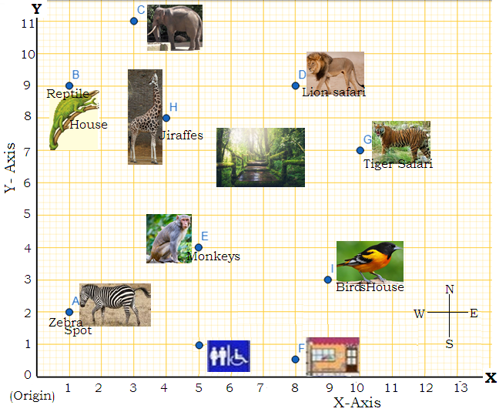
(1units on each axis = 50 metres)
On a graph sheet, a point is located using a pair of numbers such as (x, y)

Q4.1. The coordinates of the Reptile house is ---------.
( a ) ( 3 , 11 )
( b ) ( 1 , 2 )
( c ) ( 1 , 9)
( d ) ( 4 , 8 )

Q4.2. The distance between Zebras spot and the Lion safari is -------.
a) 14 units
b) 7 √2 units
c) 98 units
d) None of these

Q.4.3. The cost of a ticket for a child is 15 Zeds and the cost of a ticket for an adult is 25 Zeds .
If the total cost of tickets is 1700 Zeds, how many children were there from the school?

Q.4.4. Which place in the zoo is at a maximum distance from the origin?
Explain with your answer.

Q.4.5. A boy started his journey from the Bird House. First he walked 1 unit towards North,
then 4 units towards West followed by 5 units towards North and then 3 units towards East.
Where did the boy reach? If the boy covers 5 m in 6 seconds, then how much time he will
take to reach the spot if he walks with the constant speed?

Description of Answer Key and Credits:
Full credit : 02 Partial credit : 01 No credit : 00

4.1. Full Credit: Option (c)
No Credit: Any other response or missing response

4.2. Full credit : Option (b)
No credit : Any other response or missing response

4.3. Full credit : Process with answer as 105 children.
Partial Credit : Correct process with wrong answer.
No credit : wrong response or missing response.

4.4. Full credit : Tiger Safari.
Distance of Tiger Safari is$\sqrt{{10}^{2}+7^{2}}=\sqrt{149}$ units.
Whereas distance of Lion safari is $\sqrt{81+64}=\sqrt{145}$ units.
Partial Credit : Tiger Safari without explanation.
No credit : Wrong response or missing response

4.5. Full credit : Lion safari. Time=780 seconds or 13 minutes.
Partial Credit : Any one correct answer
No credit : Wrong response or missing response

Practice Item-5

Domain: Mathematical Literacy | Theme: Introduction to Graph | Class : VIII  Expected time: 10 Min.  Total Credit: 08
Description of Item:  Text  Pie-Chart | Learning Outcome:  To analyse and interpret the graph.

FRAMEWORK | CHARACTERISTICS
Competency Cluster | Connection
Overarching Idea | Uncertainty & Data
Context | Personal
Item format | Short Answer Type
Cognitive Process | Interpret the graph
Proficiency Level | 2&3

A Survey was done on class-VIII students of Royal Public School about the time spent by the students for doing different activities in a dayhaving School. The data is given by the following pie-chart.

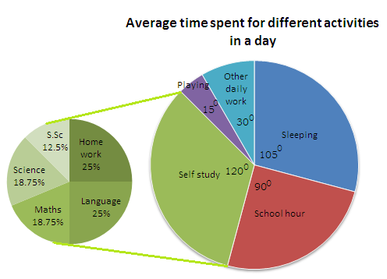

The time meant for self-study is used for doing home-work and studying four subjects daily as shown in the figure.

Q5.1. What is the average time spent in a day for sleeping?
a) 5 hours (b) 6 hours (c) 7 hours (d) 8 hours

Q5.2. What is the percentage of total time spent for schooling?
a) 25% (b) 30% (c) 20% (d) 50%

Q5.3. Find the time spent for Playing and other daily work?

Q5.4. How much time is spent for doing home-work?

Description of Answer Key and Credits:
Full credit : 02 Partial credit : 01 No credit : 00

5.1. Full Credit: Option (c)
No Credit: Other response

5.2. Full Credit: Option (a)
No Credit: Other response

5.3. Full Credit: 3 hours
Partial credit: Partly correct
No Credit: Other response

5.4. Full Credit: 2.4 hours (or 2 hours 24 min)
Partial credit: Partly correct
No Credit: Incorrect response

Practice Item-6

Domain: Mathematical Literacy | Theme: Introduction to Graphs |  | Class: VIII  Expected time: 10 min.  Total Credit: 10
Description of Item:  Text  Graph | Learning Outcome:  To interpret the line graph, to find speed, distance covered and time taken by a flight.
FRAMEWORK |  | CHARACTERISTICS
Competency Cluster |  | Connection
Overarching Idea |  | Interpret the data
Context |  | Social
Item format |  | MCQ
Cognitive Process |  | Analysis, Interpretation, problem solving
Proficiency Level |  | Level 2

An ODI Cricket match between India &Sri lanka;

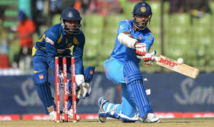

An one day international cricket match was held between India & Sri Lanka on 6th july 2019. The graphical representation of the proceedings of the match with a nail biting finish was as follows.
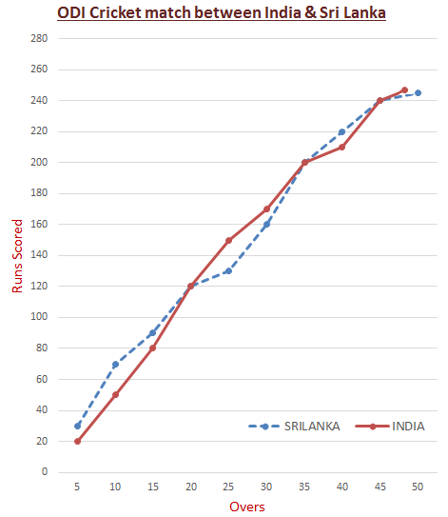

Q.6.1. In how many occasion(s) both the team scored equal runs with same number of overs bowled ?
A. Twice
B. Three times
C. Once
D. None of these

Q.6.2. During which block of 10 overs, India’s scoring rate was the slowest in the innings?
A. 10 – 20 OVERS
B. 20– 30 OVERS
C. 30 – 40 OVERS
D. 40 – 50 OVERS

Q.6.3. Which team did have more steady approach for scoring of runs ?
A. India
B. Sri Lanka
C. Both the team did have nearly the same approach.

Q6.4. How many runs were scored by the winning team in the last 8 overs?
A. Around 30 runs by SriLanka
B. Around 40 runs by India
C. Around 50 runs by India

Q.6.5. What was the run rate of India at the completion of 25 overs ?

Description of Answer Key and Credits:
Full credit : 02 Partial credit : 01 No credit : 00
6.1. Full Credit: Option (B)
No Credit: Other response

6.2. Full Credit: Option (C)
No Credit: Other response

6.3. Full Credit: Option (A)
No Credit: Other response

6.4. Full Credit: Option (B)
No Credit: Other response

6.5. Full Credit:6 runs per over
Partial credit : correct procedure but wrong calculation
No Credit: Other response

Practice Item-7

Domain: Mathematical Literacy | Theme: Introduction to Graph | Class : VIII  Expected time: 15 Min.  Total Credit: 10
Description of Item:  Text  Pie-Chart | Learning Outcome:  To analyse and interpret the graph.

FRAMEWORK | CHARACTERISTICS
Competency Cluster | Connection
Overarching Idea | Uncertainty & Data
Context | Social
Item format | MCQ, Fill in the blank, Short Answer Type
Cognitive Process | Interpret the graph
Proficiency Level | 3

To achieve development goals, Asia-Pacific countries need to spend$1.5 trillion/year, says UN report. How one Dollar is distributed for meeting the expenditure under different categories is given in the following pie-chart.

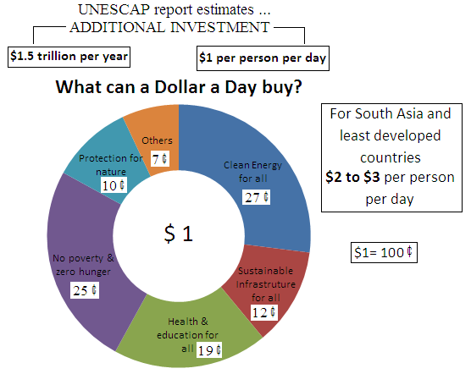

Q.7.1. As per UNESCAP report, Asia-Pacific countries need to make how much additional investment on “Health & Education” for one person in a month (30days)?
a) $11.4 b) $0.57 c) $5.7 d) $57

Q7.2. By what percent, the additional investment on “ Clean energy for all” exceeds over that on “ No poverty and zero hunger”?
a) 2% b) 4% c) 6% d) 8%

Q.7.3.(India is a developing country where as Bhutan, Afghanistan and Nepal are some least developing countries in South Asia). If India decides to make an additional investment of $2per person per day, what will be the annual additional investment on “No poverty and zero hunger”. (Given that $1=72 rupees)

Q.7.4. If NEPAL decides to make an additional investment of $2.5per person per day, what will be the total monthly additional investment on “Protection of Nature”? (Population of NEPAL is about 3crores)

Q.7.5. Is providing “Clean energy for all” a step towards “Protection for nature”? Justify your answer.

Description of Answer Key and Credits:
Full credit : 02 Partial credit : 01 No credit : 00
7.1. Full credit: (c) $5.7
Explaination: For Health & Education 19¢ =$0.19 is to be spent per person per day.
So, total investment per person in one month is $30×\$0.19=\$5.7$.
No credit: Option other than (c).

7.2. Full credit: (d) 8%
Explaination: Percent by which the additional investment on “ Clean energy for all” exceeds
over that on “ No poverty and zero hunger” =$\frac{27-25}{25}×100\%=8\%$
No credit: Option other than (d).

7.3. Full credit: Rs. 13140
Explaination: Additional investment for one person per day on “No poverty and zero hunger”
is $\$0.25×2×365=\$182.5$=$Rs.13140$
Partial credit: Partly correct
No credit: Incorrect response.

7.4. Full credit: $$2.25×{10}^{8}$
Explaination: As NEPAL decided to make an additional investment of $2.5 for one person per day.
So,additional investment on Protection of Nature is $10¢ ×2.5=25¢=\$0.25$ .
Since the population of NEPAL is 3crores=$3×{10}^{7}$, so the total additional investment per person
in one year =$\$3×{10}^{7}×0.25×30=\$2.25×{10}^{8}$.
Partial credit: Partly correct
No credit: Incorrect response.

7.5. Full credit: Yes (with correct explanation).
Partial credit: Yes (without any explanation).
No credit: No.

Practice Item-8

Domain: Mathematical Literacy | Theme: Introduction to Graphs | Class: VIII  Expected time: 15 min.  Total Credit: 10
Description of Item:  Text  Graph | Learning Outcome:  To interpret the line graph, to find speed, distance covered and time taken by a flight.

FRAMEWORK | CHARACTERISTICS
Competency Cluster | Connection
Overarching Idea | Interpret the data
Context | Educational
Item format | MCQ
Cognitive Process | Analysis, Interpretation, problem solving
Proficiency Level | Level 2

Abhishek Banarjee completed his graduation from Acharya Jagadish Chandra Bose College under Calcutta University. He wanted to prepare for CIVIL services at New Delhi. So for taking admission in Delhi University, he went to Delhi by Air. During his journey from Kolkata to Delhi, the height covered by the aeroplane is shown in the given graph.

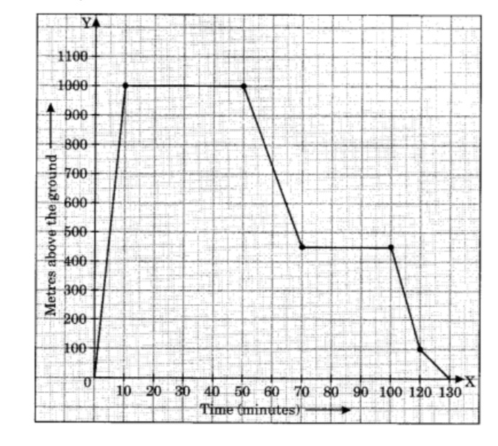

Q8.1. What the maximum height the aeroplane has covered?
- 450 m. (b) 100 m. (c) 0 m. (d) 1000 m.

Q8.2. What was the average speed of the aeroplane while rising?
- 100 m/min. (b) 200 m/min. (c) 500 m/min. (d) 1000 m/min.

Q8.3. How long was the plane in level flight?
- 40 min. (b) 30 min. (c) 70 min. (d) 100 min.

Q8.4. The flight took off at 9.30 a.m. from Kolkata Airport. When did it reach at New Delhi Airport?

Q8.5. What is the scales used in x-axis and y-axis respectively?

Description of Answer Key and Credits:

Full Credit: 2 Partial Credits: 1 Nil Credit: 0

8.1. Full Credit: Option (d) The aeroplane rose up to 1000 metres.
No Credit : any other option

8.2. Full Credit: Option (a) The speed of the aeroplane while rising was 100 m per min.
No Credit : any other option

8.3. Full Credit : Option (c)
The time taken by the aeroplane to be in level flight is 40 + 30 = 70 min
No credit : Wrong answer

8.4. Full Credit: Time of reaching at Delhi is 11.40 a.m.
No credit : Wrong answer

8.5. Full Credit: In x-axis, 1unit=10 min and y-axis, 1unit=100m.
Partial Credit : Scale used on any one axis
No credit : Wrong answer

Practice Item-9

Domain: Mathematical Literacy | Theme: Introduction to Graph | Class : VIII  Expected time: 10 Min.  Total Credit: 08
Description of Item:  Text  Pie-Chart | Learning Outcome:  To analyse and interpret the Pie-chart

FRAMEWORK | CHARACTERISTICS
Competency Cluster | Connection
Overarching Idea | Uncertainty & Data
Context | Personal
Item format | Short Answer Type
Cognitive Process | Interpret the graph
Proficiency Level | 2

A TRIP TO KASHMIR

Mr. P. Srivastava is working in Oil India Corporation, Duliajan, Asam. He planned to visit Kashmir (the heaven of India) with his mother, wife and two children. Since his children are studying in Kendriya Vidyalaya, they planned to visit the place during summer vacation. They planned to start their journey on 16th June 2021 and will return to their city on 25th June 2021. They want to spend Rs. 52,500 for their visit to Kashmir. The budget allocations for 10 days under different categories are given in the pie-chart.

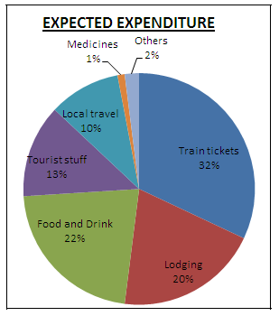
Q.9.1. Find the total money to be spent for train tickets.

Q.9.2. What is the average expenditure per person per day towards Food and drink?

Q.9.3. Recent study says, in Kashmir, the cost of lodging is increasing at a rate of 5% per year. If they will visit the place after 2 years, then what will be the expected amount they will spend on lodging?
(a) 11025 (b) 11550
(c) 11576 (d) 12155

Q.9.4. During the planning, Mrs. P. Srivastava (a school teacher), ask her daughter Alpha to find the central angles of the sector representing expenditure for tourist stuff?

Description of Answer Key and Credits:
Full credit : 02 Partial credit : 01 No credit : 00

Question-1
9.1. Full credit: Rs.16,800
Partial Credit: Correct process but wrong answer
No credit: Incorrect response

9.2. Full credit: Rs.231
Partial Credit: Correct process but wrong answer
No credit: Incorrect response

9.3. Full credit: Option (d)
No credit: any other response

9.4. Full credit: Central angle for tourist stuff is 46.8⁰.
Partial Credit: Correct process but wrong answer.
No credit: Incorrect response

Practice Item-10

Domain: Mathematical Literacy | Theme: Introduction to graph | Class-VIII  Expected time:15 minutes  Total Credit:10
Description of Item:  Text  √ Line graph | Learning Outcome  To solve the problems related graph

FRAMEWORK | CHARACTERISTICS
Competency Cluster | Connection
Overarching Idea | Data
Context | Personal
Item format | MCQ
Cognitive Process | Analysis, problem solving
Proficiency Level | 2

The graph below describes a journey of Rohan that has several parts to it, each represented by a different straight line. Study the graph and answer the following questions:
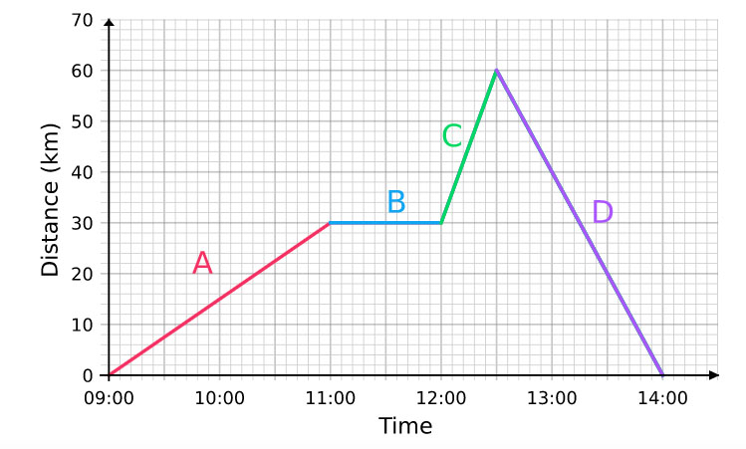
Q.10.1.The speed between 9:00 to 11:00 is
(a) 10 km/ hour (b) 15 km/hour (c) 20 km/hour (d) 25 km/hour

Q.10.2. Between which period of time Rohan was not travelling any distance?
(a) 11:00 – 12:00(b) 12:00 – 13:00 (c) 13:00 – 14:00 (d) None of these

Q.10.3. What distance did he travel between 12:00 to 12:30?
(a) 10 km(b) 20 km(c) 30 km(d) 40 km

Q.10.4. In what period of time did he travel the full 60 km back to where he began?
(a) 11:00 – 12:00(b) 12:00 – 13:00 (c) 12: 30 – 14:00 (d) 13:00 – 14:00

Q.10.5. In which of the following period of time did he travel the fastest?
(a) 9:00 – 11:00(b) 11:00 – 12:00(c) 12: 00 – 12:30(d) 12:30 – 14:00

Description of Answer Key and Credits:
Full Credit: 2 Partial Credit: 1 Nil Credit: 0

10.1: Full credit :(b) 15 km/hour No credit: other responses

10.2: Full credit: (a) 11:00 – 12:00 No credit: other responses

10.3:Full credit: (c) 30 km No credit: other responses

10.4:Full credit: (c) 12: 30 – 14:00 No credit: other responses

10.5:Full credit: (c) 12: 00 – 12:30 No credit: other responses

NAME OF THE MASTER TRAINERS, (BHUBANESWAR REGION)
DOMAIN-: MATHEMATICS LITERACY.

- MR. SURYAKANTA NANDA, PGT(Maths), K V NO-5, Bhubaneswar
- MR. SARBESWAR SAHOO, PGT(Maths), K V No-6, Bhubaneswar
- MR. G P BARIK, TGT(Maths), K.V INS Chilka
- MR. DEVASHISH BHUI, TGT(Maths), K V No-2, Bhubaneswar

